*Inflation Report*

# Summary

The *Inflation Report* considers recent developments in inflation and puts forward the Bank of England's analysis of future prospects. It contains seven sections covering:

1. recent price developments;
2. monetary and fiscal policy;
3. demand and output;
4. the l abour market;
5. price dynamics;
6. the prospects for inflation; and
7. conclLfsions.

Underlying inflation-defined as the twelve-month change in the Retail Prices Index excluding mortgage interest payments (RPIX)-has risen since the last *Inflation Report.* It was 2.8% in June, but has increased in each of the last three months, to reach 3.3% in September. The headline rate of inflation has also risen.

RPIX i nflation has been affected by the switch from the Community Charge to the Council Tax. To disentangle the impact of such tax changes on the price *level* from the 'underlying' rate of *inflation,* it is useful to examine a price index which excludes not only mortgage interest payments but also indirect taxes and local authority taxes. Inflation measured in this way rose from 2.8% in June to 3.5% in September, the same as a year ago before sterling's depreciation began to affect import prices.

Some i ncrease in inflation between June and September had seemed likely at the time of the last *Report.* Sales discounts were unusually widespread in June, suggesting that a rise in the inflation rate would follow post- sale price rises. In addition, seasonal food prices fell by more than is usual in June.

In fact, RPIX inflation has risen a little more than projected last time: to 3.3% compared with 3. 1 %. This difference partly

409

reflects smaller than expected falls in food prices in July, and partly the larger than expected recovery in the prices of household goods and clothing and footwear associated with the end of the summer sales.

To conduct monetary policy effectively, it is necessary to form a view about the likely course of inflation over the longer term.

Given current policies, the B ank's view of the most l ikely outturn is that inflation-both headli ne and RPIX-will rise until the middle of 1 994 and then start to decline again. The new information available since the August *Report* has led to a small upward revision in the twelve-month inflation rates expected over the next few months, but it has not produced any significant change to the expected rate of inflation two years from now. The central projection remains within the target range for RPIX inflation. But there is a slight possibility that in the first half of next year inflation will briefly rise above the top of the target range. This is partly because of changes in indirect and local authority taxes. Excluding those taxes, inflation is expected to start falling in early 1 994, and could reach a level c lose to the middle of the target range in 1 995.

But there are considerable uncertainties. The first concerns the exchange rate. If attempts to stimulate recovery lead to bigger than expected cuts in interest rates abroad, this would be likely to push up the sterling exchange rate and reduce inflationary pressures in the short run.

A second source of uncertainty is the behaviour of wage bargainers. If the short-run increase in inflation is simply extrapolated forward and earnings start to rise more rapidly, then more of the growth of nominal demand which is expected over the next year or two will take the form of higher prices rather than higher output and employment. But the continuing output gap, moderate growth of nominal demand, and slow growth in broad money a.nd credit, all point to the possibility of bringing inflation down further at the same time as output growth picks up.

410

# Recent price developments

*1.1* Retail

Chart 1.1 lnflation

Increase in prices on a year earlier

Per cenl

- 12

-10

- 8

- 6

- 4

- 2

Underlying inflation-defined as the twelve-month change in the Retail Prices Index excluding mortgage interest payments (RPIX)-has risen since the last *Inflation Report.* It was 2.8% in June but has increased in each of the last three months to reach 3.3% in September (Chart 1 . 1 ) . The headline rate of i nflation has also risen. Three months ago it had fallen to 1 . 2%, the lowest rate for nearly 30 years, but by September it had increased to 1 . 8%.

Headline inflation has been lower than RPIX inflation since the middle of 1 991. The difference between it and RPIX primarily reflects changes in mortgage i nterest payments during the previous twelve months. The gap will narrow in the next few months as the reductions in interest rates which took place last autumn fall out of the twelve-month calculation.

1 990

0

93 During the course of this year, RPIX inflation has been

(a) Bank estimate based on estimates of lhe VAT and excise dUly content of RPI components.

Table 1 .A

Contributions to RPIX inflation

Goods Of which: Services Council RPIX(a)

Tax

Seasonal Clothing

foods and

affected by the switch from the Community Charge to the Council Tax. The change lowered the twelve-month rise in RPIX, an effect which will persist until the second quarter of next year. At that point the increase in VAT announced in the March Budget will enter the index. To disentangle the impact of such tax changes on the price *level* from the 'underlying' rate of *inflation,* it is useful to examine a price index which excludes not only mortgage interest payments but also indirect taxes (VAT and excise duties) and local authority taxes.

Chart 1.1 shows inflation measured in this way­

- --

fOOlwear

-- denoted by RPIY-since the beginning of 1 990. RPIY

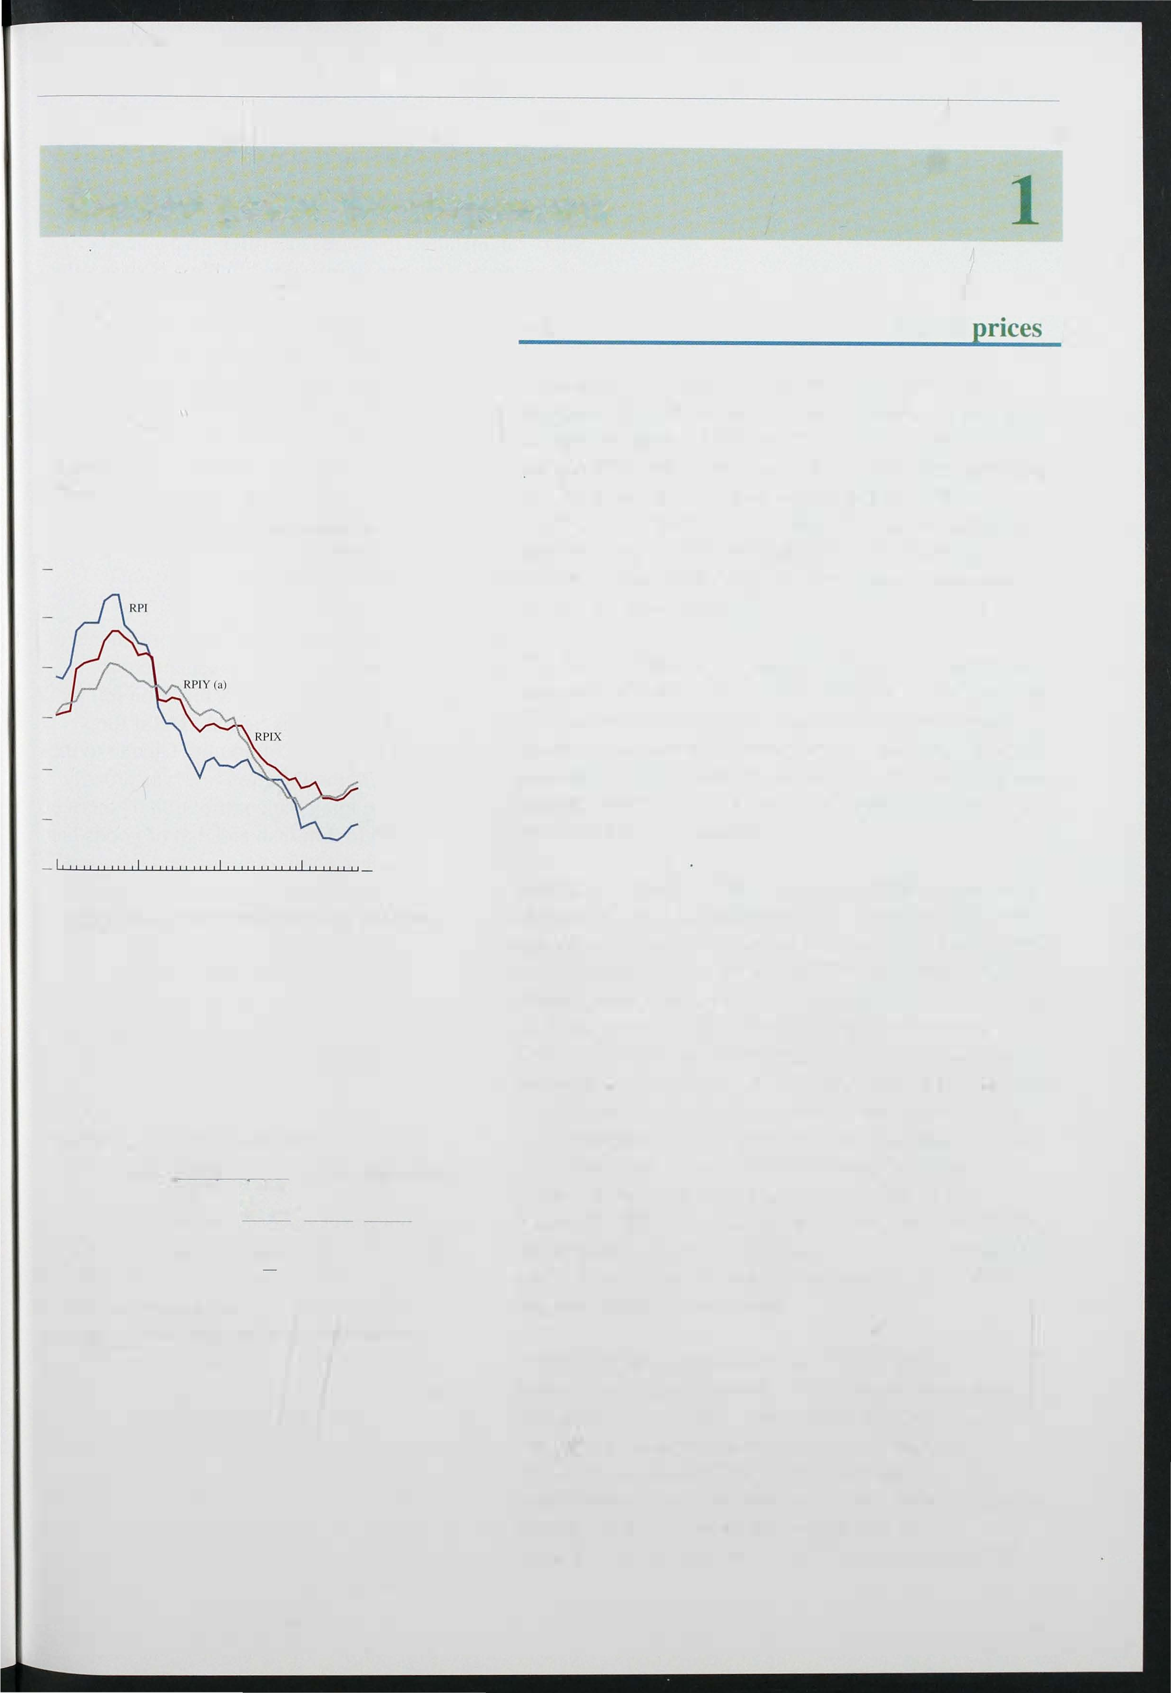Sept. 1992 1.62 -0. 17 -0.02 1.91 0.43 4.0

Mar. 1 993 1.33 -0. 16 0.02 1.75 0.43 3.5

June

1993 1 .44 -0.10 1.59 -0.30 2.8

3.3

Sept.

1 993 1 .95 0. 11 0. 12 1.64 -0.30

(a) Percentage changes on a year earlier.

Contributions may not sum to RPIX because components" weights change in any twelve-month period.

inflation rose from 2.8% in June to 3.5% in September, the same as a year ago before sterling's depreciation began to affect import prices.

Some increase in both RPIX and RPIY inflation between June and September had seemed likely at the time of the last *Report.* Sales discounts were unusually widespread in June, particularly for clothing and footwear, suggesting that a rise in the inflation rate would follow post-sale price rises. In addition, seasonal food prices fell by more than is usual in June.

Table I.A shows that these two factors accounted for

411

Bank of November 1993

most of the rise in inflation between June and September.

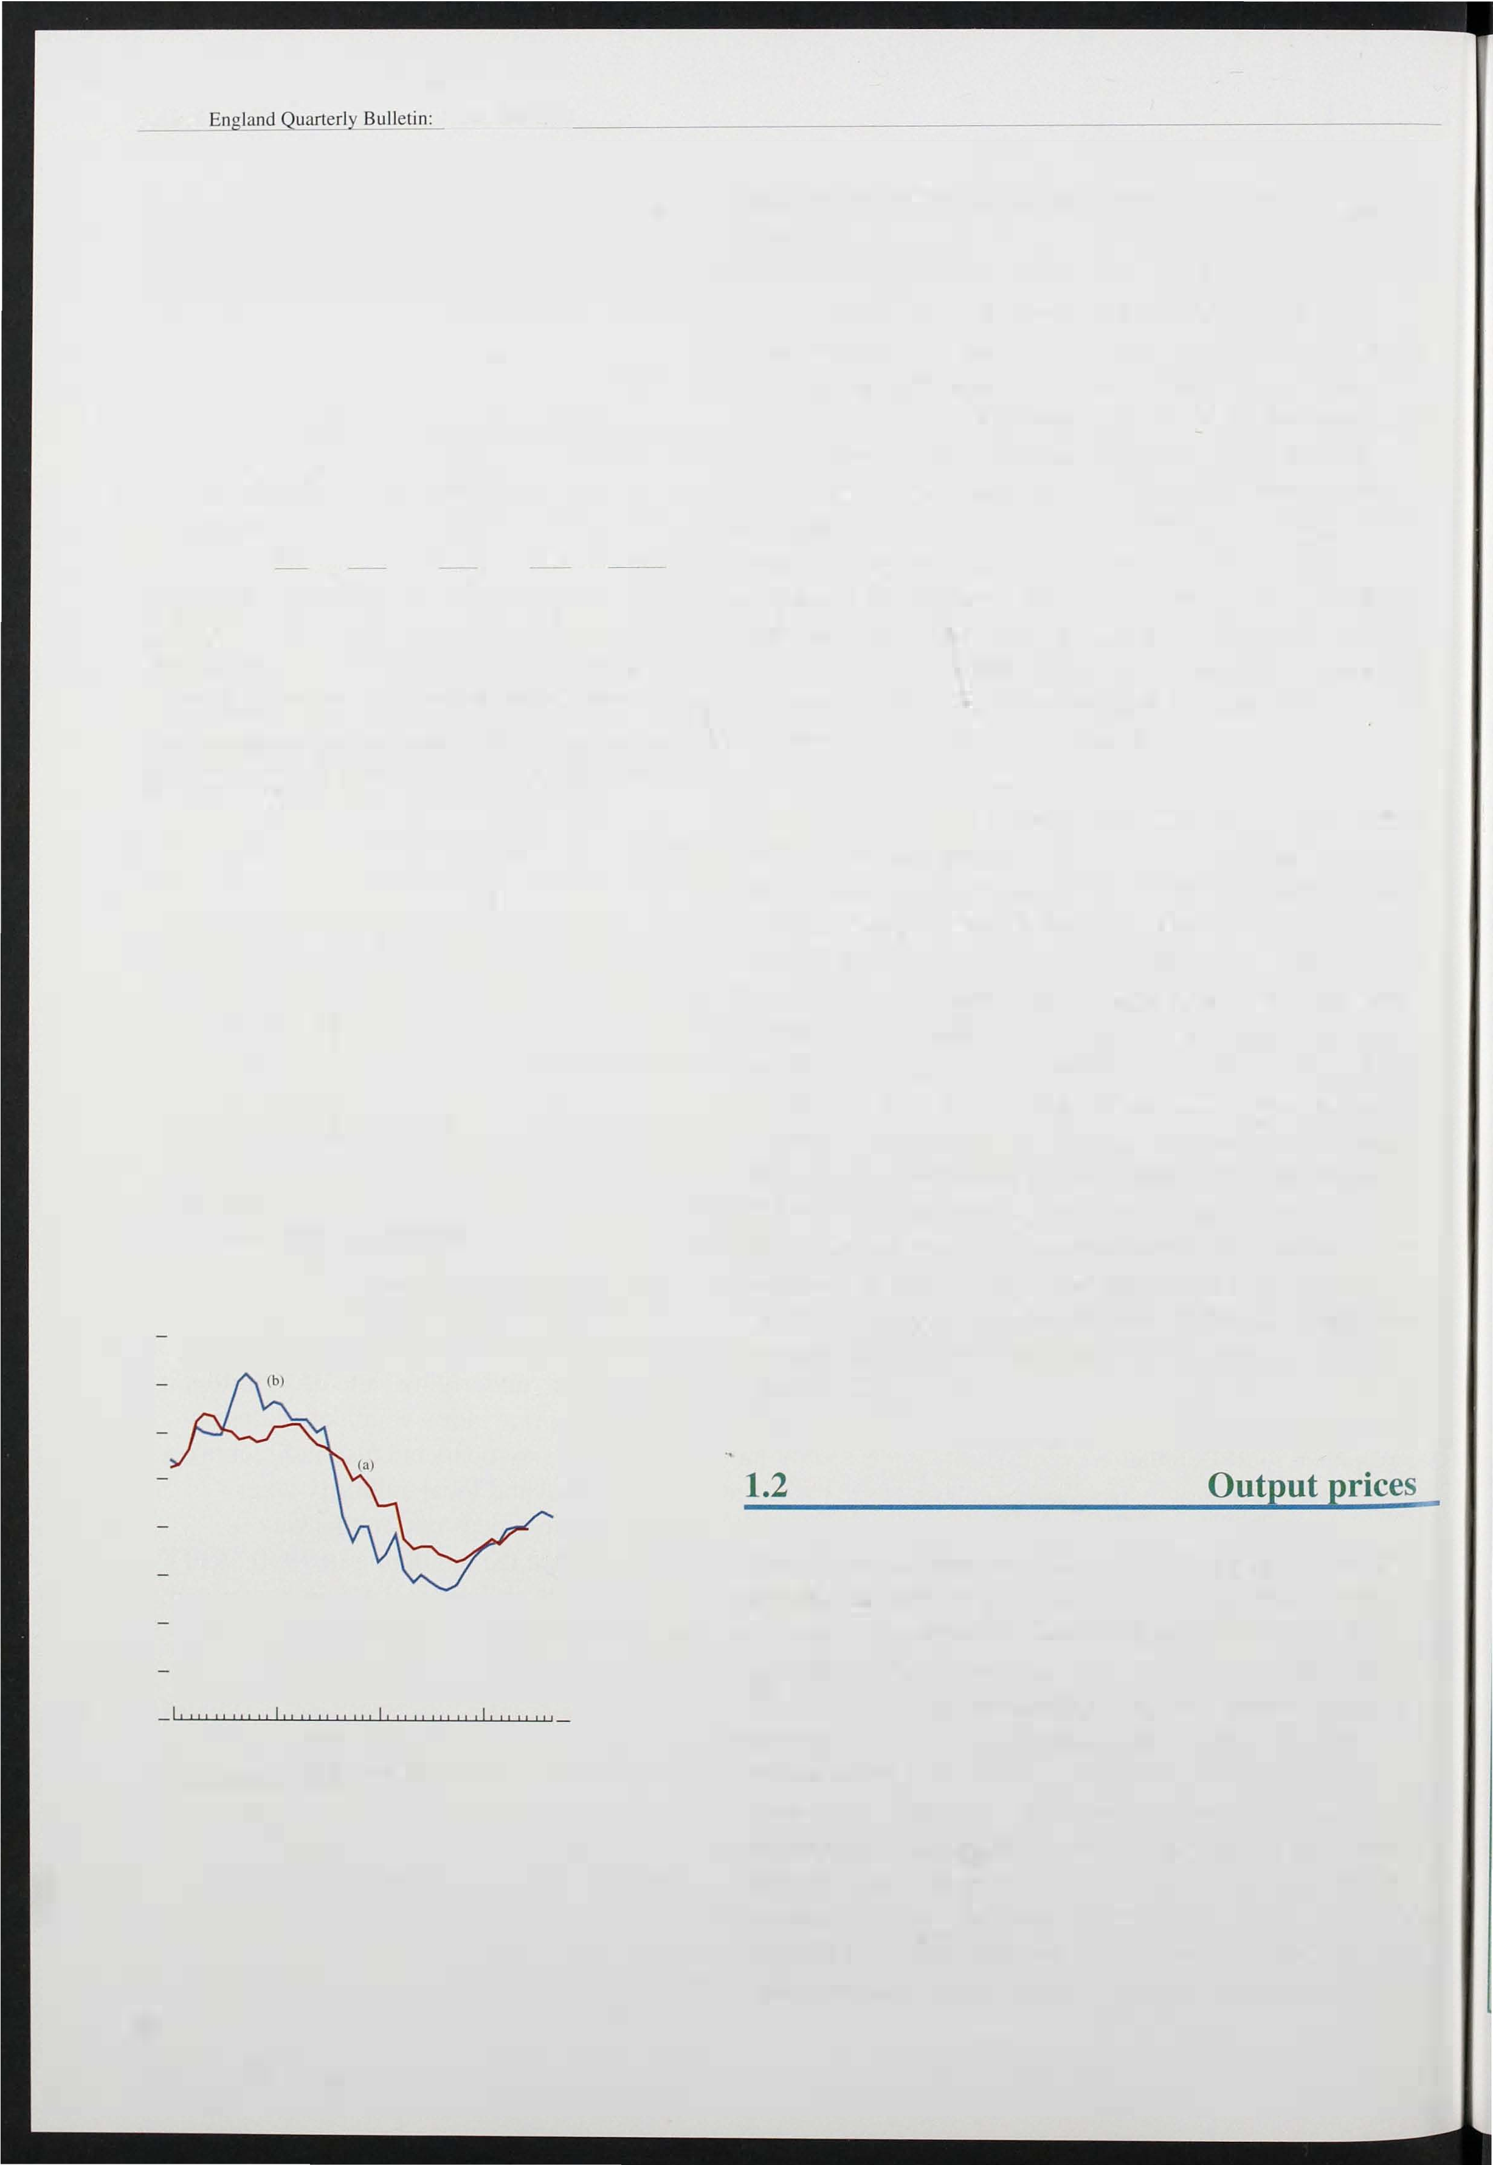

Table 1.B

Short-run measures of inflation

Percentage changes (a)

|  |  |  |  |  |
| --- | --- | --- | --- | --- |
| RPI | RPIX | RPIY | Goods | Services |
| SepLember 1992 2.2 | 2.6 | 2.1 | 1.2 | 4.8 |
| December 1992 | 3.8 |  | 2.8 |  |
| March 1993 0.8 | 3.8 | 3.8 | 3.8 | 6.2 |
| June 1993 1.1 | 0.9 | 2.9 | 2.1 | 2.6 |
| SepLember 1993 |  | 4.5 | 4.4 |  |

(a) The change in the latest month on three months earlier. seasonally adjusted and 3nnualised.

4.5

The nalural logarilhms of the price series were seasonally adjusted using a Kalman filler decompose the series into trend, cyclical, irregular and seasonal components. The

10

series for goods and services do not exhaust the RPIX series because the lalter also comprises the Community Charge. personal nrticles and dwelling insurance.

Chart 1 .2

Producer output price inflation

Increase in prices on a year earlier

Per cent

- 8

- 7

- 6

- 5

- 4

- 3

- 2

- I

0

91

L990 93

1. TotaL manufacturing (L985=100) (SIC 80).
2. Total manufacturing (L990=100) (SIC 92).

412

Short-run inflation measures can often give an early indication of a change in inflation. Table 1 . B shows the three-month inflation rates for a number of indices. The figures have been seasonally adjusted and annualised, to allow comparison with conventional twelve-month measures. Short-run measures need to be interpreted with particular care in order to distinguish changes in the normal seasonal pattern (such as the early start of summer sales in June), from persistent changes in the inflation rate. The table shows that, following a sharp fall in short-run RPIX inflation between March and June as a result of the introduction of the Council Tax, the rate rebounded to 4.5% in September.

Table I.A shows the main changes to the components of RPIX inflation since sterling left the exchange rate mechanism in September 1 992. RPIX inflation fell by

0.7 percentage points during this period. B ut if the impact of the switch from the Community Charge to the Council Tax is removed, the inflation rate was broadly unchanged. Within the total, the contribution of services to inflation has tended to diminish and that of goods has increased. Petrol, clothing and footwear, and seasonal foods are all contributing significantly more. For petrol and clothing and footwear, this reflects the impact of depreciation on i mport prices. By contrast, retail

non-seasonal food prices contributed no more to inflation during the past year than in the year before sterling's withdrawal from the ERM, despite sharp rises in farm gate prices caused by a net devaluation of the green pound.

Manufactured output prices have accelerated since the last *Inflation Report.* In the year to September, prices rose by 4.2%, up from 4.0% in the year to June. The manufacturing sector has been redefined by the CSO since the last *Report,* and the price series has also been rebased to allow for changes in the composition of output in the late 1 980s (see the box on rebasing on page 413 ). The new series, which now i ncludes petroleum refining, shows that output prices rose more slowly during the past two years than when they were

measured by the old series (Chart 1 .2). But it also means

that the rate of increase of prices has risen since a year ago, a change which was less obvious in the earlier data.

IlIjlGliOIl Report

## Rebasing and revisions-how has history changed?

The UK national accounts statistics have recently been rebased on the year 1990. This means that all the expenditure components of GDP are now expressed in terms of average 1 990 prices and new aggregate measures have been calculated. Similarly, the detailed components of output, which were previously weighted together using 1 985 values for net output, have now been reweighted according to values of net output in 1 990. Together with other data revisions and methodological changes, rebasing alters recorded history.

Percentage change

'Money" GDP Real GDP Domestic

base base inflation

base

-3.5

|  |  |  |  |  |  |  |
| --- | --- | --- | --- | --- | --- | --- |
|  | Old | New | Old | New | Old | ew |
| 1988 QI-  1990 QI | 18.4 | 18.2 | 4.4 | 4.3 | 14.0 | 13.9 |
| 1990 QI-  1992 QI | 8.0 | 7.8 | -3.6 |  | 1 1 .6 | 1 1 .3 |
| 1992 QI-  1993 Q2 |  | 4.9 | 1.6 | 2.0 | 2.5 | 2.9 |

The table details the output and price components of money GDP growth in the United Kingdom over the past four years or so, on the new and old bases. The fall in inflation is now estimated to have been a

little less. This is offset by a higher estimate of real growth. Since the trough in output, which is now estimated to have been in 1 992 Q 1, 59% of the increase in money GDP derived from price increases. This compares with 61% over the same period on the old base.

At the same time, with stronger recovery now evident, the output gap--the gap between actual and

Chart A

Manufacturing output

1990= 100

- 102

- 100

potential output-- and its deflationary impact may now be smaller. Real GDP (at factor cost) is now thought to have risen by 2.0% in the year to 1993 Q2, compared with a previous estimate of 1.5%.

The recovery appears steadier, rising gently through 1992, increasing less rapidly around the turn of the year.

Manufacturing on its revised definition--it now includes coke, ovens, mineral processing and nuclear fuel production--has grown more slowly since the beginning of this year than originally recorded. In the first six months of 1 993 manufacturing output is estimated to have grown by 1.5%, compared with an earlier estimate of 2.7%.

This downward revision to manufacturing output largely reflects a reassessment of the movement of prices and volumes in this sector. In particular, export prices, which have grown sharply since last autumn following the fall in the exchange rate, are now included in the deflator used to derive 'real' output. As a result, estimated volume growth in this period has been reduced.

By contrast, service sector output has been revised up, both through the period of recession and in the

subsequent upturn. On the 1 990 based data, total

. services output--which accounts for 63% of GDP-­ is back above its recent peak at the beginning of

1 990; on the old base it was 112% below this peak. The increase in growth in this sector since the turn

of the year is now more marked. In the year to Q3, service sector output now stands 2.7% higher than a year earlier.

Chart B

Total services output

- 1 01

- 98

- 96

1988 89 91

93 92 1988 89 90 91 92 93

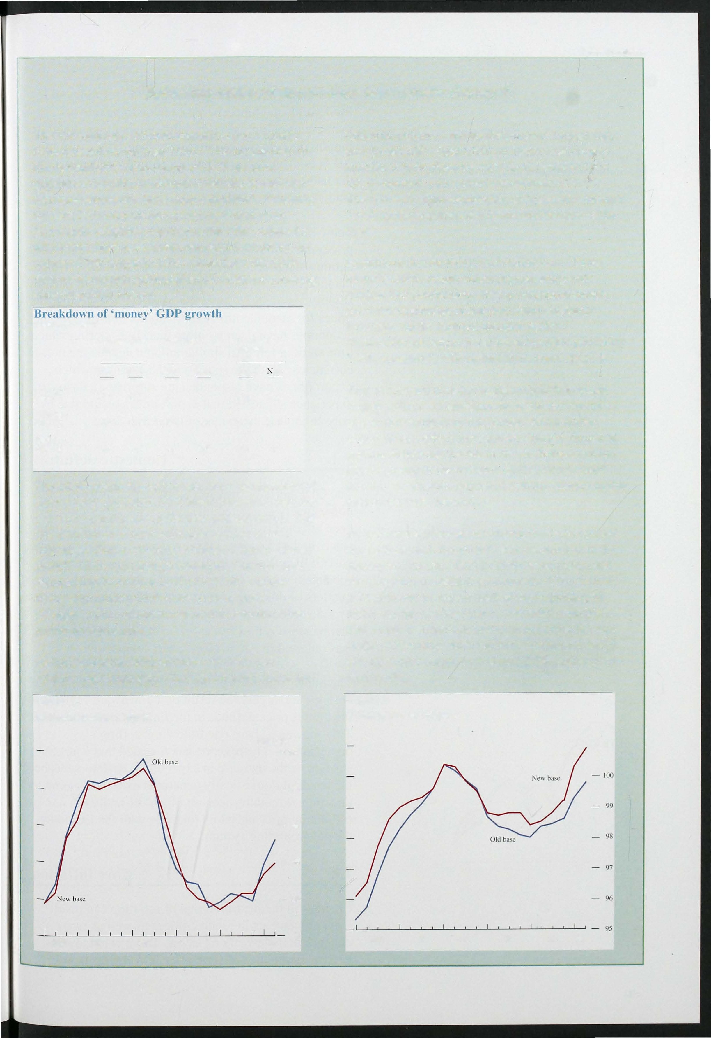

413

Chart 1 .3

Manufacturing export and producer price inflation

Producer output prices excluding food. beverages, petroleum and tobacco, seasonally adjusted.

Manufacturing export prices. non·EC based data. Exchange rate (sterling against non-EC currencies).

Percentage changes on a year carlier

_ 25

_ 20

15

_

_ 10

5

_

+

0

_ 5

_

10

_ 15

If the more volatile prices of petroleum refining, and food, drink and tobacco, are excluded, the rate of increase of output prices is a little higher than three months ago. In the year to September, prices rose by 2.9%, up from 2.4% in the year to June. Moreover, in the latest three months, prices have risen at an annualised rate of 3.7%.

Some rise in the rate of increase of producer output prices during 1 993 had seemed likely at the time of last autumn's depreciation. Chart 1 .3 shows that, although manufacturers' prices in the home market have risen by slightly less than 3% over the past year, the sterling prices for manufactured exports to the non-EC economies have risen by more than 14%, during which time sterling fell by a similar amount against the non-EC currencies. Both the speed and the extent to which export prices have responded are surprising. Past experience suggested that export prices would rise by only about half the extent of the devaluation.

- 1990 91 92 93 20

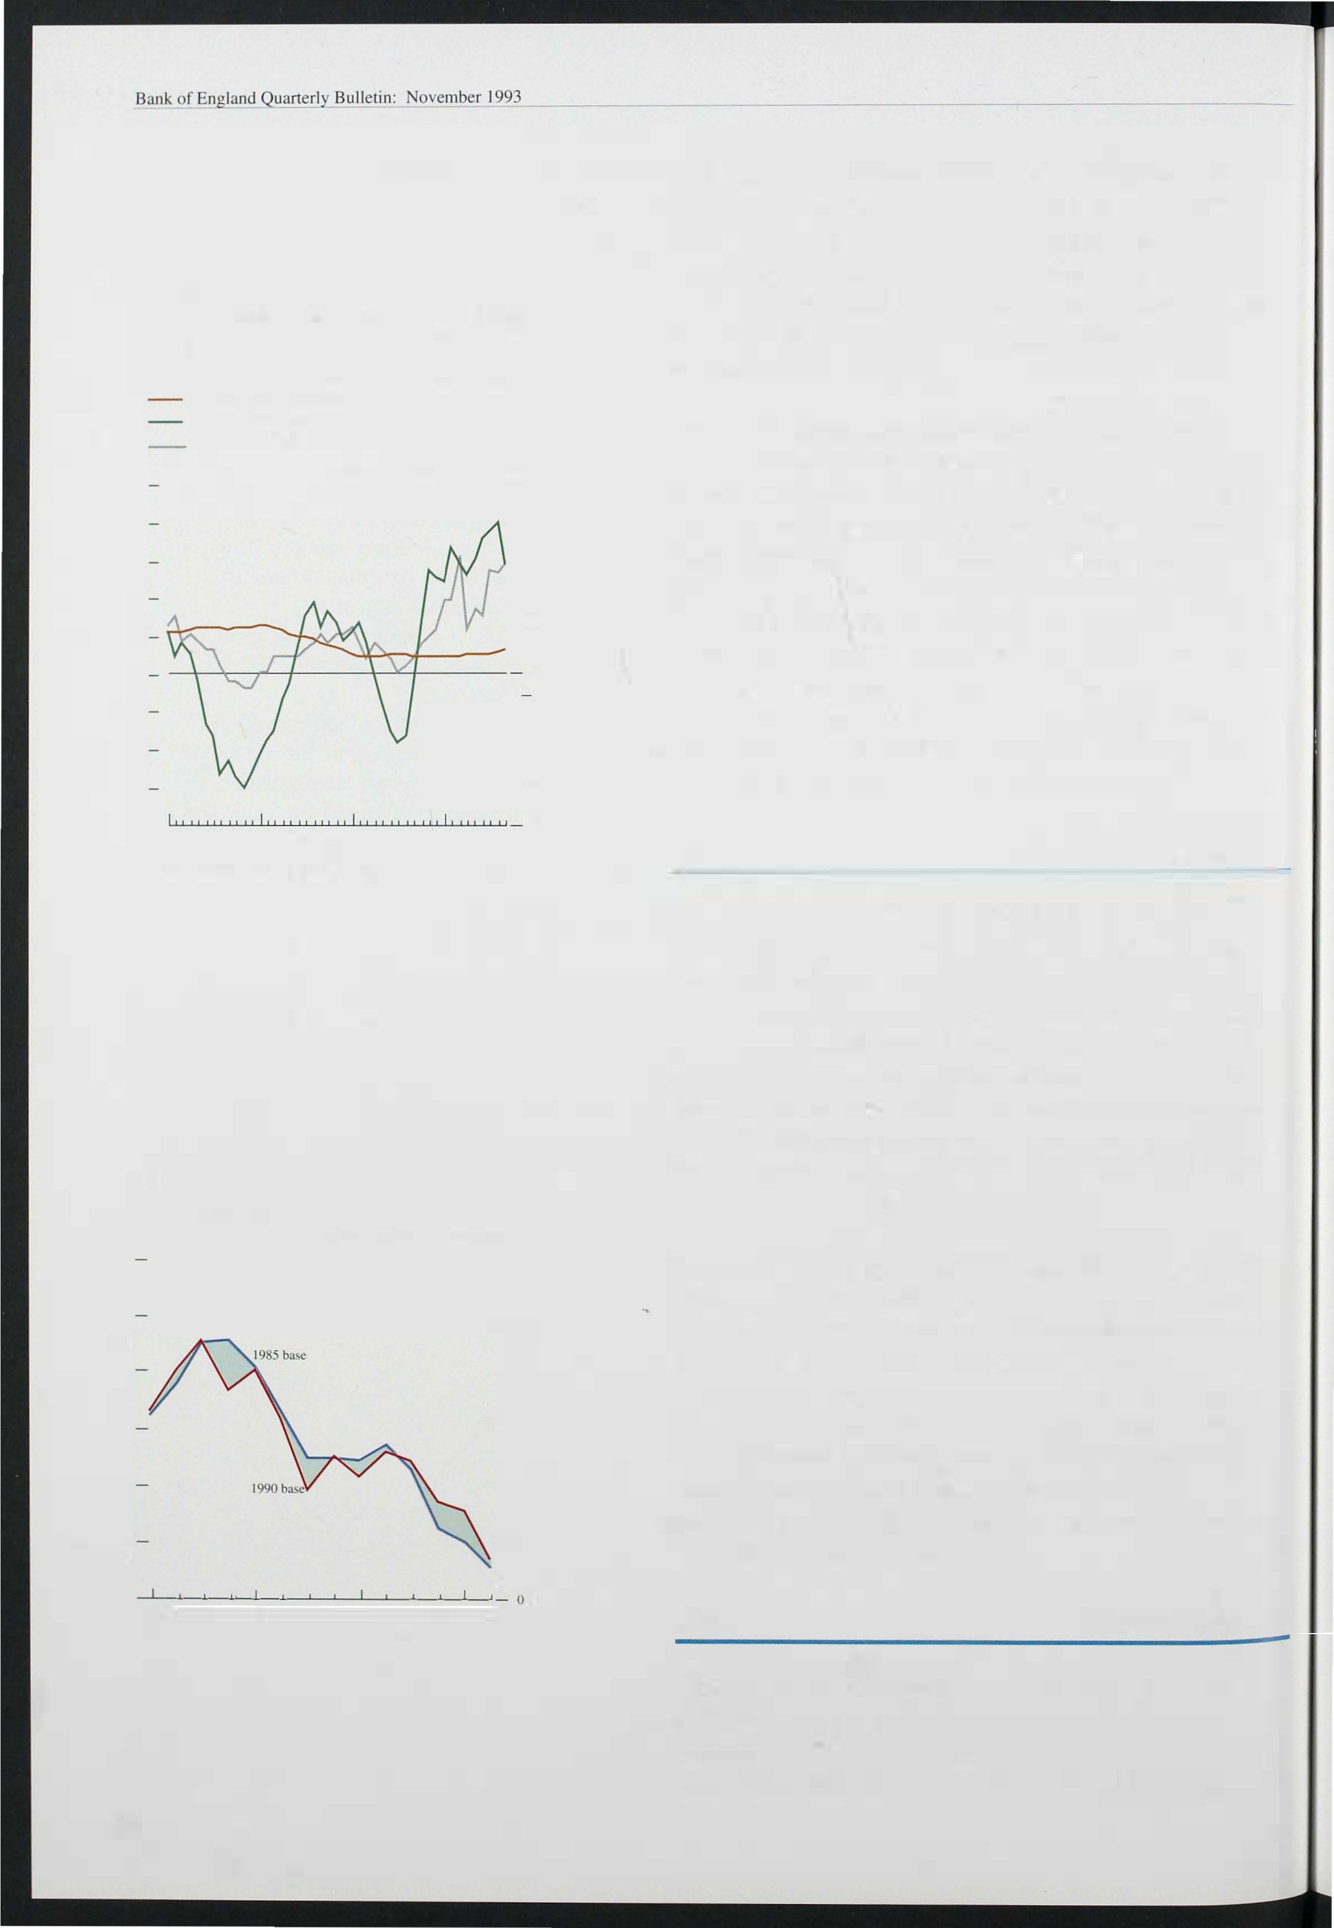

+ means price rise or sterling depreciation.

Chart 1 .4 GDP deflator

Percentage changes on a year carlier

- 12

- 10

- 8

- 6

- 2

QI Q2 Q3 Q4 QI Q2 Q3 Q4 QI Q2 Q3 Q4 QI Q2 1990 91 92 93

414

## Domestic deflators

The GDP deflator provides a broader measure of domestically generated inflation. This series too has been affected by the rebasing of the national accounts since the last *Report.* The new data show that the factor cost GDP deflator (which excludes i ndirect taxes and subsidies) was unchanged between the first and second quarters of this year. In the year to Q2, the deflator rose by l . 5%. This was much lower than in the year to Q1; that increase is now put at 3. 1 %, against the 2.0% that was reported in August (see Chart 1 .4).

The higher estimates of the increases in the recent GDP deflatoT are largely the result of a downward revision to the import price deflator in the final quarter of last year. This showed a sharp rise following sterling's depreciation. The revision has revealed that a larger

fraction of the increase in expenditure deflators has been

the result of domestically generated inflation. Some uncertainty remai ns because of the difficulty of estimating price deflators for trade with the EC under the new reporting system.

## Core inflation

Changes in the measured rate of inflation can result from movements in relative prices as well as from changes in underlying inflation. But it is not always easy to distinguish relative price movements from

changes in the general price level; hence the development of indicators that try to identify 'core' inflation.

Chart 1 .5

Alternative measures of 'core' inflation

Increase in prices on il year earlier

Pcr cent

- 12

RPIX - 10

Most 'core' inflation measures tackle the problem of relative price movements by excluding particularly volatile prices. The example in Chart l . 5 (which excludes food and energy as well as mortgage interest payments and taxes) is typical. But it is also possible to construct measures with clearer theoretical foundations. The median inflation rate, which also appears in Chart 1 . 5, was discussed in detail in both the May and August *Reports.* It excludes the effect on headline inflation of large changes in relative prices. As the chart shows, the median inflation rate tracks RPIX inflation reasonably closely over much of its range, but indicates a further small fall in inflation since June.

1990 91

(a fucl

_ 0

Chart 1 . 6 shows two other useful measures: the housing adjusted (HARP index) RPI and the Tax and Price Index (TPI). The HARP index has an estimate of the user cost of housing in place of mortgage interest payments (and

RPI excluding mortgage inlCreSl payments, food and and light. local authority taxes and indirect taxes.

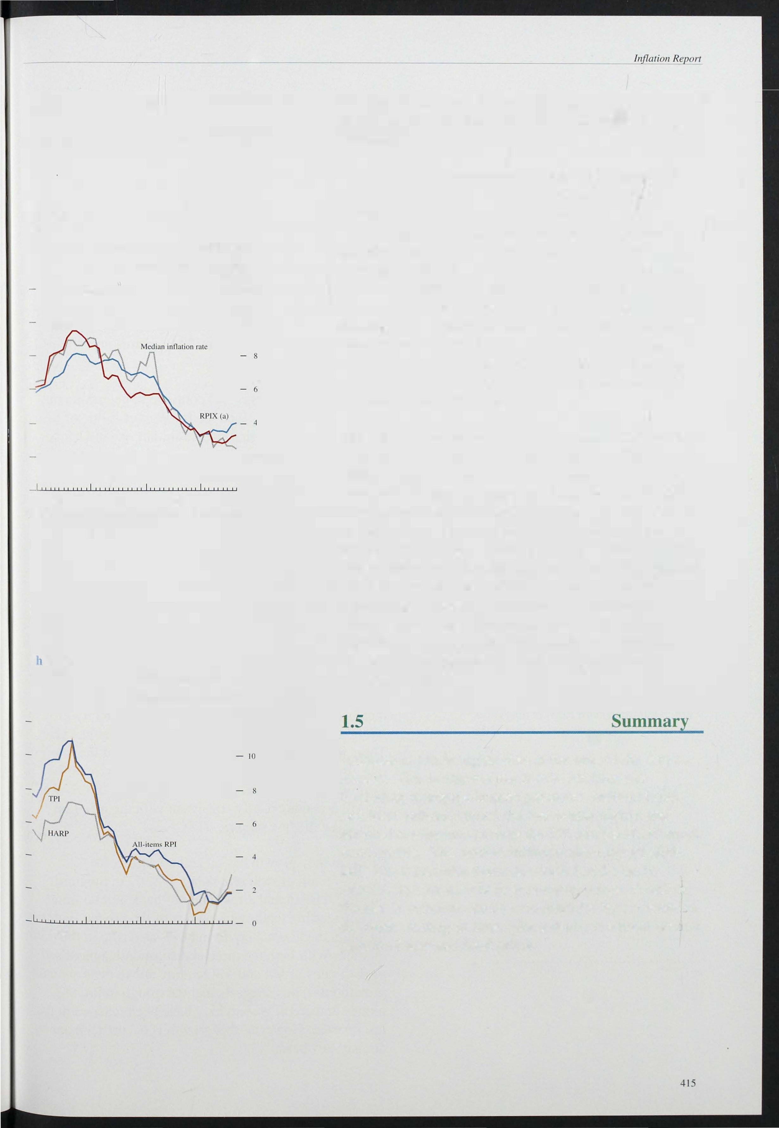

93

Cart 1 .6

RPI, TPI and HARP inflation rates

Increase in prices on a year earlier

Per cent

- 12

1990 91 92 93

was discussed in the February *Report).* On this measure, inflation has risen more steeply, partly because house prices rose over the last twelve months (whereas interest rates, which affect headline inflation, fell). The Tax and Price Index is an index of the gross taxable income needed for tax payers to maintain their purchasing power; it increases if direct tax rates or the RPI increase. The·TPI has followed the RPI closely, reflecting the absence of substantial direct tax changes in the last twelve months.

Inflation is a little higher than at the time of the August

*Report.* This is true not just for the headline rate. Excluding mortgage interest payments, indirect taxes

.

and local authority taxes, the rate is also higher, and

alternative measures such as the TPI and the HARP index confirm this. The median inflation rate shows a slight fall. But it excludes items discounted in the early summer that are now back at non-sale prices. Much of the rise in inflation can be accounted for by a reversal of discounts starting in June, plus a return to a more normal pattern of seasonal food prices.

# Monetary and fiscal policy

## conditions

Chart 2.1

Twelve-month growth rates of MO, M4, Divisia and the credit counterpart to M4

Per cem

- 22

- 20

- 18

- 16

- 12

- 10

-- 86

MO - 2

0

1990 91 92 93

The growth of both narrow and broad money has risen slightly since the last *Report* (Chart 2. 1 ) . So the monetary aggregates are showing a greater degree of consistency than was the case in the first half of this year. However, MO remains well above the top of its 0%-4% monitoring range and M4 remains near the bottom of i ts range.

The monthly changes in MO continue to be erratic, but the general direction since the last *Report* is one of faster growth. The provisional twelve-month rise in October was 5.4%, the highest since July 1 990. Some of these monthly fluctuations in MO can be attributed to movements in bankers' balances, but the provisional demand for notes and coin alone (a better i ndicator of underlying narrow money) has also accelerated to 5. 3% Notes and coin are a good and timely guide for nominal

1. Bank and building society lending

10 the private sector.

demand growth, as reflected in increases in the value of retail sales (Chart 2.2). The twelve-month growth in the value of retail sales has averaged over 6% in recent

months, the highest sustained growth since the middle of 1 990. Thetwelve-month growth of notes and coin is also the highest since that period.

Chart 2.2

Twelve-month growth rates of notes and coin and value and volume of retail sales

Per cent

- 10

Retail sales value

A large part of the strength of MO is attributable to the increase in l iquidity and the reduction in velocity growth brought about by lower interest rates over the last year. There is uncertainty about the precise size of the interest rate effect on MO in the short run. However, over the medium term, the present monitoring range of 0%-4% for MO remains broadly consistent with the i nflation target (see the box on page 41 8).

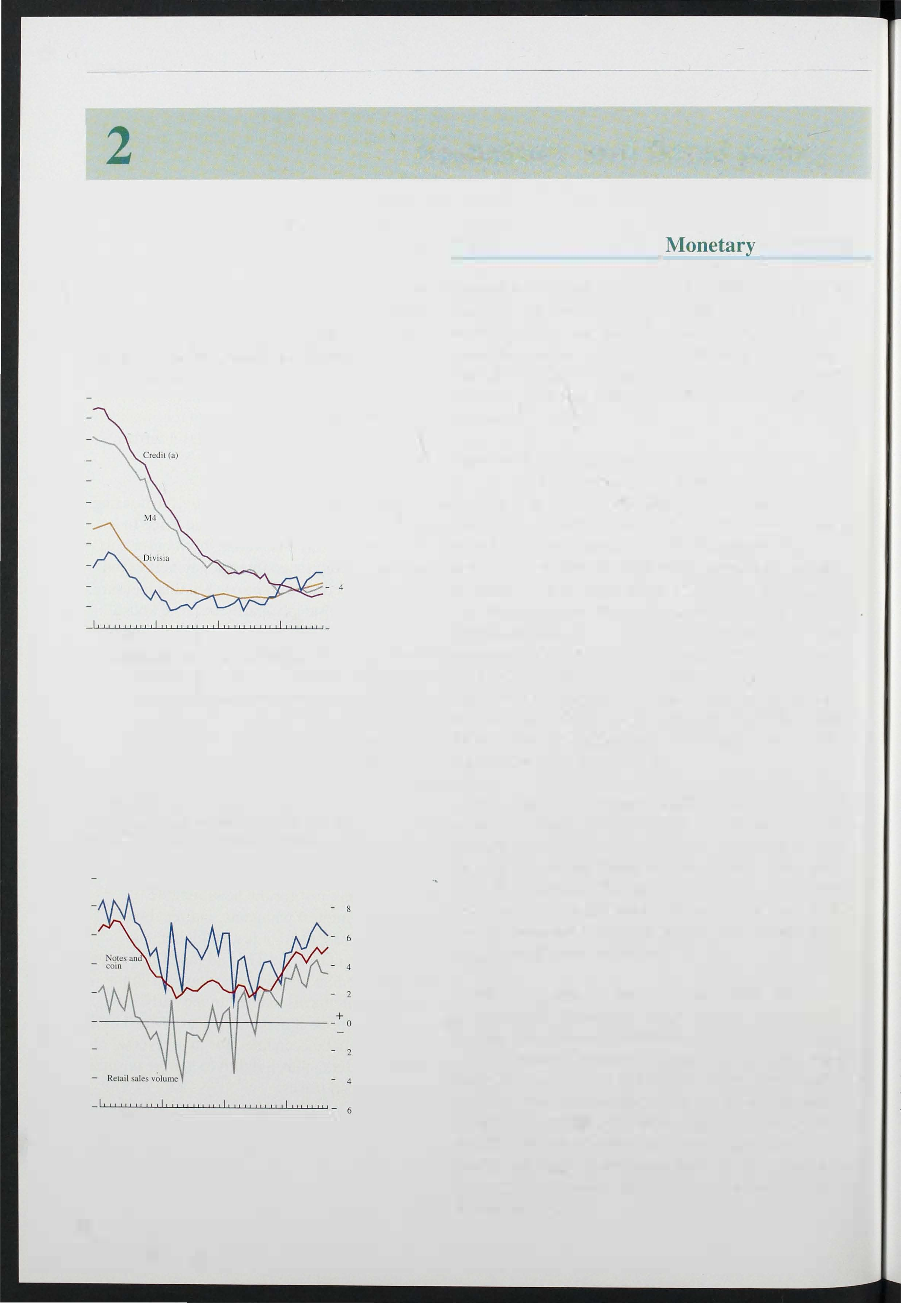

416

1990 91 92 93

B road money growth has picked up a little, its twelve-month growth rate rising to 3.9% in the third

quarter. The annual growth rate of bank and building society sterling lending to the rest of the pri vate sectof­ the main credit counterpart to M4-also rose in the third quarter. With both the three and six-month annualised growth rates of M4 and M4 lending above their annual growth rates, this suggests that the trough in broad money and credit growth may have been reached in the last quarter. However, this growth is occurring from an already low base.

Report

( art 2.3

E�timated total quarterly sterling borrowing by I Cs

- Total. of which:

Net issues of sterling commercial paper. unadjustcd Net sterling capital issues. unadJustcd

Borrowing from banks and building societies. seasonally adjusted

£ billions 10

-

- 6

- 4

- 2

+ 0

1 990 91 92 93

Chart 2.4

Pr vate sector net sterling borrowing from ha ks and building societies

OFIs 0 ICCs 0 Persons Total

£

Recent work by the B ank on the role of banks and building societies in the transmission mechanism (see the article on pages 478-9 1) highlights the significance of sectoral measures of money and credit. Empirical evidence suggests that the characteristics of the demand for both money and credit (bank and building society lending) vary sector by sector. Large firms (part of the 'industrial and commercial companies' grouping) are able to switch both their assets and liabilities relatively easily between banks and non-banks. Looking just at their bank deposits and borrowings will thus provide only a partial, and possibly misleading, view of their financial decision-making and thus of their potential spending.

This is important when i nterpreting recent monetary trends. Industrial and commercial companies have repaid borrowing from banks and building societies in each of the last three quarters (see Chart 2.3). But at the same time companies have taken advantage of buoyant capital markets to issue shares and bonds: though capital issues were lower in the third quarter than in the second quarter, they were still higher than in any quarter last year. So the pattern of financing among industrial and commercial companies appears to represent balance sheet restructuring, rather than balance sheet contraction. They may be reducing bank debt either to increase the maturity of their liabilities through longer-dated bond issues, or to reduce their indebtedness more generally by increasing equity capital. Neither is necessarily a harbinger of weak spending.

Credit from the banks and building societies constitutes a much larger proportion of the total liabilities of small firms and households than of companies, because these

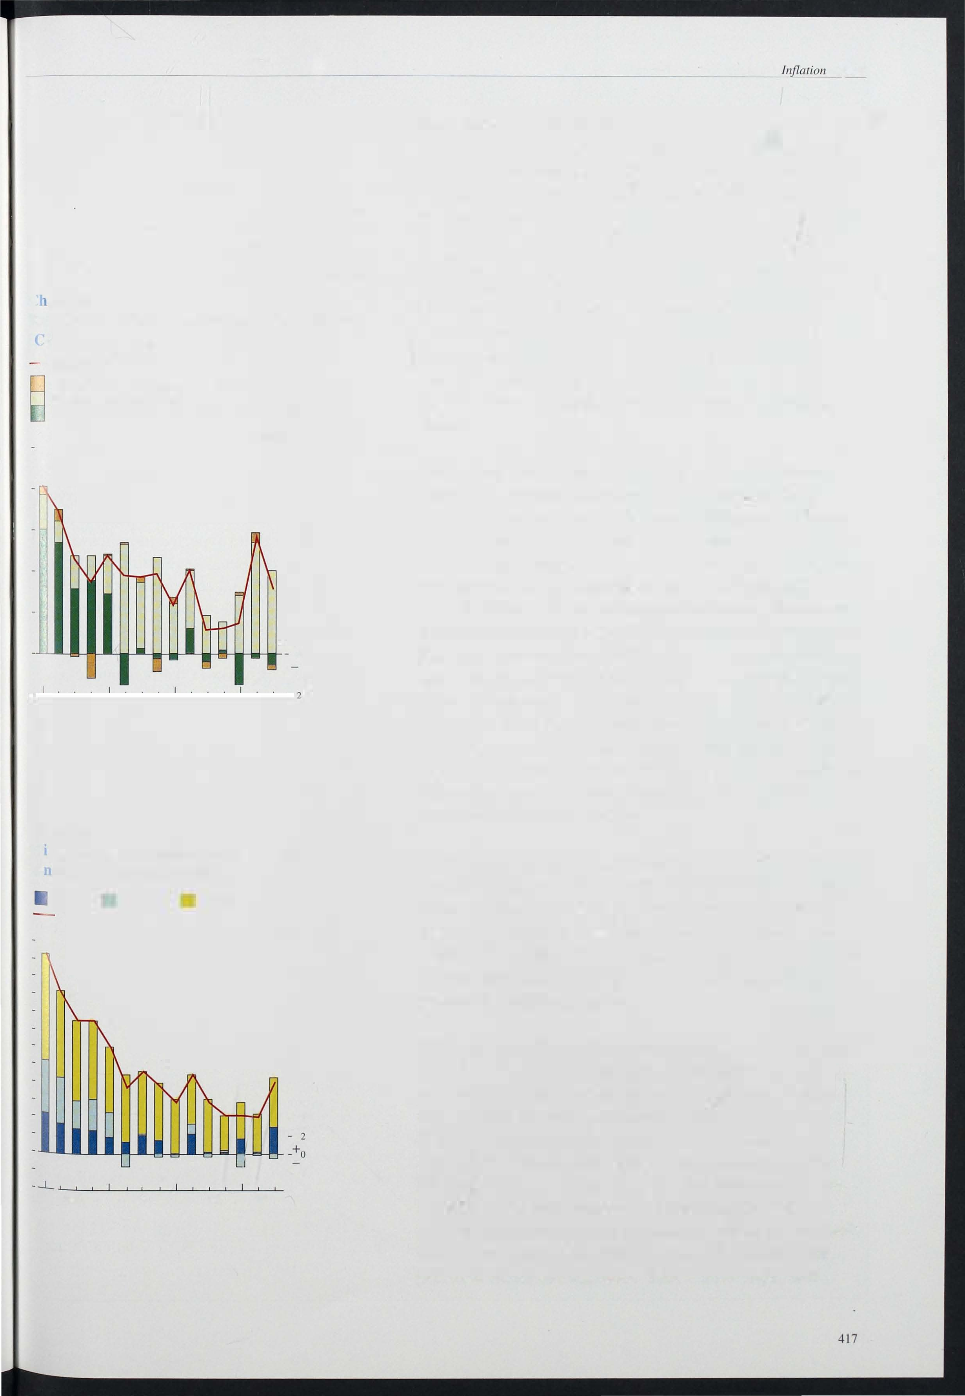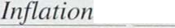

1990

billions

- 24

- 22

- 20

-- 1168

- 12

- 10

- 8

- 6

- 4

- 2

- 4

93

92

agents are typically less able to draw upon the capital markets for funds. So in principle credit should provide

a better indicator of the personal sector's actual and potential spending patterns:

Bank and building society lending to the personal sector increased by £5.5 billion in the third quarter, against

£4.2 billion in the second quarter (Chart 2.4). Within this, lending for house purchase rose by £4.9 billion, from £4.3 billion in the second quarter. This is consistent with the modest recovery in activity in the housing market. B ut lending for consumption remains broadly unchanged from the second quarter. The relatively modest rise in borrowing is, by itself, probably insufficient to account fully for the recent falls in the personal sector saving ratio. This would imply that

## MO's monitoring range

In the last Budget, fixed monitoring ranges were set for both MO and M4 (0% to 4% and 3% to 9% annual growth respectively) for the whole period covered by the Medium Term Financial Strategy

(until 1997/98). The Financial Statement and

Budget Report contained an annex on MO's monitoring range which described how MO has recently been growing faster in relation to nominal GDP than in the past. In other words, the growth rate of MO's velocity of circulation has

slowed (see the box on page 299 of the last

*Quarterly Bulletin).* The annex noted that if this were more than a temporary phenomenon, MO's medium-term monitoring range might have to be changed. But further investigation of MO

indicates that the CUlTent monitoring range may still be appropriate and consistent with inflation remaining within its target range over the medium term. Interest rates held at 6% over the medium term imply velocity growth of about 2.5% per annum in the medium term. So, for example, 4% MO growth could be consistent in the medium term with nominal GDP growth of about 6.5%, which accords with the real growth needed in the recovery and the inflation target.

But, in the short run, account must be taken of temporary effects on the demand for MO. An important example of this is the effect of changes in interest rates. Interest rates can have both temporary and permanent effects on the relationship between MO and nominal GDP. With lower interest rates, the cost of holding cash (the interest foregone) is lower, other things being equal. But low interest rates may also reduce the rate at which new methods of payment or of

handling cash are introduced, because the benefit they bring-economising on the use of cash-is

reduced. The permanent effects of changes in

different MO equations. The equations shown are the Treasury equation (from the January 1 993

P ublic Release of the Treasury macroeconomic model) the current Bank of England equation (described in a forthcoming Bank of England

working paper) and an earlier equation estimated by the Bank in 1 989 (described in 'The long-run determination of the UK monetary aggregates' *Bank ofEngland Discussion Paper No. 41).* The estimates shown in the chart include only the

direct effect of interest rates on MO for a given level of nominal demand. The most noticeable feature of this chart is that the estimates of the short-run effect of interest rates on MO vary greatly among the three equations. The Treasury equation predicts that after about five quarters a cut in interest rates can be expected to increase MO growth by over 0.8 percentage points whereas the earlier Bank of England equation predicts less than a 0.2 percentage point increase in MO growth over the same period. The current Bank of England equation falls between these two, predicting an effect of just over 0.4 percentage points.

This range of estimates illustrates how difficult the interpretation of MO growth becomes after a change in interest rates. In particular, these estimates do not give a clear indication whether the current strong growth of MO is an indicator of loose monetary conditions or whether it is the result of simply a temporary change in the rate of growth of the velocity of circulation.

Comparative interest rate response of MO to a one

percentage point reduction in short-term rates

MO annual growth rate (differences from bas-e) .0

Treasury equation

interest rates may cause the monitoring range for the growth of MO that is consistent with the inflation target in the medium term to change.

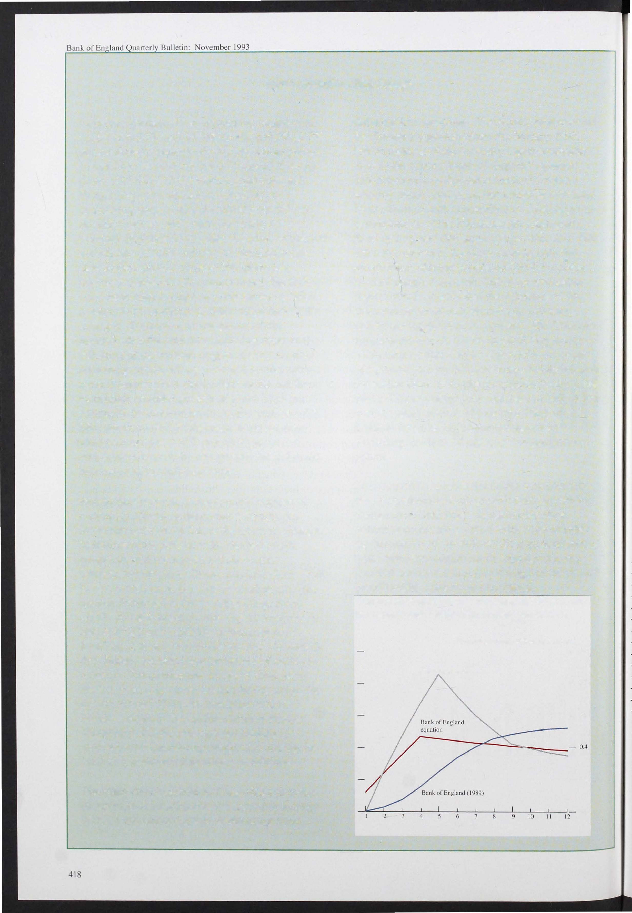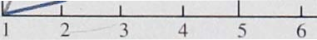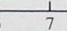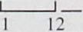

Temporary effects, although not altering the medium-term monitoring range, may change the current assessment of monetary conditions.

The chart shows estimates of the effect of a one percentage point reduction in short-term interest rates on the rate of growth of MO using three

Quarters

- 0.8

- 0.6

- 0.2

0.0

Report

1 able 2.A

Cfficial interest rates overseas

Per cent per annum

1992 1993

|  |  |  |  |  |  |
| --- | --- | --- | --- | --- | --- |
| United States: | I Sepl. | I Mar. | 7 May | 2 Aug. | 27 0cl. |
| Prime(a) | 6.0 | 6.0 | 6. 0 | 6.0 | 6. 0 |
| Discount | 3. 0 | 3. 0 | 3.0 | 3.0 | 3.0 |
| Japan: |  |  |  |  |  |
| Discount | 3. 25 | 2. 50 | 2.50 | 2.50 | 1.75 |
| Call(a) | 4.10 | 3. 20 | 3.20 | 3. 30 | 2.50 |
| Germany: |  |  |  |  |  |
| Discount | 8.75 | 8.00 | 7.25 | 6.75 | 5. 75 |
| Lombard |  | 9.00 | 8 . 50 | 7.75 | 6.75 |
| France: |  |  |  |  |  |
| Imervention | 9. 6 |  | 8.0 | 6.75 | 6.45 |
| 5-10 day repo | 10. 5 | 12.0 | 9.0 | 10.00(b) | 7.25 |
| Italy: |  |  |  |  |  |
| Discount | 13.25 | 11.5 | 11.0 | 9. 0 | 8.0 |
| Advances | 14.75 | 12.5 | 12.0 | 10. 0 | 9. 0 |

These are not official rates.

9. 75

1. 24 hour repo.

Chart 2.5

Ex ected French-German interest rate

individuals are financing a greater proportion of their spending out of income, through a slower accumulation of savings. Partly, this will be reflected in sluggish bank and building society deposit growth. Equally, however, it may be reflected in slower accumulation of non-bank assets, such as equities, which-unlike non-bank liabilities-make up a significant proportion of the personal sector's balance sheet.

Borrowing by unincorporated businesses rose by

£0.4 billion in the third quarter, following a net repayment of £0.8 billion in the first half of this year. If sustained, this rise in borrowing would suggest that the scaling back of these businesses' liabilities has been completed. Future income may be used for spending, rather than to repay existing debts.

The Bank's Divisia i ndex rose by 1.1 % in the third quarter, compared with an increase of 0.9% in the previous quarter. On an annual basis its growth rate increased for the third consecutive quarter from its trough of 2.8% in the fourth quarter of 1 992 and currently stands at 4.2%. Consistent with the signals given by the sectoral analysis, the growth in Divisia was largely related to personal sector activity. The personal sector index incre<l:sed by 1 . 3% in the third quarter, raising its annual growth rate to 5.0%-the highest since 1 990 Q4. The corporate sector index, on the other hand, grew. by only 0.5% and its annual growth rate fell further to 1.1 %-the lowest since 1985 Q3.

Per cent

December 1993

0.6

0.5

0.4

0.3

0.2

0. 1

*Interest rates*

Although official interest rates in the United Kingdom have not changed since the last *Report,* rates in continental Europe fell after the widening of the ERM

6 13 20 27 3 10 17 24 I 8 15 22

July August September October

- 0.0

0.1

+

0.2

0.5

0.6

0.8

bands on 2 August, though not by as much or as quickly as some were expecting. T�e Japanese discount rate has also been reduced (see Table 2.A). The European sequence of changing expectations is best illustrated by changes in the di fferential between French and German three-month interest rate futures (Chart 2.5). The differential widened significantly in early August as the

market expected large and rapid French interest rate

(a) Calculated as the implied 3-month interest nlles on selected French

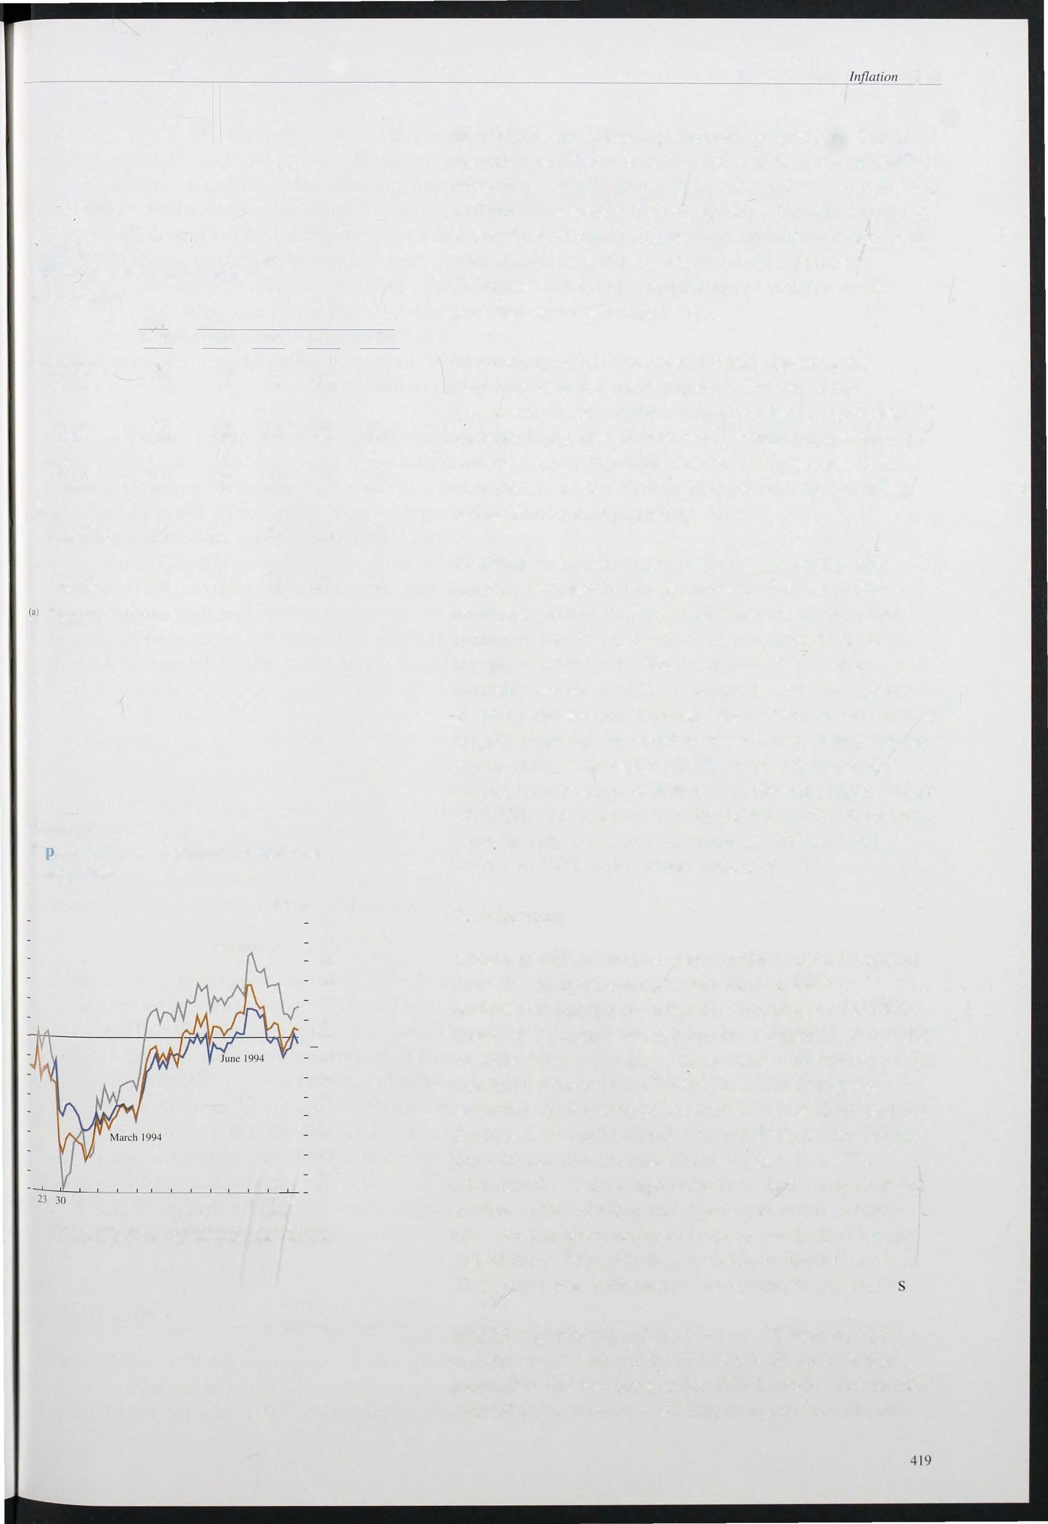

franc futures contracts minus the corresponding OM futures rales.

cuts, but has since returned to lie above its level at the end of July. The reduction in Gelman interest rates on 21 October was followed by most other EC countrie .

Market expectations of the level of UK interest rates at the end of the year fell by two thirds of a percentage point after the widening of the ERM bands. The market seemed to be expecting sterling to appreciate, thereby .

Table 2.B

Sterling exchange rates

1 992 1 993

15 SepL. 5 Feb. 7 May 2 Aug. 270et.

|  |  |  |  |  |  |
| --- | --- | --- | --- | --- | --- |
| Sterling ERI | 90.90 | 77.70 | 80.90 | 81 .40 | 80040 |
| US dollar | 1.89 | 1045 | 1 .58 | 1 .48 | 1048 |
| Deulsehe Mark | 2.78 | 2040 | 2049 | 2.55 | 2049 |

Chart 2.6

Implied forward interest rates

Per cent

- to.O

7 May 1993 - 9.5

- 9.0

- 8.5

2 Aug 1993

- 8.0

|  |  |  |  |  |
| --- | --- | --- | --- | --- |
|  | | | | - 7.0 |
| - 6.5 |
| - 6.0 |
| - 5.5 |
| 1994 | 98 | 2002 | 06 | IQ |

Chart 2.7

UK and trade-weighted world interest rate yield curves (September 1993)

Per cent

- 6.0

offering scope for an interest rate cut. These expectations receded as the anticipated large reductions in continental interest rates failed to materialise.

Latterly, however, interest rate expectations in the United Kingdom have once again been lowered as domestic data have been interpreted as making a monetary easing more likely, given the prospect of some fiscal tightening in the Budget. A half percentage point cut is now expected before the end of the year, with a further (at most) half percentage point reduction expected in the early part of next year.

Consistent with this, there has been a marked decline in implied one-year forward interest rates (Chart 2.6). (The box in Section 6 of the last *Report* explains the method used to derive these rates.) But no adverse effects have been felt at the long end of the yield curve, with yields falling to new lows. The yield curve suggests that interest rates are expected to rise to a peak of 8% early next century and then decline to a

plateau of 71/z%. These levels are respectively around 60

and 1 00 basis points lower than at the time of the last

*Report.*

*Exchange rates*

The effective exchange rate index for sterling is little changed since the last *Report;* it stood at 80.4 on

27 October against 81 .4 on 2 August (see Table 2.B). Since its suspension from the ERM just over a year ago, sterling has fallen by 1 1 %; the fall against EC currencies has been 6.5% and against non-EC currencies 16.5%.

3-monlh 6-momh 12-monlh

- 5.7

- 5.6

Previous *Reports* have compared the short-term yield curve for the United Kingdom with that for 'world' interest rates. At the time of the last *Report* the differential between these curves was around -0.52% for three-month interest rates and -0. 13 % for

twelve-month rates. Since then, the differentials have been reversed. UK rates stood at a premium of 0. 26% during September at the twelve-month horizon

(Chart 2.7). This implies that the sterling effective index

_ UK trade weighted world interest r.tle differential - 0.3

- 0.2

is expected to depreciate slightly over the next year,

compared with an expected appreciation at the time of the last *Report.*

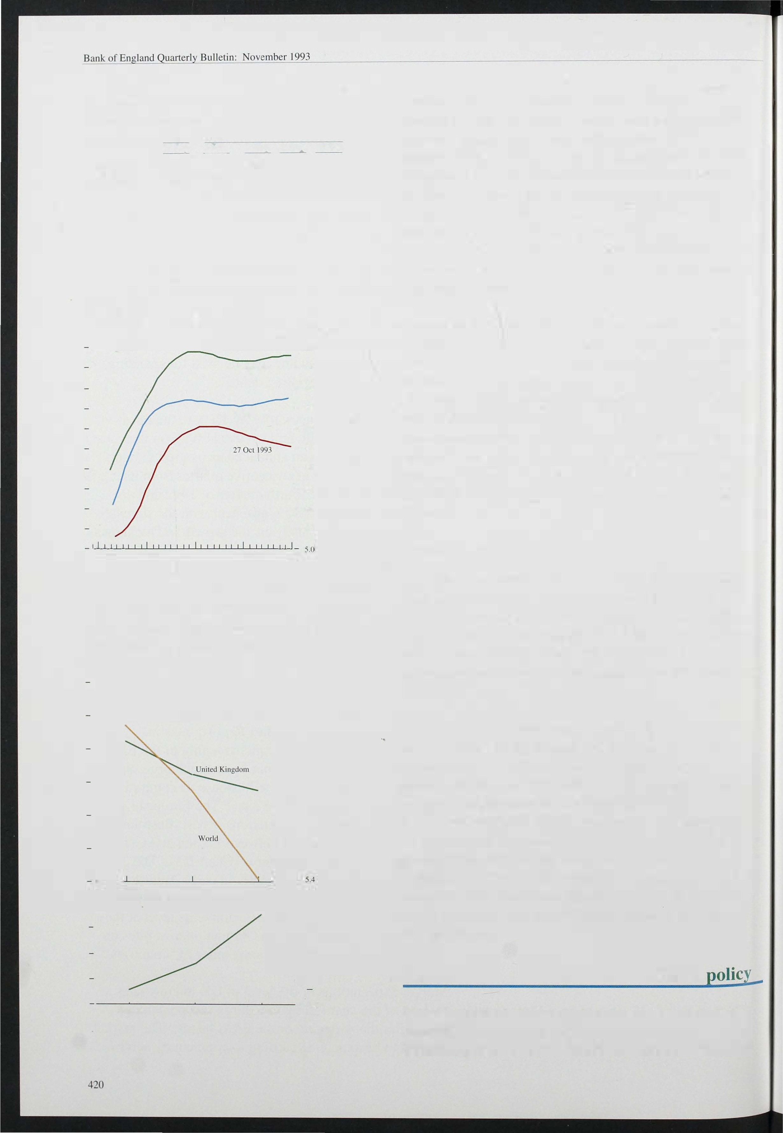

3-month 6-momh 12-ll1onth

- 0.1

- +0.0

- 0.1

## Fiscal

In the Budget on 30 November, the Government will be announcing a new forecast of the public sector borrowing requirement ( 'PSBR' ) for the 1 993/94 fiscal

year. The current forecast, made at the time of the March Budget, is £50 billion. At the halfway point in the fiscal year (taking account of the monthly outturns to end-September) both government expenditure and receipts, particularly those most directly dependent on economic activity, were broadly in line with the March forecast.

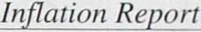

able 2.C

government expenditure(a) as a ercentage of money GDP

Total(b) Final Subsidies Current Gross Debt consumption grants capital interest

formation

|  |  |  |  |  |  |  |
| --- | --- | --- | --- | --- | --- | --- |
| 1986/87 | 43.0 | 20. 8 | ---- | | 1.9 | 4.5 |
| 1987/88 | 41.1 | 20. 4 | lA | 13.0 | 1 .8 |  |
| 1988/89 | 38.2 | 19.7 | 1.2 | 11.8 | 1.4 | 3.8 |
| 1989/90 |  | 19. 8 | 1.1 | 11.9 | 2.2 | 3. 6 |
| 1990/91 | 40.3 | 20. 8 | 1.1 | 12.2 | 2.1 | 3.3 |
| 1991192 | 42.0 | 21.9 | 1.1 | 13. 3 | 2.2 | 2.9 |
| 1992/93 | 44.0 | 22. 2 | 1.0 | 14. 9 | 2.2 | 3.0 |

1.7 13.8

39.4

1. National Accoullts basis.
2. The difference between the total and the components shown here is accounted for by capital grants and transfers and the increase in the book value of stocks and work in progress.

In each fiscal year since 1 988/89, general government expenditure (' GGE') has increased as a proportion of GDP (Table 2.C). Over the same period, the public finances have moved from a surplus (of 3% of GDP in 1988/89) to an expected deficit of 8% of GDP in 1 993/94. The share of current grants (which include social security payments and unemployment benefit) in spending increased during this period, reflecting the 'automatic stabilisers'. Expenditure related to the general government pay bill has remained at around 30% of total expenditure throughout this period, but has i ncreased as a proportion of GDP since 1988/89; in

1 991 /92 (the latest period for which data are available) it accounted for 1 2% of GDP. The measures recently announced by the Government to limit pay rises in the public sector will reduce the public sector pay bill, as a proportion of both. GGE and GDP.

Since 1 99 1 /92 the public finances have been in deficit and �he value of outstanding government debt has increased sharply, albeit from a low base. In previous periods when the government has borrowed heavily, inflation was higher, and the real increase in government indebtedness was less (see the article on pages 5 1 2-20). The five percentage point increase in the net debt to GDP ratio in 1 992/93 was exceptionally high by historical standards. In spite of the measures announced in the 1 993/94 Budget, the net debt to GDP ratio is forecast by the Treasury to .increase by a further 16 percentage points between 1 992/93 and 1 997/98, although its rate of increase should decline.

The annual growth rates of both broad and natTOw money rose in the third quarter, although MO remains above its monitoring range and M4 remai ns close to the floor of its monitoring range. The existing monitoring ranges would seem appropriate over a medium-term horizon. The term structure of interest rates-at both long and short maturity-has shifted downwat-ds. So expected interest rate reductions have had no adverse impact upon longer-term inflation expectations. The continuing rapid increase in the ratio of public debt to

421

GDP need not jeopardise this development, as long as the efforts of the Government to reduce the PSBR retain credibility.

422

# Demand and output

Table 3.A

components of GDP at constant rices, 1993 Q2

Percentage changes

|  |  |  |
| --- | --- | --- |
| Consumers' expenditure | Quarterly changes  0.4 | 1 .6 |
| Public consumption | 1 .6 | -0.3 |
| Investment | -2.0 | 0.3 |
| Domestic demand |  | 0.7 |
| Expons(a) |  | -0.4 |
| Total final demand | -0.1 | 0.5 |

The path of inflation towards its long-run rate depends on demand relative to the economy's potential output and on the demand for l abour relative to labour supply. This section examines the recent behaviour of aggregate demand to assess whether there will continue to be downward pressure on the inflation rate in the short run.

## Demand

The rebased figures on demand and output show a recovery from the trough in 1 992 Q1, with quarterly growth averaging nearly half a percent (see the box on page 41 3), broadly in line with the trend in productive potential. The recovery so far has been evenly balanced between traded and non-traded sectors, reflecting the substitution of domestic goods for imports and a recovery in domestic demand (Table 3.A). Net trade

Impons(a)

GDP(b) 0.6

1. Total goods and services (data subject lO revision).
2. E�penditure estimate aI faclor cost.

Chart 3.1

Personal sector saving and borrowing

4 8

2.0

- .

contributed half of the 2% rise in GDP between 1 992 Q1 and 1 993 Q2, and domestic demand the rest. A positive contribution of 1 .4 percentage points from consumption during the period was partly offset by a negative contribution from investment and stockbuilding; government consumption was flat.

*Personal spending*

Per cent Per cent

|  |  |  |  |
| --- | --- | --- | --- |
| 18_ | - | 0 | Consumption turned up at the same time as GDP; in |
| 16- | - | 2 | 1 992 Q2 it rose for the first time in two years. Since |
| 14- | - | 4 | then it has increased slightly more slowly than GDP:  1 .6% in the year to 1 993 Q2, compared with a rise in |

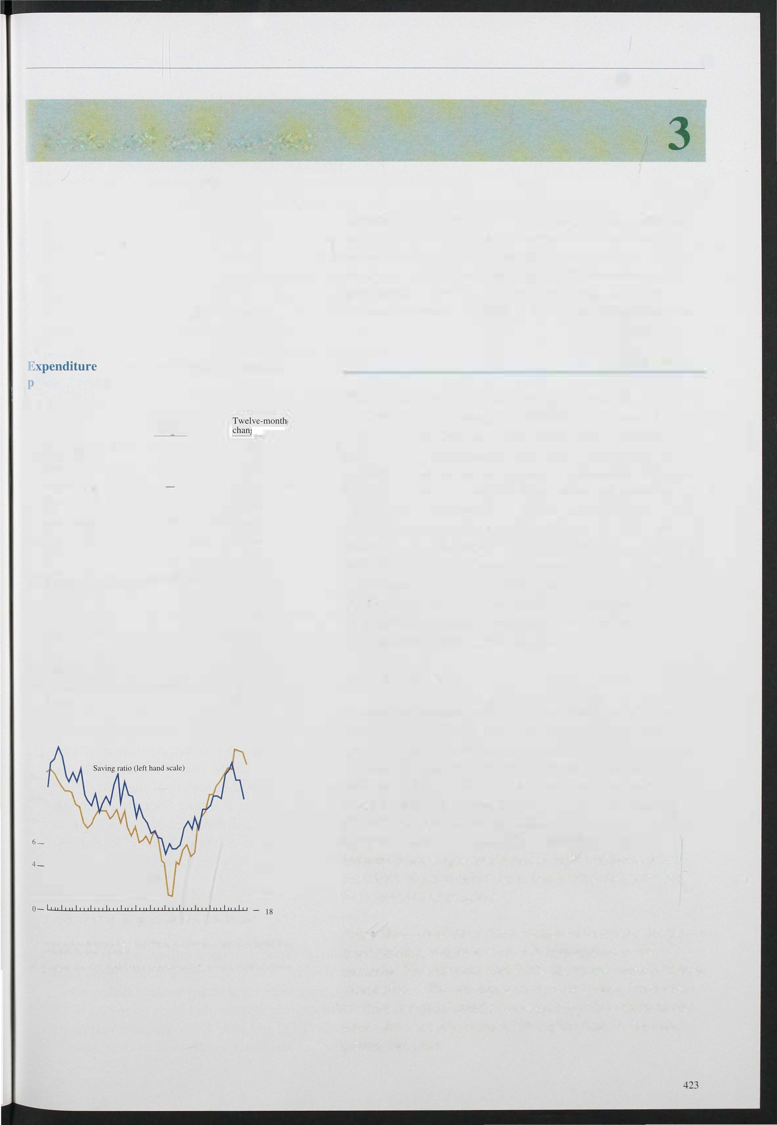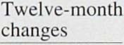

12_

|  |  |  |  |
| --- | --- | --- | --- |
|  | | - | 6 |
| 10- |  | - | 8 |
| 8- |  | - | 10 |
|  |  | - | 12 |
| 2- | Borrowing ratio (a)  (right hand scale inverted) | -  - | 14  16 |

1980 81 82 83 84 85 86 87 88 89 90 91 92 93

(a) Bank and building society borrowing by the personal sector as a proportion of personal disposable income.

Borrowing ratio in 1993 Q3 is based on an eSlimnte of personal disposable income.

by

GDP of 2.0%. At first, the recovery in consumption also lagged behind that in real personal disposable incomes (RPDI), so that the savings ratio rose, to 13. 3% in 1 992 Q3 (see Chart 3. 1 ) . Since then, RPDI has fallen .

Income from wages and salaries, now comprising just over half of personal income, barely rose between the first and second quarters.

Since then, retail sales have remained buoyant: in the third quarter, volumes were 1 % higher than in the previous three months and 3.8% above the same period a year before. The strongest components have been sales of durables (particularly household goods) which in the latest three months were 9.2% higher than in the same ' period last year.

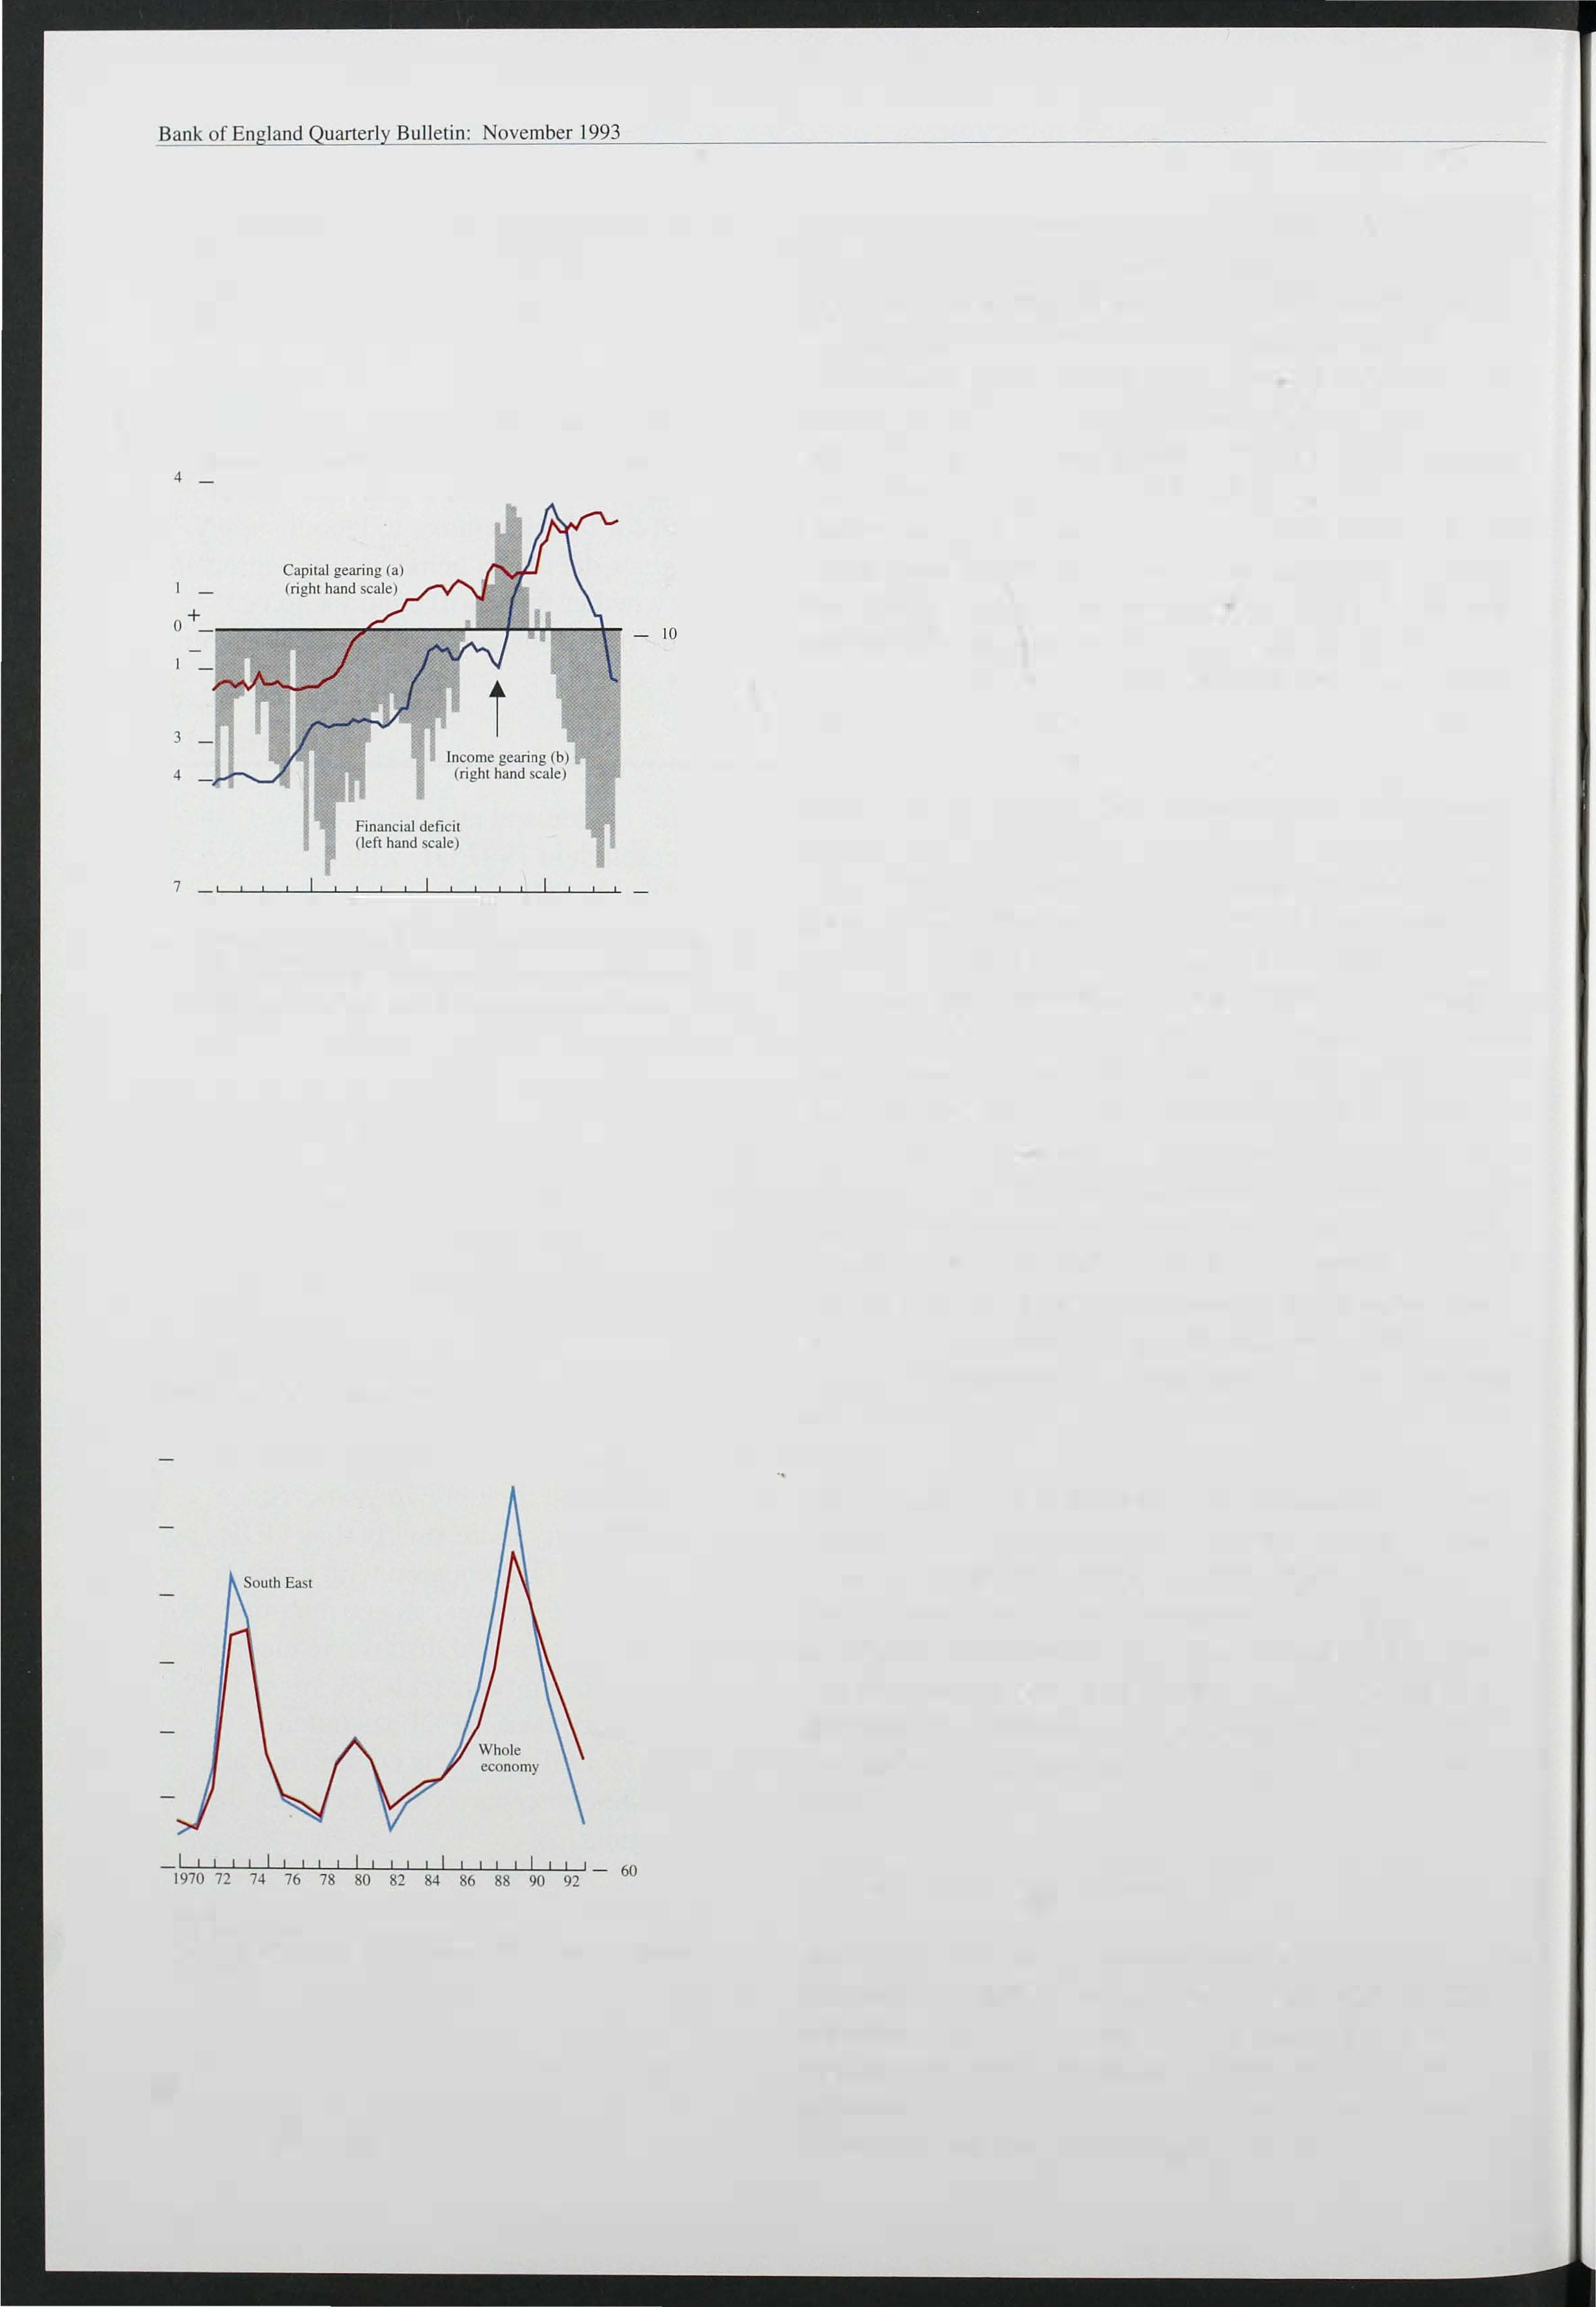

Chart 3.2

Personal sector gearing and financial deficit

Percemage of nominal GDP Per cent

- 16

- 14

|  |  |  |  |  |  |  |
| --- | --- | --- | --- | --- | --- | --- |
| 3 | _ |  | | | | |
| 2 | _ |  |  |  |  |  |
| 2 | _ |  |  |  |  |  |
| 5 | _ |  |  |  |  |  |
| 6 | _ |  |  |  |  |  |

- 12

- 8

- 6

-

4

- 2

1. Borrowing from banks and building societies as a proponion of personal soector financial and physical asselS.

as a

1 976 78 80 82 84 86 88 90 92

1. Gross personal sector interest payments proportion or personal disposable income.

(+

1. Financial deficit as a proportion ofGDP means deficitl- means surplus).

Chart 3.3

House price/earnings ratio

1990= 1 0-0 120

- 1 10

- 100

- 90

- 80

- 70

Sources:

UK

House prices: Department of Environment index, (QI ).

Earnings: Average weekly wages, all male adult full-time workers. New Earnings Survey. April.

424

The fall in the savings ratio to 10.1 % in 1 993 Q2 has reflected stronger consumer confidence: the Gallup index has improved from a low of -26.3 in 1 992 Q4 to

-8.6 in 1 993 Q3 . The rise in confidence probably reflects reduced i ncome gearing (brought about by lower interest rates), better employment prospects, and some stability in the housing market. The sharp fall in interest rates since sterling left the ERM last year has substantially eased the squeeze on the disposable income of indebted households, while reducing the i ncome of households with net financial assets. Chart 3.2 shows that the income gearing of the personal sector has returned to the same level of the mid- 1 980s and is about half its peak in 1 989.

Borrowing by the personal sector has remained light, so that most of the increase in consumption relative to income has been financed by a fall in personal sector assets. This is unusual : in the past, changes in the savings ratio have been associated with changes in consumer borrowing (Chart 3. 1). The likely explanation for the current anomaly is that many households are still heavily geared, while others have accumulated substantial assets. People are still cautious about borrowing, with capital gearing close to its peak

(Chart 3.2) and the housing market still weak. They are particularly cautious about mortgages (which account for almost 80% of total personal sector borrowing), and the fall in interest rates has made financial assets less attractive compared with goods. However, there was an increase in consumer credit in August, apparently linked to purchases of cars.

The housing market appears to be responding at last to lower interest rates and to low house prices relative to earnings (Chart 3. 3). House prices rose by 1 .7% between the first and third quarters of the year, according to the Halifax Building Society. Although activity remains subdued, the level of transactions, as indicated by particulars delivered to Land Registries, was higher in the third quarter than in the first half of 1 993.

*Investment and stoc building*

Since total investment stopped falling in 1 991 Q3, it has fluctuated within a narrow range around 15 % of GDP. But there have been some sharp sectoral differences: real manufacturing investment fell by over 1 0.3% between 1 991 Q2 and 1 993 Q2, whereas investment in electricity, gas and water supply rose by over 1 6%.

Between the first and second quarters of 1 993, whole economy investment fell by 2.9%, close to its level a

year earlier. Manufacturing investment fell by 3 1/2% in

the second quarter, and by the same extent compared with 1 992 Q2.

Chart 3.4

Whole economy fixed investment in three recessions and recoveries

o Trough orGO? recession = 1 00

_ 1 20

_ 11 8

_ 1 1 6

_ 11 4

_ 1 1 2

_ 1 1 0

Chart 3.4 shows how investment changed in three recessions. Total investment fell less in the most recent recession than in the early 1 980s, but at an earlier stage of the downturn, perhaps as a reaction to bigger company deficits, and then levelled out barely a year after the recession started. The flatness of investment since the trough of the recession more than a year ago is similar to the pattern after the previous two recessions.

-Q6 -Q4 -Q2 QO Q2 Q4 Q6

(a) Data do not include revisions as at 29 September 1 993.

_ 108

_ 106

_ 1 04

_ 102

_ 100

_ 98

96

Compared with the last recession, investment has fallen relatively more in non-manufacturing and relatively less in manufacturing. Investment in commercial construction has fallen particularly far. In 1 993 Q 1 the value of new construction work for the private commercial sector was only two thirds of its level a year earlier, and little more than a third of its peak in 1 990 Q3 .

Chart 3.5

Retained earnings and investment

millions

{

- 16.000

The CBI's quarterly survey for October shows a balance of 1. % of manufacturing firms expecting to reduce investment in plant and machinery over the next year, compared with balances of 3% in July and 8% in April. The balance of firms planning to reduce investment in buildings was 18 %, compared with 20% in July. The CBI survey shows that uncertainty about demand remains the most important constraint on investment; the cost of finance is seen as the most important constraint by only 4% of firms, compared to an average

Ices' fixed investment

- 14.000

of 1 2% in 1 992.

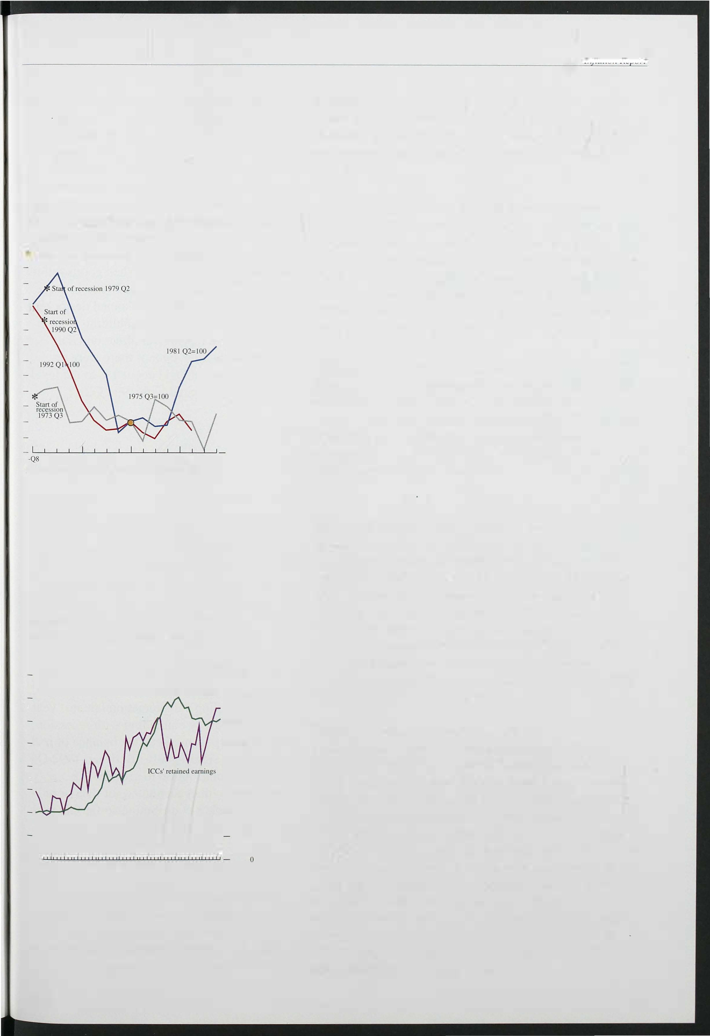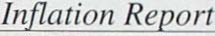

- 1 2.000

- 10.000

- 8.000

- 6.000

- 4.000

2.000

1980 81 82 83 84 85 86 87 88 89 90 91 92 93

Chart 3.5 shows that most investment used to be financed from retained earnings, but that in the late 1 980s and early 1 990s external finance increased its share. Recent data show a sharp increase in company profits since the recovery began. In 1 993 Q2 the gross trading profits of companies (excluding the North Sea sector and net of stock appreciations) were 1 . 6% higher than in the previous three months and more than 1 3% up on a year earlier. Over the same year, company interest payments fell sharply, taxes remained flat and dividends increased less than profits, so that companies' undistributed income rose by over a third. In the near term, some companies may want to use surpluses to reduce debt-company capital gearing is still high­ rather than for more investment.

425

Bank of Bulletin: November 1 993

Table 3.B

1992 balance of payments data-revisions

millions

£

Pre-revisions Post-revisions

Visible balances ·13.77 1 -1 3,406

|  |  |  |
| --- | --- | --- |
| Invisibles:  Services balance | 3,700 | 4,069 |
| Interest, profits and  dividend balance | 3,578 | 5,777 |
| Transfers balance | -5,053 | -5,060 |
| Invisibles balance | 2,225 | 4,786 |
| Current balance | -1 1,544 | -8,620 |

NB: Figures may nOt sum to the total due to rounding.

Table 3.C

UK trade volumes in non-oil goods (excluding erratics)

Percentage changes

Expons Impons

|  |  |  |  |  |
| --- | --- | --- | --- | --- |
|  | 1 991 Q4-  1 992 Q3 | 1 992 Q3-  1 993 Q2 | 1 991 Q4-  1 992 Q3 | 1 992 Q3-  1 993 Q2 |
| EC | 1 .6 | -6.6 | 8.6 | -9.5 |
| Non-EC | 3.1 |  | 6.8 | 9.5 |
| Total | 2.2 | 0. 1 | 7.8 |  |

TotaI goods and

9.4

Memo:

servIces 0.8 0.4

In the economy as a whole, stocks are estimated to have fallen by some £1 ,300 million (1 990 prices) in each of the first and second quarters of this year. In only one of the l ast twelve quarters has stockbui lding been positive, and stock/output ratios have fallen. The change has been helped by new technology, which allows easier and more accurate stock control. In addition, firms have wanted to contain costs, though the cost of stockholding has fallen as i nterest rates came down. Monthly CBI surveys suggest that the balance of manufacturing firms with more than adequate stocks of finished goods fell to 9% in September, the lowest since June 1 990; in some sectors there may have been some unplanned destocking

in recent months. The change in stockbuilding from

'

period to period can have a powerfut effect on GDP

growth; an end to destocking, even if there were no positive stockbuilding, would add about 1 % to the level of a quarter's GDP as compared with 1 993 Q2.

*Overseas trade*

Data revisions have substantially changed the picture for last year's current account, while a new system for estimating trade with the EC (VAT returns rather than customs forms) makes the data for the first half of 1 993 difficult to interpret. Table 3.B shows the revisions to the 1 992 balance of payments data, producing a deficit of 1 .4% of GDP compared with earlier estimates of

1 .9% of GDP. About 0.4 percentage points of this revision is the result of new estimates of interest, profits and dividends; the rest reflects revised estimates of trade.

The balance of trade deteriorated during 1 992, as the

. economy began to pick up, increasing the demand for imports. But, since sterling's depreciation late last year, and despite the UK recovery coinciding with recession in many of our main export markets, the balance of real net trade has improved significantly. Between 1 992 Q4 and 1 993 Q2, trade's contribution to growth, 1.5 percentage points, more than accounted for the overall expansion in GDP. Trade's contribution so far this year has reflected a larger fall in imports than in exports: between 1 992 Q4 and 1 993 Q2 the volume of exports fell by 0.7%, while imports fell by almost 5 .4%.

The figures show that the apparent falls in import and export volumes reflect movements in trade with the EC (Table 3 *.*C*).* Between the third quarter of last year and the second quarter of this, the volume of goods imported

from the EC fell by nearly 1 0%, implying a fall in



426

## *cso* trade figures: new collection methods

With the completion of the EC single market at the end of 1 992, data on EC trade flows can no longer be obtained from customs declarations as in the past. Since the beginning of the year, data on EC

trade values have been based on the Intrastat

Chart A

UK import penetration by area(a)

Per cent

_ 22

system, which is linked to the collection of VAT. In World

the press notice accompanying the release of the latest world trade statistics, the CSO acknowledged that 'the EC component of the figures has a greater margin of error and is more subject to revision than the non-EC component' .

Only partial information on the *prices* of goods EC

imported from and exported to the EC is available from the Intrastat system. As a result, EC prices

_ 20

_ 18

_ 16

_ 14

_ 12

_ 10

are calculated by adjusting non-EC prices in an attempt to reflect the divergence in price movements between the two regions. The CSO's latest estimates indicate that the prices of non-oil goods imported from the EC rose by 1 4.4% between 1 992 Q3 and 1 993 Q2; non-EC import prices, over the same period, rose by 1 3.4%. The prices of non-oil exports to EC countries rose by 9.5% between 1 992 Q3 and 1 993 Q2, compared with an increase of 7.3% in non-EC export prices. Given sterling'S substantially greater depreciation against non-EC currencies than EC currencies, these import and export price movements are surprising, and may suggest that, as a result of the limited information available from Intrastat, the prices of UK exports to and imports from the EC have been overstated. However, although the new estimates of prices could be revised when more information is available from the Intrastat system,

the CSO are unaware of any reasons why future

revisions to prices should necessarily be downwards rather than upwards.

7 7

0

(a) Import volumes divided by domeslic demand (both in 1990 prices).

These charts suggest that, on economic grounds, we would expect any future revisions to cause both import and particularly export volumes to be revised upwards. Any underesti mating of net export volumes would have a different i mpact depending on whether it is the result of an underrecording of trade values or an overrecording of prices. If it is purely because of an underrecording of total values, the trade deficit will be overstated but real GDP (as measured by the output index) is likely to be unaffected. By contrast, if export prices are overestimated this will mean that GDP would be underrecorded, because export deflators are now used to deflate manufacturing output values when measuring manufacturing output.

Chart B

Trends in UK exports(a)

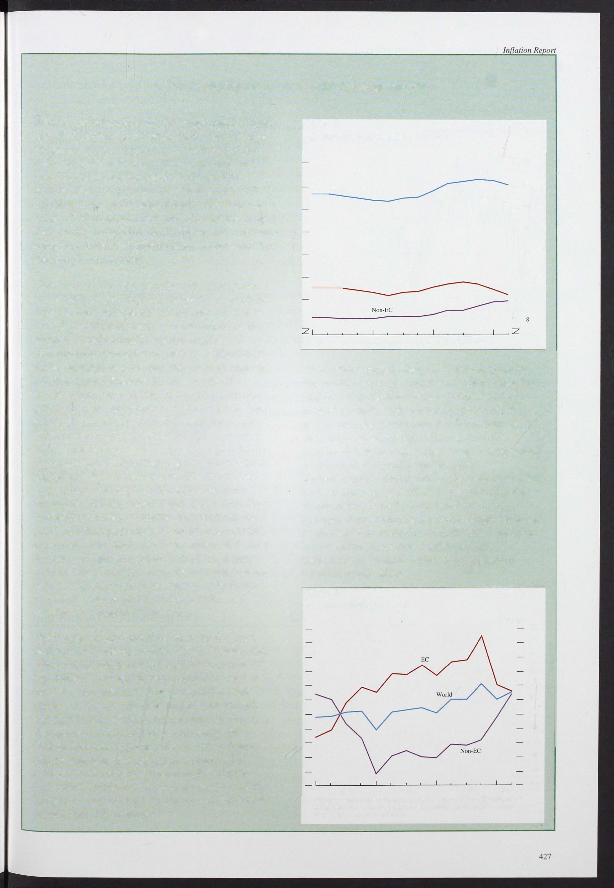

Trade *volumes* are calculated by using the price data to deflate the value data. Chart A shows that, while import volumes from the non-EC relative to UK domestic demand have continued to increase since the beginning of the year, published data imply that EC imports have dropped off sharply.

Similarly, Chart B shows Ihat, despite sterling'S depreciation following the suspension of the United Kingdom's membership of the exchange

rate mechanism, UK exports as a share of EC domestic demand have fallen sharply. This is particularly difficult to explain, given the United Kingdom's improvement in price competitiveness against other EC countries.

1990=100

1990 91 92 93

10

1. UK export volumes excluding oil and erratics as a ratio EC/non·EC demand. EC includes France. Gennany. Italy and Netherlands. Non-EC includes Austria, Canada, Japan and the United States.

112

110

108

106

104

102

100

98

96

92

90

Chart 3.6

Sectoral financial balances

Corporate sector and current account

Percentage of nominal GO?

- 5

- 4

Current account

- 2

-

I

+

- I

penetration of UK markets significantly larger than past relationships suggested would follow from the improvement in UK competitiveness. For UK exports, there has also been a sharp divergence between performance in the EC markets and in the rest of the world. Between 1 992 Q3 and 1 993 Q2, UK exports outside the EC have risen by 9.4%, increasing their market share. B ut export volumes to the EC appear to have fallen nearly 7%, much more than the slowdown in activity there, despite the improvements in UK

competitiveness. One possible explanation is that the

Corporate sector (a)

-- 23

new system for estimating trade with the EC has underestimated trade volumes (see the box on page 427).

- 5

- 6

1 971 73 75 77 79 81 83 85 87 89 91 93

* 1. ICes plus financial companies and institutions.

Public and personal sectors

Percentage of nominal GOP

- 4

- 3

- 2

- I

+

- 0

- 2

- 3

- 4

- 5

--- 786

9

1971 73 75 77 79 81 83 85 87 89 91 93

Measured in current prices, seasonally adjusted.

Table 3.D

Sectoral performance in the recovery

Per cent

During the recent recession, the balance of payments deficit was larger as a proportion of GDP than in most earlier recessions. Chart 3.6 shows that, during the boom of the late 1 980s, the main counterparts to the initial deterioration in the current account were sharp moves into deficit by households and companies. The persistence of the deficit during the recession has partly reflected the change in the policy mix towards monetary restraint and fiscal ease. Since sterling's exit from the ERM, the balance of policy has changed. The falls in interest rates and the exchange rate are stimulating overall demand and improving competitiveness; and tighter fiscal policy will serve to restrain domestic demand relative to output. The evolution of the current account will depend on the balance between these various effects, and on how external demand changes. The box on page 429 discusses the measurement of competitiveness, which should be thought of as an outcome of the interplay of these macroeconomjc factors.

## and the

Industry

Agriculture

Mining (in oil and gas)

Manufacluring Electricity. gas.

water

Total production industries

Construclion Distribulion. hotels

Weigh One quarter Change in Change in

in GDP change in in output between (1 990) output in year peak in 1 990 Q2

I

OUIPUI

10

1 993 Q2 1 993 Q2 and 1993 Q2

1 .9 -2.9 -4.6 0.9

2.2 1 .2 6.2 -2.7

23.7 0.6 2.3 -5 .1

2.2

2.3

28. 1 0.8 2.7 -4.0

7.2 -0.2 -4.3 -17.1

The rates of recovery in output in manufacturing and services have been sirlil ar. Manufacturing production rose by 0.6% in 1 993 Q2, for an increase over four quarters of 2.3%; for service industries, the corresponding figures were 0.6% and 2.4%. But the early stages of this recovery have not been reached by all sectors of the economy. Construction output has continued to decline-by 4.3% in the year to 1 993 Q2-

and catering; repairs 14.2 0.5 2.5 -5.0

Transport and

and is only about five sixths of its peak in 1 990 (see

communication Financial and

0.8 2.9 -0.7

Table 3.D).

business services 18.6 1.1

Govemment and other

services 21 .7 0.3 1 .5

2.2

Total services 62.9 0.7 2.5 0.6

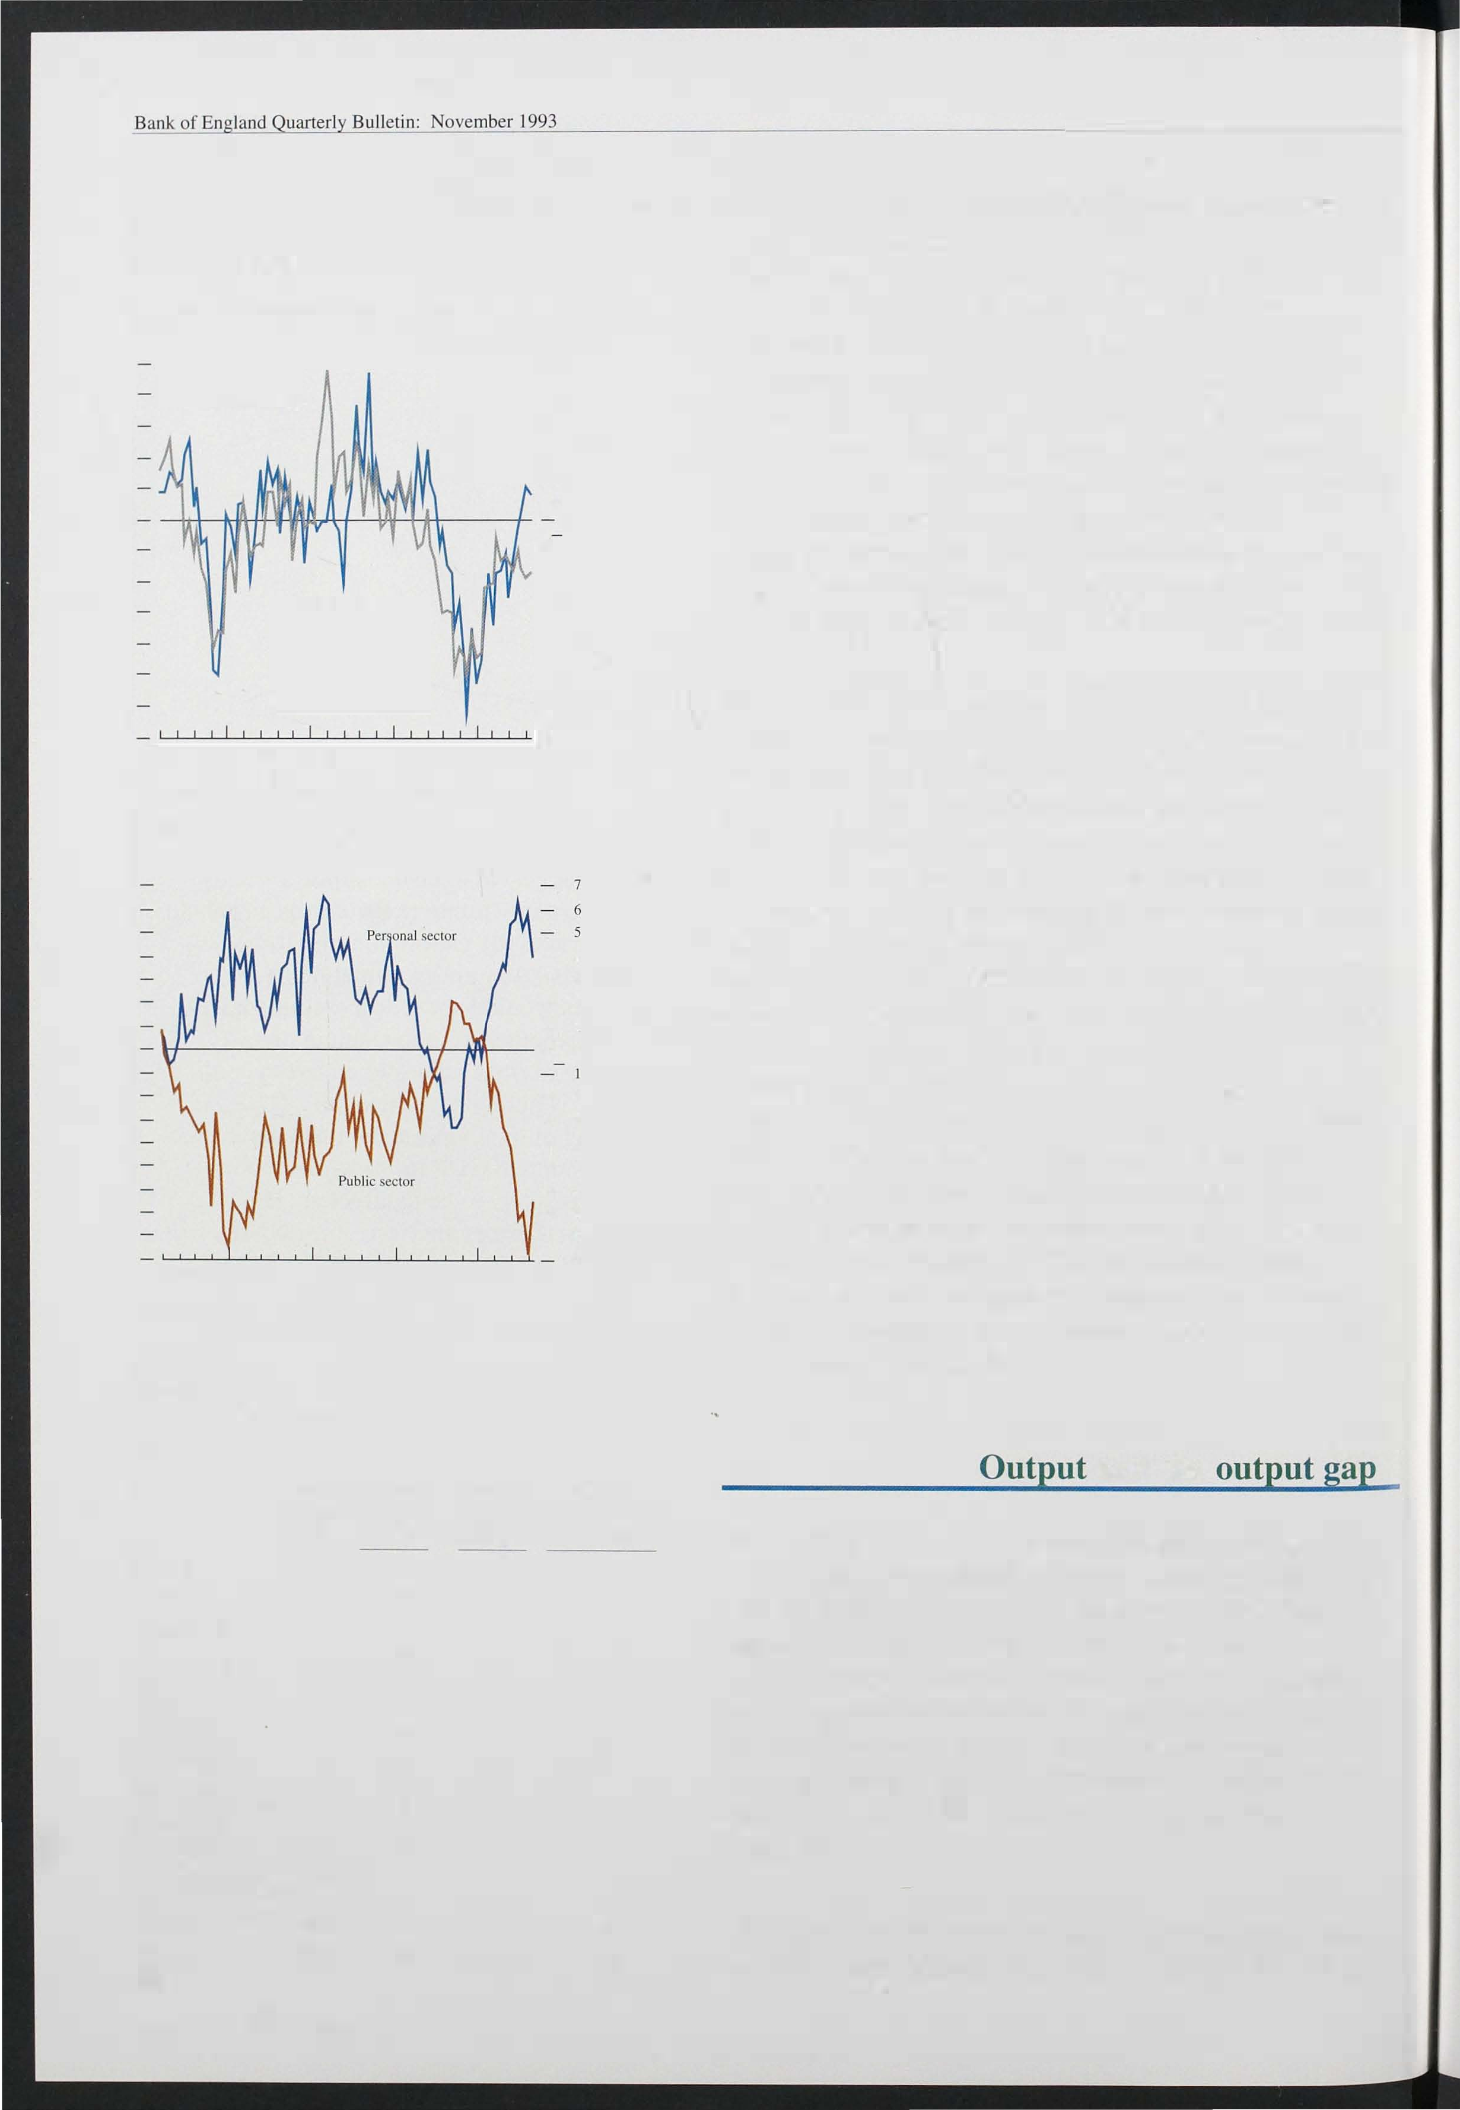

Total 100.0 0.6 2.0 -1.9

428

CBI figures show capacity utilisation in manufacturing has fal len substantially since the late 1980s, but not as

## *UK* competitiveness

Competitiveness is usually measured by relative priCes or costs, expressed in a common currency. Competition in international markets tends to equalise these prices and costs, but in the short term changes in exchange rates can allow them to diverge. Differences in the product mix and

non-price factors, such as product specification and reliability, can also affect indices of competitiveness in the longer term.

Chart A

Price/cost competitiveness in a common currency(a)

1985=100

140

_ 130

_ 1 20

11 0

100

1981 82 83 84 85 86 87 88 89 90 91 92 93

(a) UK manufacturing cost/price competitiveness relative the other G7 countries. adjusted for exchange rate movements.

10

Measures of competitiveness based on prices and costs do not always move together. Market structure is an important influence on their relative movements. In a competitive market, where goods and services are perfectly substitutable, firms will be unable to influence the world price. A fall in the exchange rate would be reflected fully in higher sterling export prices. So this increased incentive to supply for the export market would

not be reflected in (common currency) relative prices, which would remain unchanged. However,

produce. Although cost measures might therefore be preferred conceptually, they are typically based on relative unit labour costs or relative unit wage costs (which do not include non-wage labour costs) . These vary with the cycle, and do not include non-labour costs, such as the cost of raw

material inputs and capital. Ultimately, the choice of which measure of competitiveness to use is an empirical question.

The charts show movements in the UK real effective exchange rate against the other G7 countries on a relative unit wage cost and a relative price basis. As a result of sterling's depreciation, both the price and cost measures of competitiveness have significantly improved since sterling'S suspension from the ERM (see Chart A). But the improvement in UK competitiveness has not depended entirely on exchange rate movements; in the year to 1 993 Q2, unit wage costs in the United Kingdom fell by around 4% relative to other G7 countries (see Chart B). An increase in competitiveness as a result of lower domestic costs is likely to be regarded as more

permanent than a change in competitiveness

caused solely by fluctuations in the nominal exchange rate, so it is more likely to lead to a supply response.

Part of the difference in (local currency) cost performance reflects cyclical productivity effects. The United Kingdom is emerging from recession before the major continental economies.

Chart B

Relative prices/costs(a) in local currency and the effective exchange rate

1985= 100

- 140

measures of (common currency) relative cost competitiveness would show an improvement. In imperfectly competitive markets, firms will be able to vary their prices in foreign currency terms; a fall in the exchange rate in this case would then lead to an improvement in both relative costs and relative prices.

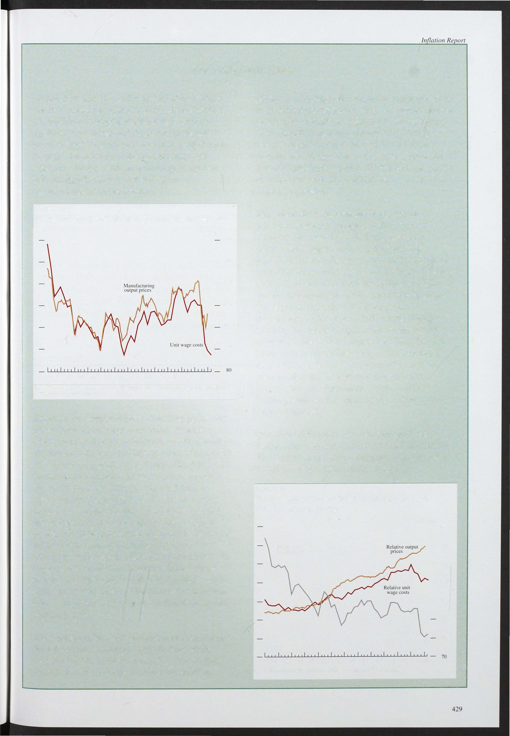

P rice measures have the advantage of measuring the prices that consumers actually face, While measures based on costs attempt to capture the impact of competitiveness on the incentive to

Nominal effective exchange rale

1981 82 83 84 85 86 87 88 89 91 92 93

90

(a) UK manufacturing costs/prices relative IQ the olher G7 countries.

- 130

- 1 20

- 1 1 0

- 1 00

90

80

Table 3.E

Capacity utilisation in manufacturing industry (percentage of respondents at less than full capacity)

October 1 993 Average October 1 993

1 972-93 I 972-July 93 minus average

I 972-July 93(a)

All manufacturers 60 60.2 -0.2

Capital goods industries 68 62.2 +5.8

much as in the previous recession; and capacity utilisation has risen in recent quarters. Table 3.E shows that in October 1 993 60% of manufacturing firms reported that their capacity was underutilised, compared with a mean of 60% in the previous two decades.

Capacity utilisation in consumer goods industries is slightly above the average of the previous twenty years. The main outliers are food, drink and tobacco, where only 37% of firms report capacity being u nderutilised, and motor vehicles and transport, where over 93% of firms report underutilisation of capacity. The more that

Consumer goods

Food. drink and tobacco

55.7 -4.7

50.0 -1 3.0

- . 1

capacity utilisation varies across industries, the greater

will be the upward pressure on prices (for a given overall

Chemicals 50 52. 1 2

Textiles 40 52.1 -12.1

Mechanical engineering 64 64.6 0 6

- .

Electrical and instrument

Engineering 60 61.1 -1.1

level of utilisation) as more firms run into capacity constraints.

Motor vehicles and transport 56.3 (b) 36.7 (b)

Paper, printing and publishing 50 51 .6 (b) . 1.6 (b) Source: CBI Industrial Trends Survey.



1. Negative number implies capacity utilisation higher than historic averages.
2. Average based on data from 1984 10 1993.

43 0

The amount of slack in the goods m arket-the 'output gap'-can be estimated in various ways from survey results and statistical models (see last August's *Quarterly Bulletin,* pages 309- 1 0). Most measures point to a gap at the moment, although the CSO's coincident indicator suggests the gap has closed.

The recovery in output seen so far has been at a moderate pace. The company sector's own spending has as yet made little contribution to the recovery, though it may do so once the recovery becomes better established and as companies' balance sheets improve. However, low growth in demand abroad and the expiry of temporary investment incentives at the end of October are likely to inhibit rapid investment growth. The personal sector's savings ratio has fallen quite sharply from i ts peak last year, but consumption growth is still lagging behind GDP growth. Consumers seem cautious about borrowing. Though confidence may improve with the recent turnaround in the housing market, it seems unlikely that there will be a rapid fall in the savings ratio fuelled by borrowings. After several years of

below-trend output growth, there is scope for above-trend growth for several quarters before the

markets for goods and services start to produce strong upward pressure on prices.

# The labour market

## and settlements

Chart 4.1

Underlying earnings growth

Percentage changes 011 <.I year earlier

- 12

In the year to August underlying earnings in the whole

economy rose by 3 1/2%, the same as in July, well down on the rises in the first quarter of 1 992 (Chart 4. 1). From

February to July 1 993, the reduction in twelve-month earnings growth came almost entirely from the services sector, but in August underlying earnings growth in manufacturing fell. The recently published New

Whole economy

1990 91

Chart 4.2

- 10

- 8

- 6

- 4

Services - 2

93 0

Earnings Survey showed that earnings in the public sector rose by 4.3% in the year to April, compared with 4.0% in the private sector, but these figures were

affected by settlements concluded before the 1 112% limit

on public sector pay increases was imposed.

The percentage increases in wage settlements have stopped falling. According to the Industrial Relations Service (IRS) measure, the median whole economy

settlement declined from 3% in the first quarter to 2% in the second, rose t6 2 1/4% in the third. Earlier falls were

largely attributable to a bunching of settlements in the public sector (Chart 4.2). Surveys by the CBI and Incomes Data Services (IDS) are consistent with little recent change in settlements. The most recent IDS data have shown a marked fall in September, but recorded very few settlements. The CBI reports that in the three months to July over one in four companies froze their

Private and public sector settlements(a)

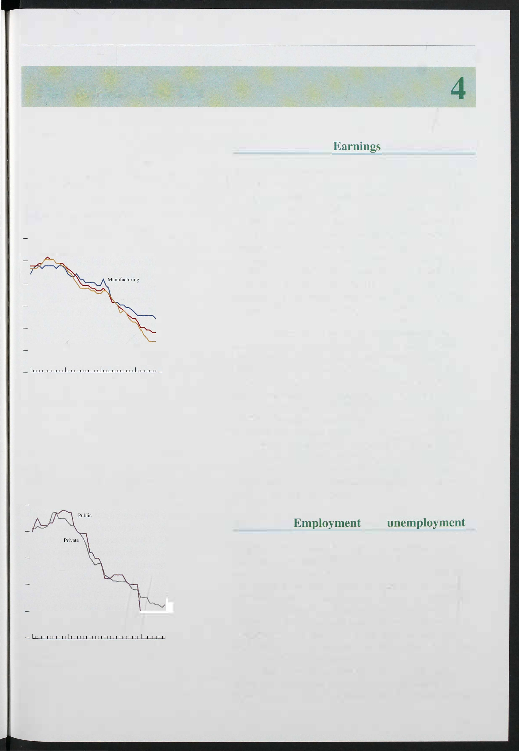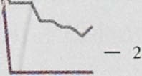

Per cent

- J O

- 8

- 6

- 4

1990 91 92 93 _ 0

SOurce: IRS.

(11) Three-month median.

pay, though some have introduced bonus schemes or lump sum payments instead.

## and

Employment has started rising sooner after the turning point in output than it did in earlier cycles. In the early stages of the previous two recoveries, employment was still falling a year after output had begun to rise. One explanation for the change may be that the labour market is now more flexible and hence more responsive to output changes, with companies willing to take on new staff earlier in the recovery. If this is indeed the case, there will be less cyclical movement in productivity than in the past, and whole economy productivity will grow at a rate close to its trend of around 2%. An alternative explanation is that the recent rise in employment may represent a reversal of sentiment after the fall in Autumn

43 1

Table 4.A

Labour market indicators

United Kingdom. seasonally adjusted

(Units) Latest Half year Year ago ago

1 992, which was stimulated by business pessimism around the time of sterling's exit from the ERM. On this view, employment will rise further only if output growth goes well above 2%. A third possibility is that activity may be stronger than shown by the official data; in particular, the trade statistics may be underestimating

Unemployment

|  |  |  |  |  |  |
| --- | --- | --- | --- | --- | --- |
| Change (goq) | OOO·s | 1 993 Q2 | -23.6 | 1 24.2 | 68.5 |
| Rate |  | Sept.93 | 10.3 | 10.5 | 10.1 |

Employment %

Employed labour force

- - - -

exports to other EC countries.

Recent data give mixed signals about labour market pressures (see Table 4.A). Unemployment fell by 13 ,600

change (qoq) OOO·s 1 993 Q2 22 -1 09 -1 74

Manufacturing

change (1110111) aaa's Aug. 93

-24 +4

in September, after rising for two months. Claimant

unemployment has now fallen by 84,000 since January

Vacancies OOO·s Sept. 93 127.3 123.2 1 1 1.5

Hours of overtime I11n Aug. 93 9. 29 9. 18 9.36

Hours lost through

short-time working mn Aug. 93 0. 19 0.76 0.43

Wages

%

Underlying average Aug. 93 3.5 4.5 5.75

Earnings (1 2-l11onth change)

(GB) Manufacturing

%

1 993 (see Chart 4.3). In the second quarter, the workforce in employment increased for the first time since 1 990, with a substantial rise in self-employment. Short-time working has fallen below its level in August 1989. But manufacturing employment was down by

(1 2-l11onth change) Aug. 93 (GB) Services

%

5.00 6.00

24,000 in August, and overtime working in

(1 2-l11onth change) Aug. 93 2.75 4.25 5.75

Settlements

manufacturing fell after a sharp increase the month

before. The number of unfilled vacancies at job centres

IRS IDS

|  |  |  |  |
| --- | --- | --- | --- |
|  | | 2.3 | 2.5 |
| CBI Services (Private)  Modal class. | % 1 | 2.6 | 2.8 |

CBI Manufacturing

Chart 4.3

Sept. 93 2.25 3.0 4.3

Sept. 93 0- 1.9 (,) 3-3.9 (,,) 4-4.9(a)

3.9

4.3

%

993 Q3

% 1993 Q3

was virtually unchanged in September.

Earlier in the year, the abrupt end to the rise in claimant unemployment, despite the large recorded falls in employment throughout 1 992, made it hard to gauge pressures in the l abour market. But data from the

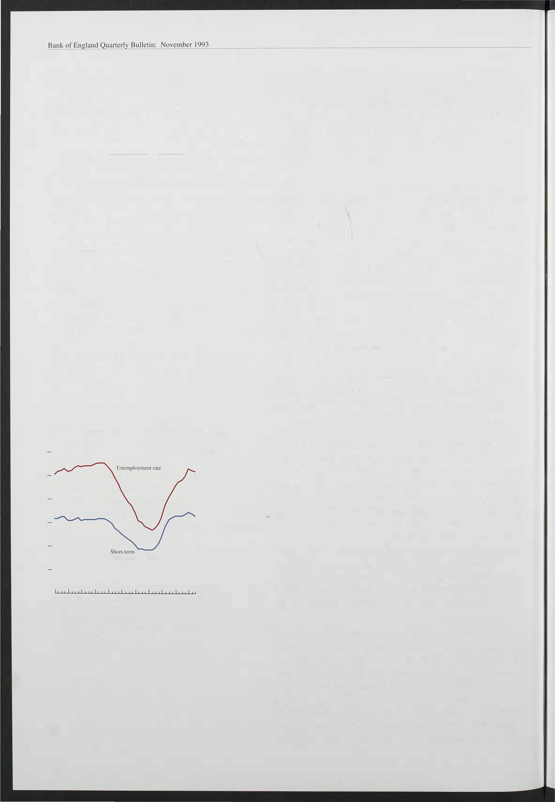Unemployment and short-term unemployment(a)

Per cent

- [2

- [0

- 8

- 6

- 4

unemployment rale

- 2

_ [983 84 85 86 87 88 89 90 9[ 92 93_ 0

All figures are for Great Britain.

(3)

Less lhan 52 weeksduration. Adjusted by the Bank for seasonal factors and discontinuities.

432

Labour Force Survey (LFS) for March to May 1 993 show that unemployment-measured on the basis of those seeking work, rather than those claiming

benefits-peaked during the winter, when employment began to i ncrease. The LFS reports a firmer trend than do the data derived from the unemployment register and employers' records. The LFS follows the International Labour Office (ILO) in counting as unemployed all those who do not have a job but who have sought work in the four weeks before being surveyed. It shows that unemployment fell by 90,000 between the winter 1 992/93 and spring 1 993. Over the same period, the claimant count, which covers just those claiming unemployment-related benefits, fell by 40,000.

Although the unemployment rate is commonly used as a measure of labour market slack, some analysts argue that it ignores potential workers who instead retire, stay on in education, or simply stay at home. An alternative is to look at the employment rate for the population of working age; if this is below trend, then there is labour market slack. The LFS shows a rise in the employment rate between the winter and spring surveys, although it is still three percentage points below its peak; most of the

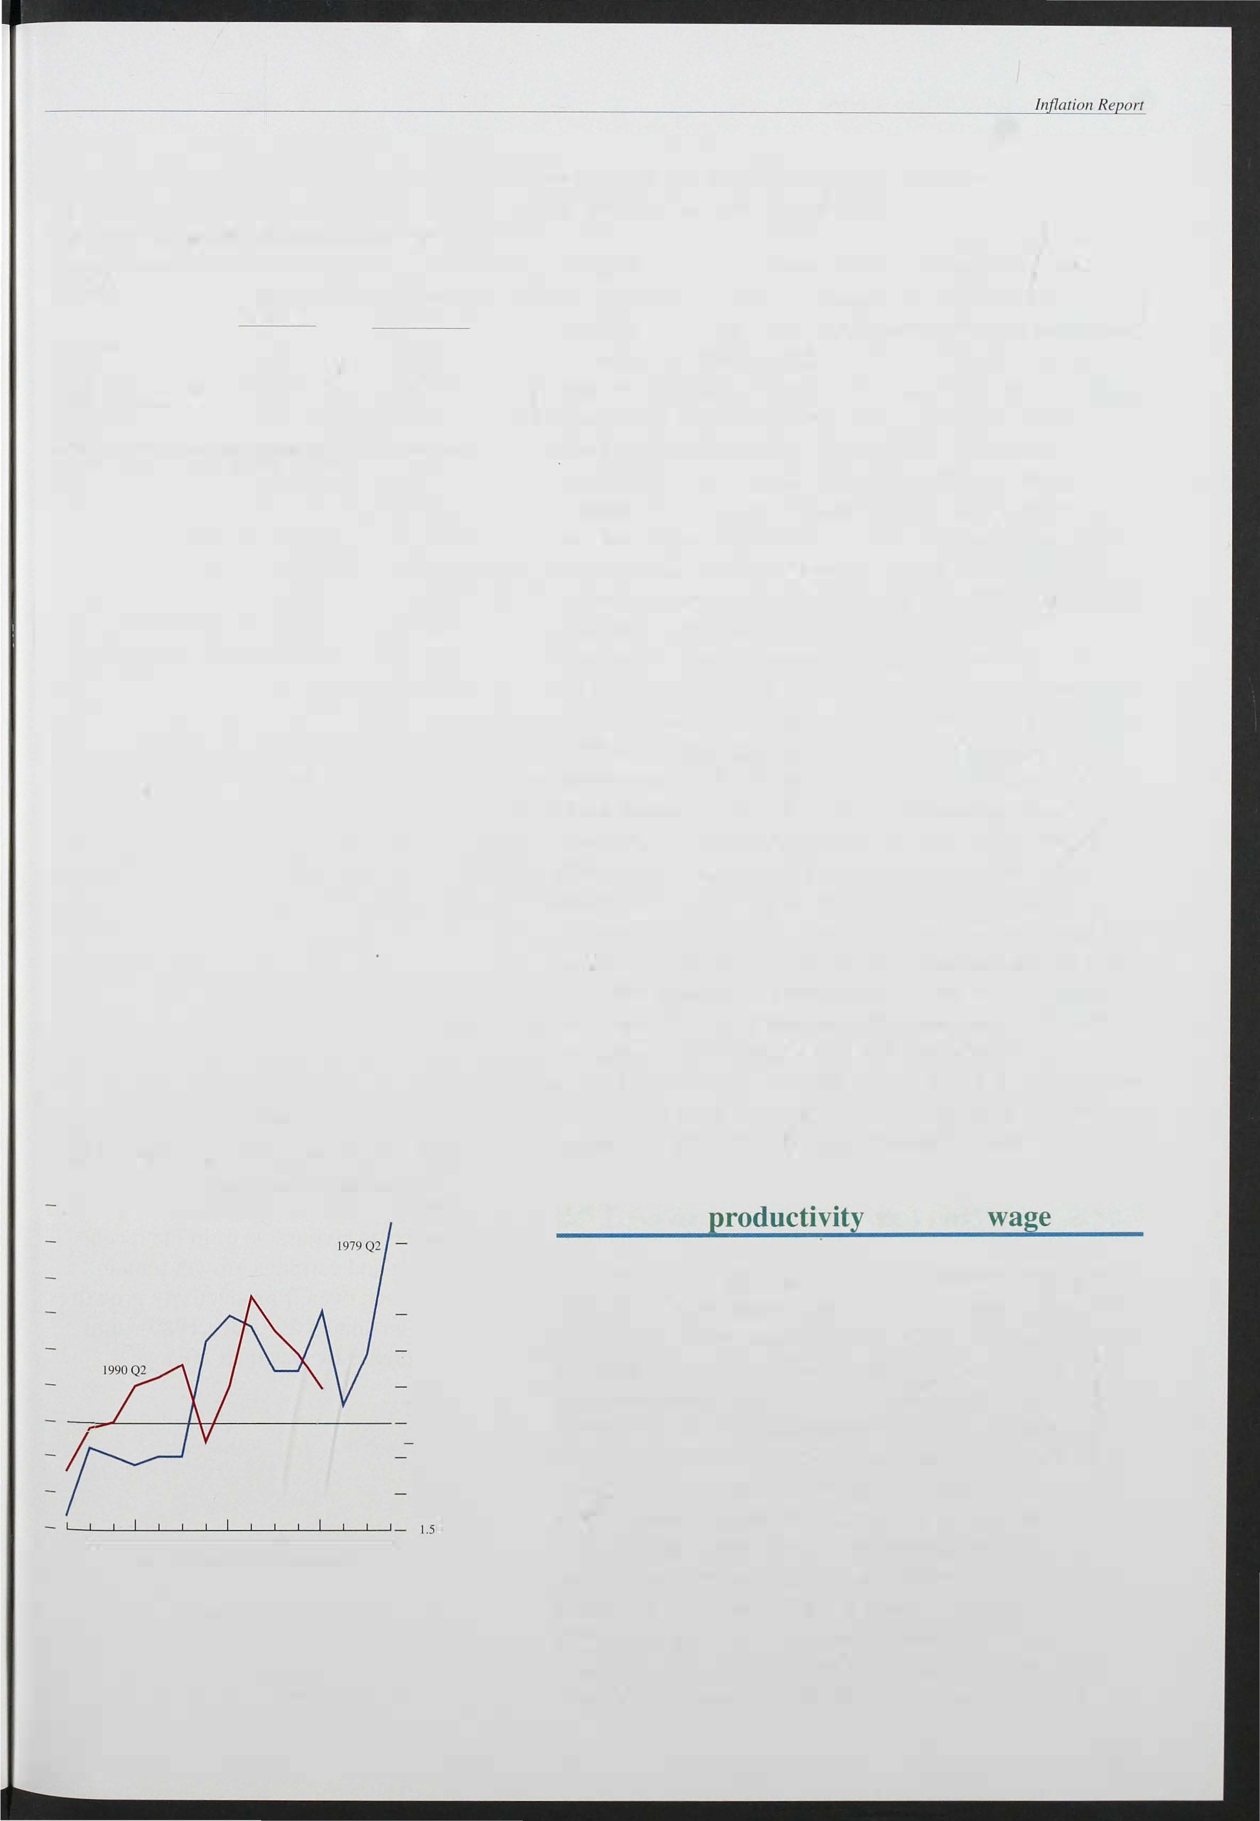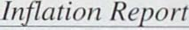

Table 4.B

Labour force survey: changes in employment

Thousands, GB, seasonally adjusted

|  |  |  |
| --- | --- | --- |
| Employment: | Spring 1990-  spring 1 993 | Winter 1992/93- spring 1993 |
| All(a) | -1 ,473 | 151 |
| Men | -1 .302 | 50 |
| Women | -171 | 101 |
| Full-timers | -1.69 1 | 24 |
| Part-limers | [ 90 | 103 |

(a) Total includes those on governmem-sponsored job training schemes or unpaid family workers, who are not included in components.

Chart 4.4

Whole economy productivity in two recessions

Percentage chan es on a quaner earlier

g

- 3.0

2.5

- 2.0

1.5

1.0

0.5

+

0.0

0.5

1.0

QI 2 3 4 5 6 7 8 9 10 11 12 13 14 15

Number of quarters from start of recession

growth in employment since the winter has been in part-time work (see Table 4.B).

As in the 1980s recession, the rise in unemployment since 1 990 has been associated with a fall in the 'participation' rate-the proportion of the population of working age who are either in work or looking for it. In part the fall may represent 'discouraged workers', with people ceasing to look for work as unemployment rises. But the figures probably overstate the fall in the participation rate during a recession, for two main reasons. First, some of those with two jobs (about 4% of those in employment) may lose one of them, causing the job count to fall without adding to the unemployment count. Second, some of the rise in unemployment during a recession will involve people who, for a variety of reasons, do not claim unemployment related benefits.

Figures from the Labour Force Survey point to a rise in non-claimant unemployment of 90,000, equivalent to 0.2% of the population over 1 6, between spring 1 990 and spring 1 993. These factors suggest that the ' true' participation rate fell by only 1 .6 percentage points, rather than 2 percentage points. In the rnid- 1 980s, the participation rate. rose once unemployment began to

flatten out, and continued to rise until 1 989, when

unemployment was close to its trough. As the economy recpvers from the recent recession, the participation rate may rise again, as the number of people with two jobs rises, and 'discouraged' workers decide to re-enter the job market. This suggests that the measured unemployment rate may understate the degree of slack in labour market, and therefore understate the scope for output to expand before wage pressures begin to mount.

## Labour and unit costs

Productivity growth has been much stronger during the recent recession than in previous downturns (Chart 4.4). In the early stages manufacturing output fell around half as quickly as in the 1 980s recession ; but employment fell at much the same rate, so productivity behaved quite differently. In the fourth quarter of 1 980, manufacturing productivity was about 8% lower than a year earlier; by contrast in the year to 1 990 Q4 productivity fell scarcely at all, because employers reacted sooner and more fully to the fall in output. In both recessions, productivity grew strongly when output began to recover. However, it was closer to trend in the 1 990s recession than in the

1 980s one, leaving less ground to make up. For example, short-time working is lower now than at the comparable stage in the 1 980s cycle, and overtime per

433

Table 4.C

Contributions of earnings and productivity to unit wage costs

1. Whole economy

Percentage changes on same period in previous year

Output Employment Labour Earnings Unit wage

productivity per employee costs

1990

|  |  |  |  |  |
| --- | --- | --- | --- | --- |
| 0.6 |  | -0. 1 | 9.9 | 9.8 |
| -2.3 | -2.8 | 0.5 | 7.9 | 7.0 |
| -0.5 | -2.7 | 2.3 | 6.5 | 4.2 |
| -1.2 | -2.9 | 1.7 |  |  |
| -0.7 | -2.4 | 1 .7 | 6.5 |  |
| -0. 1 | -2.8 | 2.8 |  | 2.9 |
| 0.2 | -3.0 | 3.3 | 5.4 | 2.6 |
| 1 .4 | -3.0 |  | 3.0 | -0.9 |
| 2.0 |  | 4.5 |  | -0.9 |

1 991

1992

1992 QI

Q2

Q3

5.4

Q4 1993 QI

Q2

1. Manufacturing industryCa)

Percentage changes on same period in previous year

-5.3

|  |  |  |  |  |  |
| --- | --- | --- | --- | --- | --- |
|  | Output | EmploymentCb) | Labour productivity | AverageCb) earnings | Unit wage costs |
| 1990 | -0.2 | -1.9 | 1.9 | 9.4 | 7.3 |
| 1991 |  | -6.6 | 1 .4 | 8.2 | 6.9 |
| 1992 | -0.8 | -5.5 |  | 6.6 | 1 .6 |
| 1992 QI | -2.9 | -6.6 |  | 8.6 | 4.7 |
|  | -0.8 |  | 4.4 | 6.0 | 0.9 |
|  | -0.2 |  | 5.1 | 6.2 | 1 .2 |
|  |  |  | 6.2 |  |  |
| 1993 QI | 2.0 |  | 7.8 |  | -2.8 |
| Q2 | 2.2 | -4.6 | 7.2 |  | -2. 1 |

not available.

Q3 Q4

Ca) SIC 92.

(b) SIC 80.

Chart 4.5

Whole economy productivity and unit wage costs

worker is higher. This means that the pace of productivity growth may not be sustained for as long as it was in the early 1980s. Indeed, the latest monthly data for manufacturing show that the annual increase in productivity fell to 4.4%, and its level was below that of April.

Productivity increased by 4.5% in the economy as a whole in the year to 1 993 Q2, and by 7.2% in manufacturing (Table 4.C). Earnings have increased by less than this, resulting in a fall in wages and salaries per unit of output of about 1 % in the whole economy in the year to 1 993 Q2 (Chart 4.5). However, with the slowdown in productivity, unit wage costs fell only marginally in 1 993 Q2. Since productivity growth is unlikely to regain the pace achieved at the beginning of this year, unit labour costs will stop falling, though they are unlikely to rise by much.

Monthly data for manufacturing support this view; manufacturing unit wage costs have risen since April. However, they continue to fall relative to those of the United Kingdom's major competitors. In Germany, for example, productivity has been falling and unit wage costs have been rising sharply.

Percentage changes on a year earli� 12

_ 1 0

_ 8

_ 6

_ 4

_ 2

+

1990 91 92 93

Wages are moving more or less in line with past behaviour, given the changes in taxes and the exchange rate which have taken place. Recent labour market indicators suggest an end to the slackening seen during the recession, but not the sort of tightening that might stimulate significantly faster pay increases, given expectations of infl ation . Thus developments in unit l abour costs may not be as favourable as in the recent

.past. B ut if settlements and earnings growth remain close to recent levels, then even if productivity growth is no better than trend-an annual 2% since 1 980-unit labour costs would i ncrease by less than 2% a year.

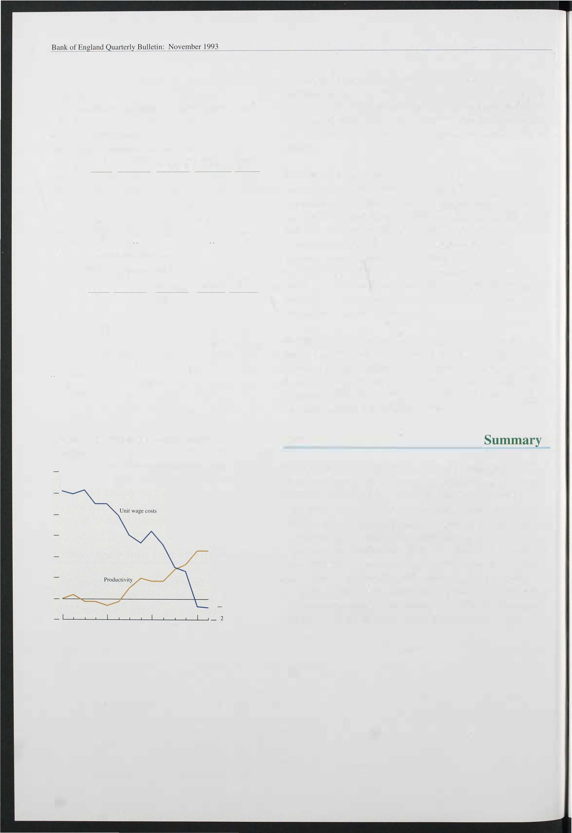

434

# Price dynamics

## 5. 1 External influences

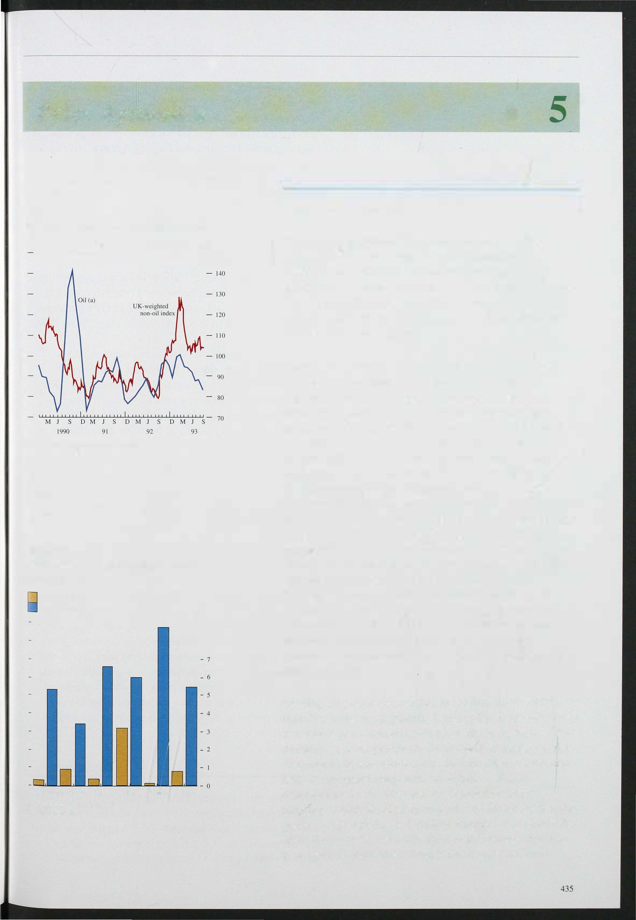Chart 5.1

Sterling oil and non-oil commodity prices

1 990 =1 00

- 150

(a) Measured by close-dated Brent crude.

Chart 5.2

LME( a) stocks as a percentage of mine production(b)

1990 average

September 1 993

Per cent

- 9

- 8

Aluminium Copper Zinc Tin Nickel Lead

1. London Metals Exchange.
2. Bank estimate.

*Primary product prices*

Primary products (including fuels) comprise about one sixth of UK imports, with industrial materials (agricultural non-foods and metals) making up three quarters of UK non-oil commodity imports and food the rest. Commodity plices may have a short-run effect on UK inflation, though in the long run it is determined by domestic monetary policy.

Commodity prices have dropped back in the last eight months, having risen sharply in sterling terms from September 1 992. Sterling's depreciation last year, especially against the dollar, together with stronger timber prices, contributed to a rise of nearly 40% in the UK-weighted non-oil commodities index between 1 992 Q3 and 1 993 Q 1. Since then, sterling has risen, and timber prices have fallen, as worries about the cost implications of U� environmental policy have eased.

This has offset slightly stronger food prices (reflecting in part the introduction of a coffee producers' withholding scheme). Sterling UK-weighted non-oil commodity prices fell by 7. 1 % in Q2 and a further 4.2% in Q3 (see Chart 5. 1 ) . In the near term, there is only a small risk of significant increases in non-oil commodity prices.

Despite the introduction of the coffee scheme, similar agreements between suppliers of industrial materials (which have a large weight in the UK index) remain unlikely. Other factors, such as l arge stockpiles

(Chart 5. 2) and the weakness of world demand, are likely to matter more.

Sterling oil prices were stable in the first half of 1 993, then fell in the third quarter. Dollar oil prices were lower as a result of continued production above quota by OPEC members, poorer prospects for demand and a favourable response to peace moves in the Middle East, which may help to safeguard long-term oil supplies. Prices increased up to 5% after the 25 September OPEC meeting, which decided upon a 24.5 million barrels a day quota. Although this is 1 million barrels a day above the official ceiling in 1 993 Q3, there is less chance that the quota will be exceeded; both Kuwait and Iran have

Chart 5.3

Major six countries' producer prices

Percentage change on a year earlier

- 5

_ 4

- 3

- + 0

agreed to produce within their (higher) quotas, which they did not in 1 993 Q3 . Further, the new quotas, which are to last for six months rather than the usual three, are below the expected demand for OPEC production, as forecast by the International Energy Agency. Even so, the doll ar price of oil has drifted down since

30 September, leaving it 2% lower than at the time of the last *Report.*

*Overseas inflation and import prices*

Inflationary pressures abroad remain weak

(see Chart 5.3); for instance, the latest figures show

,

producers' prices actually falling in Japan. According to

the Bank's latest World Economic Forecast, producer prices in the major six economies are l ikely to increase by a little over 1 % in 1 993 and a little over 2% in 1 994.

There is no automatic link between overseas and domestic inflation; the exchange rate will move to

1990 91

(a) Bank rorecast.

92 93 (a)

offset the differential, unless domestic monetary policy accommodates inflationary shocks from overseas.

Movements in the exchange rate brought about by changes in monetary policy at home or abroad often affect the sterling price of imports much more. Thus 12 percentage points of the 14% rise in UK import prices between 1 992 Q3 and 1 993 Q2 can be accounted

for by the effective depreciation of sterli ng, leaving only 2 percentage points to inflation measured in foreign currencies (Chart 5.4).

Chart 5.4

The exchange rate and UK import prices

Percentage changes on a year earlier

_

18

_

16

12

_

_ 10

_ 6

_

Import prices from the EC have risen by 14% compared with a depreciation of around 8% against EC currencies (Chart 5.5). This increase is well above what would normally be expected. Further, Chart 5.6 shows that in 1 993 recorded UK import prices from other EC countries have increased significantly more than the

prices of manufactured goods in those countries.

Despite recent i mprovements made by the CSO in their calculation of EC price deflators, it is possible that the

4

_ 2 statistics on UK import prices have been exaggerated,

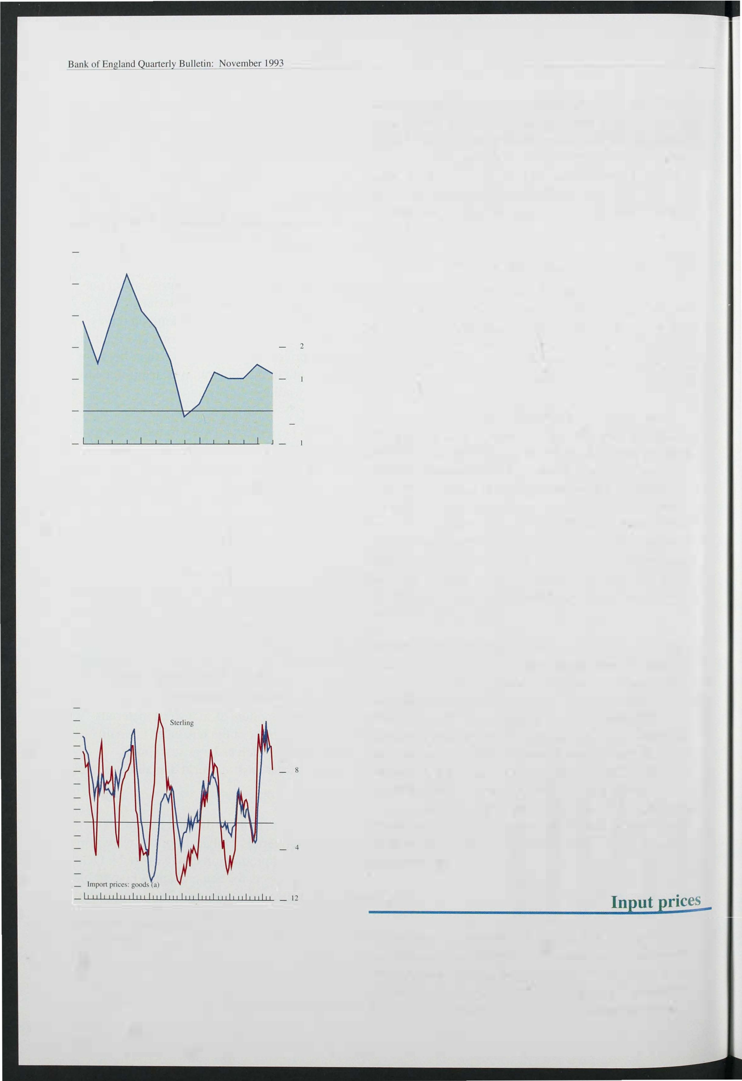

1982 83 84 85 86 87 88 89 90 91 92 93

+

means price rise or sterling depreciation.

(a) Unit vC:llue index.

436

_+ 0

6

_

_

8

_ 10

which would help to explain the muted response of

domestic prices in the United Kingdom to last year's depreciation.

_- 2

*5.2*

So far, the prices of imported materials purchased by manufacturers have increased much less than the official data on import prices suggest-by 5% in the year to the second quarter, against a rise in import prices of 13 %.

In the twelve months to September, manufacturers'

(ltart 5.5

The sterling exchange rate and import prices Q3-1993 Q2)

Impol1 prices (rises) Exchange rale (depreciation)

Per cent

- 18

Non-ECCa)

16

World EC

- Sterling

12

10

_ 2

(a) Based on the non-EC currencies in the sterling index using the following weights: United States (0.2044). Japan (0.0833). Switzerland (0.0548), Austria (0.01 24). Sweden (0.0379), Canada (0.019). Finland (0.0145) and Norway (0.0 13).

(b)

Price increase calculated from data published on 21 October. EC and world impol1

price increases calculated from data published on J I October.(c

Based on the EC currencies in the sterling index using the following weights: Germany (0.200 1), France (0. 1 175). Italy (0.0766), Belgium (0.0525). Netherlands

10.05), Ireland (0.0242). Spain (0.0202) and Denmark (0.0145).

Ch rt 5.6

Ste import prices from the EC and EC manufacturing prices (converted into sterling)

1 990; 1 00

1 1 6

- 11 4

- 1 1 2

1 1 0

108

1 06

1 04

102

100

imported input prices rose by 5. 2%, Prices of manufacturers' purchases of home-produced materials increased by 5, 1 % in the twelve months to September, whereas prices of their fuel purchases fell slightly (0.4%), The twelve-month increase in man ufacturers' total input costs was 3,5% in September 1 993, compared with 6,3% in August. The steep rise in input prices seen last autumn is now starting to drop out of the

twelve-month comparisons,

Food prices in the United Kingdom covered by the Common Agricultural Policy are influenced by the green pound-the rate at which the EC agricultural support is converted into sterling. But, it was only at the end of December 1 993 that the green pound was brought into line with the £IECU rate following the depreciation of sterling, Consequently, changes in food input prices lagged behind movements in the rest of the index, Adjustments to the green pound are now made regularly to keep the rate in line with the exchange rate, so this lagged effect is unlikely to recur.

*5.3* Business

Producers' returns on capital depend on how prices move relative to costs and to what extent capital is utilised, Chart 5,7 shows that the real return on capital of non North Sea industrial and commercial companies (ICCs), which peaked before the recession began in 1 990 Q2, fell sharply to 6,2% in 1 992 Ql. It has been rising since, The trough in ICCs' profitability during the recent recession was not nearly as deep as during the recession

1 988

Chart 5.7

Return on capitat(a)

manufacturing 98

pnces

E<;

96

94

92

91 92 93

of the early 1 980s, The return on capital is now above

the average level over the last twenty years, It is not yet clear whether this reflects higher rates of return required in the long run; this will depend upon real interest rates in the world capital market, which reflect the global balance of savings and investment.

Non North Sea ICCs

Per cent per annum

_ 14

- 12

- 10

- 8

- 6

_ 4

- 2

Chart 5,8 shows a historically close relationship between ICCs' return on capital and their capacity utilisation, However, during the boom of the late 1980s, and particularly during the subsequent recession, this link weakened and profitability varied less, for two main reasons, First, firms have adjusted their labour inputs quicker in the recent recession than in earlier periods.

Second, and partly reflecting the first factor, competitiveness deteriorated much less in the 1 990s recession than in the early 1 980s, so that there was much less downward pressure on firms' profit margins.< l)

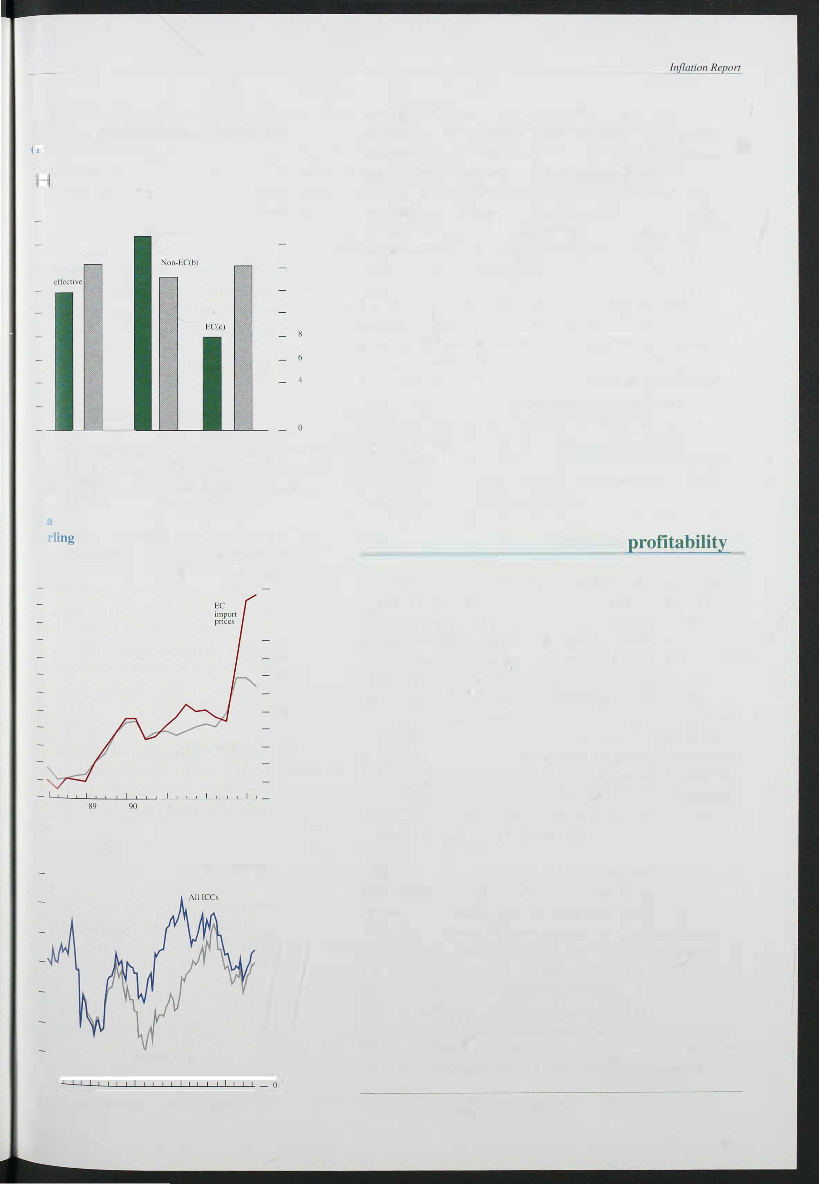

1 970

73

75 77 79 81 83 85 87

89

91 93

(a) Pre-tax rale of return on capital stock at replacement cost.

(I) See the Bank of Ellglalld Quar/erly BlIlle/in, August 1993, 'Company profitability and finance', pages 36 1 -71.

437

Bank of Bulletin: November 1 993

Chart 5.8

Rate of return on capital and capacity utilisation

Per cent Per cent per annum

70 - - 12

(<1)

Capacity utilisation (lefl hand scale)

60 - - 10

50 -

-

8

40 -

- 6

30 -

- 4

An increase in profitability during an upswing is not necessarily inconsistent with progress in reducing inflation, because higher profitability may arise from increased utilisation of capital rather than from any increase in prices relative to cost. Chart 5.9 shows trends in the rate of return on capital for non North Sea ICCs, and the ratio of profits to cost. The profits to cost ratio is more stable than the rate of return or the capacity utilisation measure and has varied less during the recent recession than in previous cycles. Since the mid- 1 980s

UK import prices have increased much more slowly than

20 -

Rate of return (b) - 2

consumer prices. This has allowed real wages to

10 - (right hand scale)

1 972 74 76 78 80 82 84 86 88 90 92 _ 0

1. Percentage of manufacturing firms reponing capacity fully utilised.
2. Rate of return on capital stocks at replacement cost of non North Sea ICCs.

Chart 5.9

Ratios of profits to capital and profits to costs(a)

1985=100

-160

-140

-120

-1 00

- 80

- 60

- 40

- 20

1972 74 76 78 80 82 84 86 88 90 92

(a) For whole economy excluding North Sea oil sector. Costs comprise employment COSts and imports.

Table 5.A

Contributions(a) to manufacturers' output price intlation(b)

Percentage points

1992 1 993

Year Q3 � QI Q2 July Aug.

I Labour productivity 2.1 2.2 2.7 3.5 3.2 204

2.4

2.2

increase in line with domestic productivity, as well as a rise in the share of profits in GDP.

A reduction in gross margins was to be expected after a depreciation which increased the prices of purchased inputs. But firms should focus on their return on capital, which depends on capacity utilisation and unit labour costs too. Table 5.A shows how manufacturers' output prices have changed. Following sterling's depreciation last year, the contribution of input prices rose sharply.

But it was offset by falling unit labour costs and a slowdown in the rate of increase of prices of bought-in services. As a result, manufacturers have been able to rebuild margins while output price inflation has been stable at around 2 1 /4%. The CBI's October Industrial Trends Survey shows that a (seasonally adjusted) balance of 4% of firms expect to increase prices rather than decrease them in the coming four months. This compares with a balance of 5% in July.

Although some of the effects of last year's depreciation have stil.to work through to prices, the immediate

effects will start to drop out of twelve-month comparisons in the next few months. However, as noted in Section 4, productivity increases are often largest in the early months of recovery, so that unit labour costs

may soon become a less benign influence on cost

1. Labour costs 2.7 2.8
2. Unit labour costs

2.0 1.3

pressures. The extent to which companies have managed to defend profitability during the recession

(3=2- 1)

0.6

-1.2 -0.8 -004 -0.6

4 Input prices -0.7 -1 .2 0.7 1.8 lA

1 .9

2. 1

means that margins may make a milder contribution to

1. Bought-in services(c) 1.2 1.0 0.7
2. Margins(d)

-0.2 -0.3 -0.4

inflation than in previous recoveries, though there are important sectoral differences.

(6=7-(3+4+5)) 1.2 2.0 1.3 lA 2.0 1. 3 1 .6

2.3

1. Output prices(e) 2.3

2.2 2.3 2.3 2.4 2.6

1. Calculated for each component as the twelve-month growth rale scaled by weights derived from 1984 input-oulpUl lables as follows:

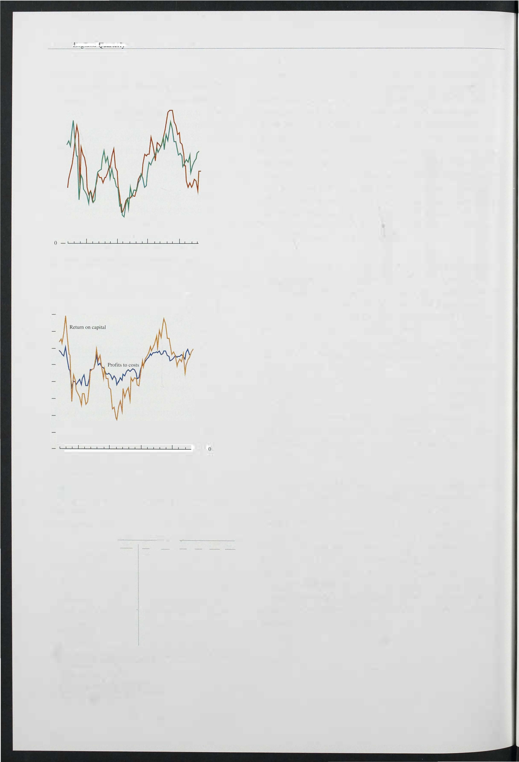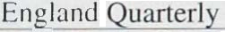

unil labour costs

input prices 0.33

bought.in services 0.23

1. Excluding food. drink. tobacco and petroleum.
2. Proxied by unit labour costs in the service sector.

10

1. Figures may not add tOlal� because of rounding.
2. Percentage changes on a year earlier.

438

*5.4*

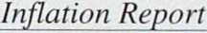

World commodity prices are li kely to be held in check by weak world demand and large stockpiles, so it is unlikely that upward pressures on firms ' prices will emerge from this direction. Nor should the rebuilding of profitability after the recession be a problem. ICCs' return on capital has been rising since 1 992 Q1 and is already above the average for the last 20 years. Spare capacity has not reduced profitability to the extent it has done in the past. Increases in the prices of imported inputs have been offset by reductions in unit labour costs in manufacturing, so it should not be a cause for concern that the ratio of output prices to input prices has fallen.

439

# Prospects for inflatior

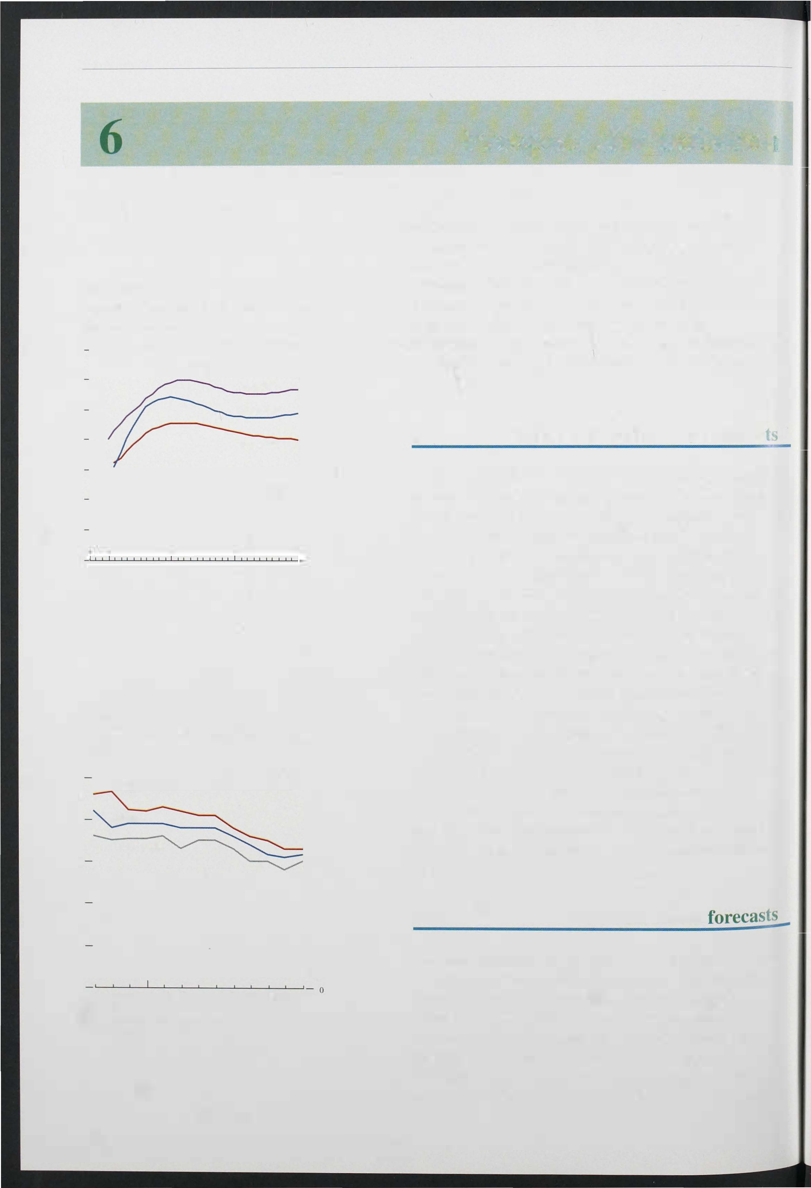

Chart 6.1

Inflation term structure derived from gilt-edged prices

Per cen� 7

7 May 1993

2 Aug. 1993 - 5

27 Dct. 1993 - 4

- 3

- 2

- 1

1995 2000 2005 2010

Year

Chart 6.2

Comparison of RPIX inflation forecasts for 1 993 Q4

Per cem

Upper quartile

Median

- 4

Lower quartile

- 3

- 2

- I

Oct. Nov.Dec. Jan. Feb. Mar. Apr. May JuneJuly AugSept.

OCI.

1992 93

Data from HMT comparison of forecasts. Number of forecasts varies over time.

are

440

During the two years that sterling participated in the ERM, inflation expectations declined significantly. But they rose sharply after sterling left the ERM in September last year. The new framework for monetary policy announced in October 1 992 was designed to help restore credibility. This section first reviews developments in inflation expectations and then presents the Bank's own view of the prospects for i nflation to mid- 1 995.

## Evidence from financial marke

The previous two *Reports* have described how the term structure of expected inflation can be estimated from yields on conventional and index-linked gilts. There was a marked rise in longer-term inflation expectations following sterling's departure from the ERM. By December 1 992, annual inflation was expected to be some two percentage points higher in around ten years' time than had been expected in early September.

Movements in gilt yields suggest that expectations remained around these higher levels until the spring of

1 993, and it was only in the early summer that there was any sustained decline. Expected inflation in around ten years' time fell by over one percentage point between early May and early August (see Chart 6. 1 ) . The fall continued into October, bringing expectations down close to. where they had been before sterling's exit from the ERM. Provided there is some risk premium on

conventional gilts, these figures suggest that longer-term inflation expectations now lie within the Government's 1 %-4% range, though they do not yet indicate full faith in price stability.

## Private sector

Forecasts produced by private sector organisations such as City firms and academic institutions i ndicate how their perceptions of future inflation are changing.

Chart 6.2 shows the median of 36 private sector forecasts of RPIX inflation in the year to the fourth

quarter of this year, as recorded each month since October 1 992. (Half the forecasts are higher than the median, and half lower.) It also shows the upper and

Chart 6.3

Comparison of RPIX inflation forecasts for

Per cent

- 5

- 4

Lower quanile - 3

- 2

- I

0

Feb. Mar. Apr. May June July Aug. Sepf. Ocl.

1993

Data are from HMT comparison of forecasts. Number of forecasts uver time.

vanes

rt 6.4

Srn h New Court/Gallup Survey of fund managers

Expectations of price changes in the 12 months December 1993

10

12 10

Expectations of price changes in the months December 1994

Per cent

- 5

- 4

- 2

- I

J J A S O N D J F M A M J J A S O

1992 93

Chart 6.5

Balance of employees expecting annual p rice inflation to be less than or equal to 4%

Bal.:lIlce (per cent)

- 70

- 80

lower quartiles (one quarter of the forecasts being above the upper quartile, one quarter below the lower quartile). Last winter the median forecast remained near to 4%, with the majority of forecasters concerned that the depreciation of sterling and higher import prices would put upward pressure on RPIX inflation. As these fears have abated, forecasts have been lowered; and their spread has naturally narrowed, as data for more of 1 993 have become avail able.

Chart 6.3 shows the evolution of the median forecast for RPIX inflation for the year to 1 994 Q4. Here too, expectations have been falling during this year, although not quite as much as for the 1 993 forecasts . By September, even the upper quartile was within the Government's target range for underlying inflation, even though most forecasters expect inflation to be a little higher next year than this.

## of inflation

Perhaps not surprisingly, the Smith New Court/Gallup Survey of fund managers shows a similar picture to that suggested by gilt-edged prices: that inflation expectations rose in October of last year but have gradually fallen back (see Chart 6.4.) Most other surveys also recorded a jump in expectations after sterling left the ERM. A Gallup survey of employees continues to show a majority expecting inflation to be 4% or below over the next twelve months if 'don't knows' are excluded (see Chart 6.5). The October CBI Industrial Trends Survey reveals that 72% of its respondents are expecting their domestic output prices to remain the same over the next four months, and the remainder are nearly equally split between price cuts and Increases.

A survey with a different pattern is Dun and Bradstreet's, which asks managing directors whether they think their selling prices will increase or decrease. As Chart 6.6 shows, the surveys undertaken late last year had substantial majorities expecting to cut prices, but by the summer of this year a small majority expected their selling prices to rise. And according to an EC/Gallup Survey, consumers are more pessimistic about inflation prospects than at any time since February 1 991 (Chart 6.6).

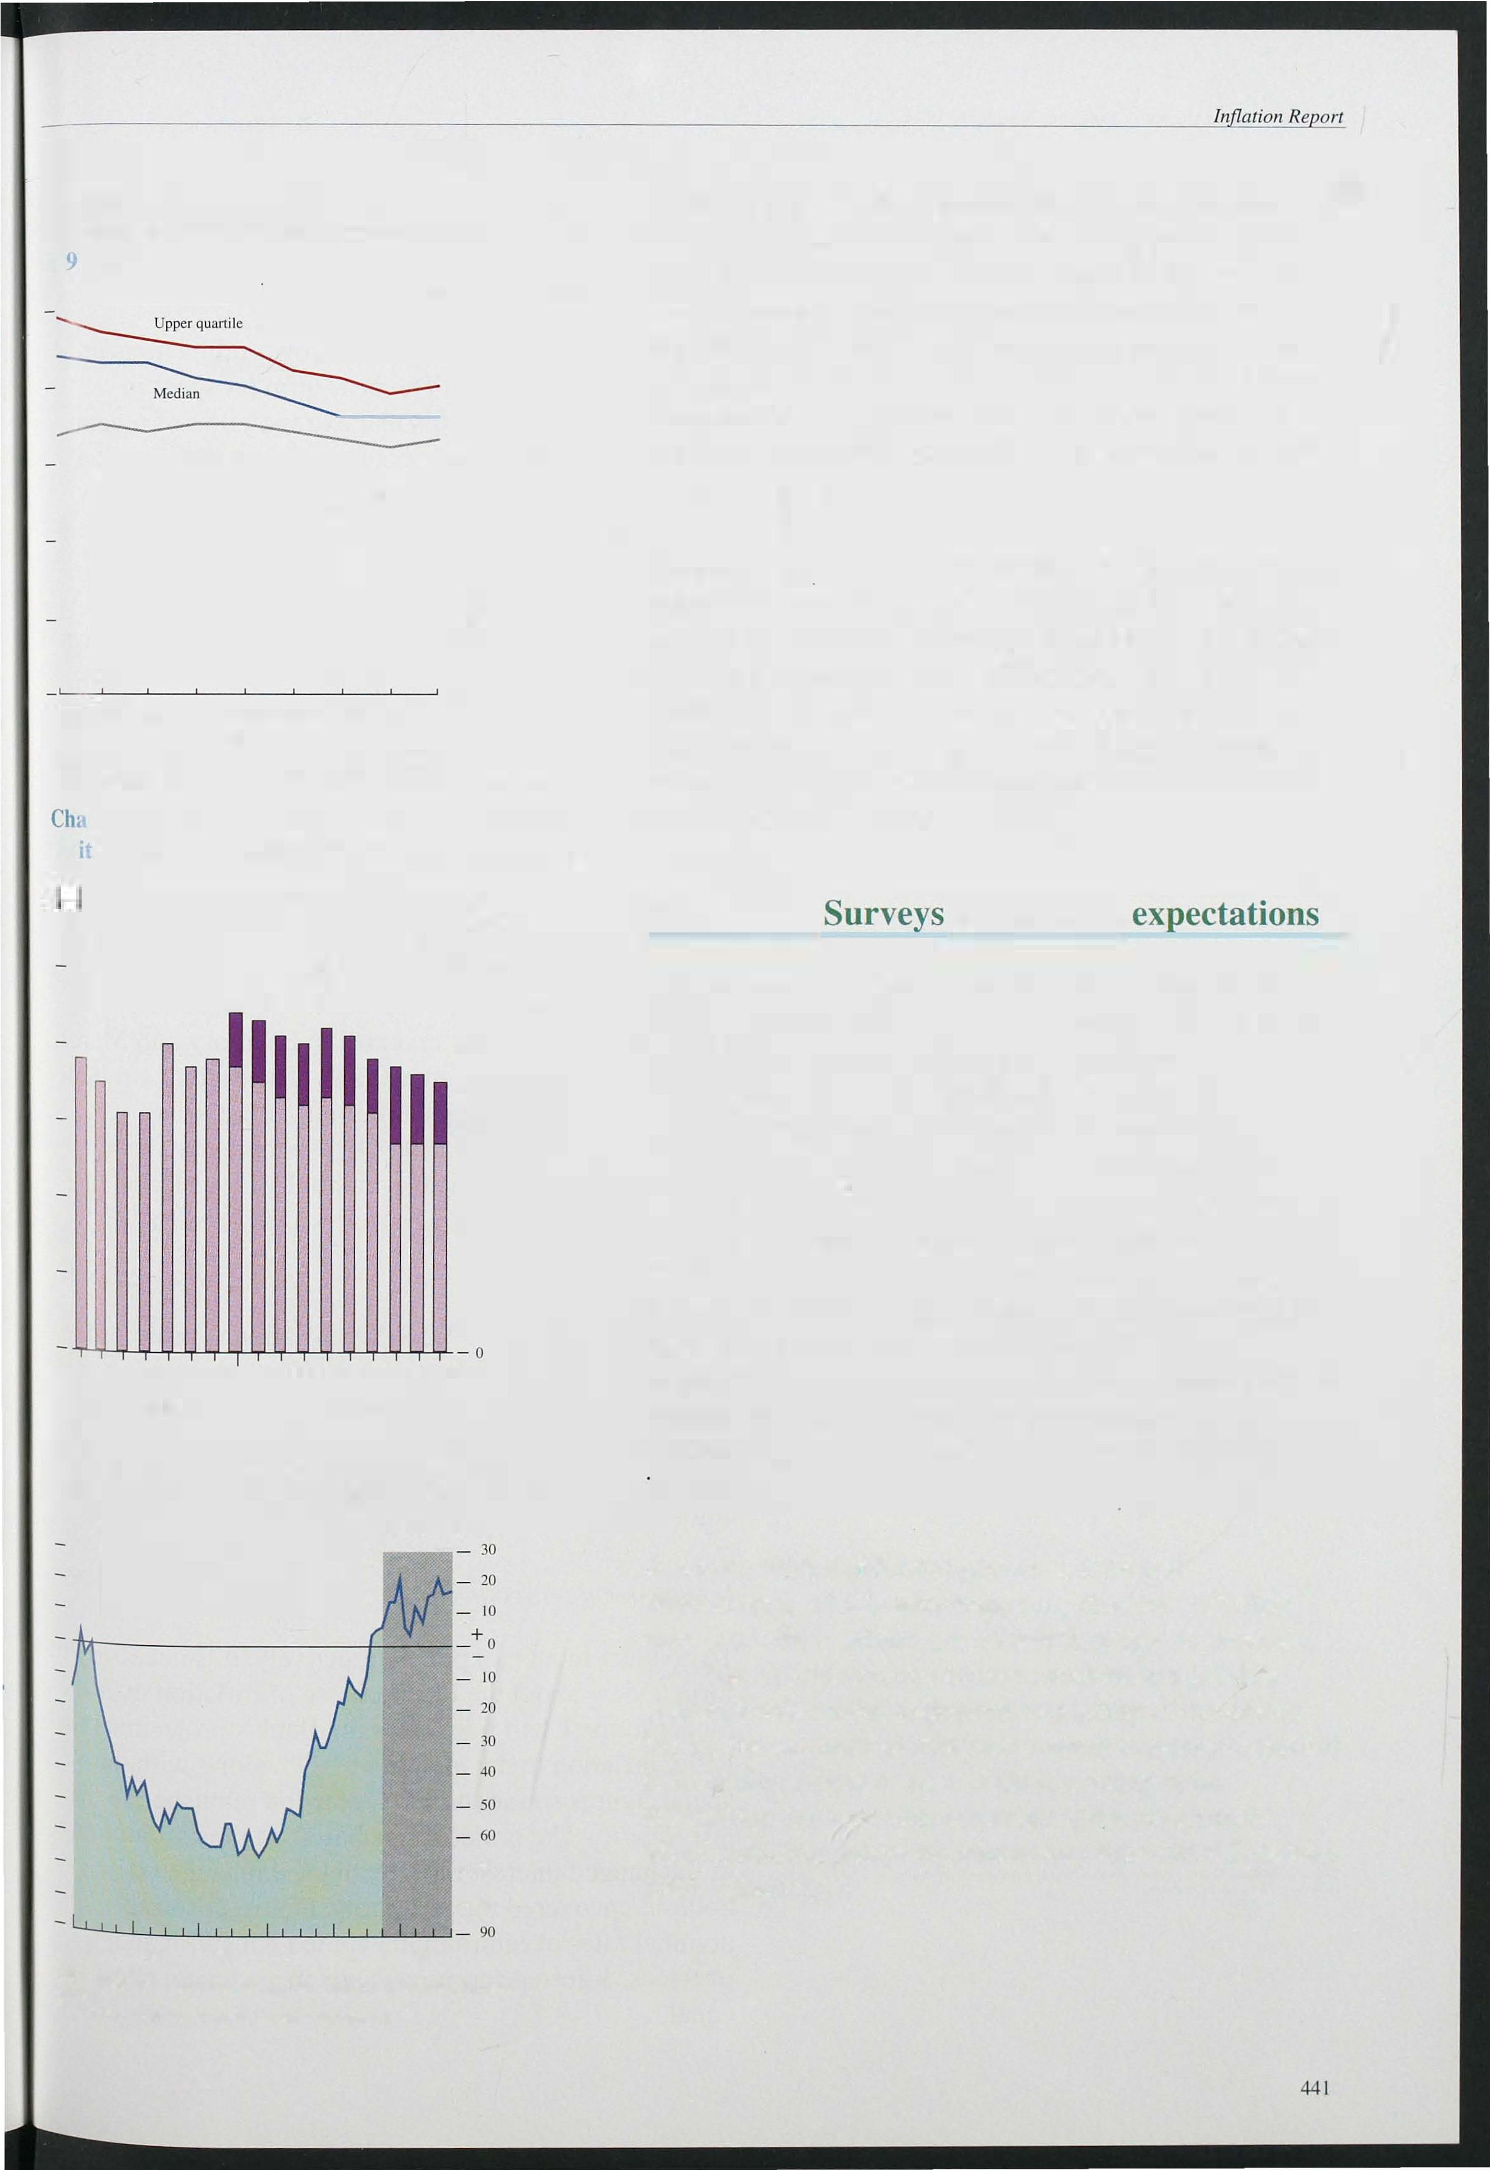

1 988 89 90 91 92 93

Lightly shaded area represents the pen. od over whi.ch .Innal.lon target has been

ased On Gallup Survey of employees' price expectations

?rating.

## Bank

*The short-run outloo*

Chart 6.6

Dun and B radstreet Survey on expectations of selling prices and EC/GalJup consumer inflation expectations

As in previous *Reports* the Bank's own projections are shown for two periods. The near-term prospect in Chart 6.7 is simply a statistical extrapol ation of recent trends in some RPI components, incorporating known factors such as changes in administered prices and

Gallup Survey (acmal) (a)

Dun and Bradstreet Survey (c)

1988 89 90 91 92 93

1. Weighted average of responses Gallup question.

10

1. Four-month moving average of the "actual' response.

(+)

- 60

- 50

- 40

- 30

- 20

- 10

+

- 0

- 10

- 20

pre-announced plans to change indirect taxes. Duties are assumed to be adjusted in line with the RPI (as are benefits in the longer-term projections). In the latest three months RPIX inflation has risen a little more than projected last time: 3.3% compared with 3. 1 %. This difference partly reflects smaller than expected falls in food prices in July, and partly the larger than expected recovery in the prices of household goods and clothing and footwear associated with the end of the summer sales.

Looking further ahead, the large discounting by retailers in the first quarter of 1 993 is not expected to be repeated

1. Percentage point balance of those expecting an increase or a

decrease (-) in their selling prices.

Chart 6.7

RPIX inflation projections and outturns

August projections CurrcnI projections

___

in 1 994 Q 1 . In January 1 993 the RPIX index fell

0.5 %-though this was reversed in February and March, in each of which RPIX rose 0.7%. The current strength of retail demand suggests a return to more usual discounting patterns in 1 994 Q 1; so there may be a temporary rise in the twelve-month RPIX inflation rate in January, which should be reversed in February and March.

In the remainder of 1 993, RPIX inflation is projected to stay around its rate in September. If so, headline

Percentage change on year earlier

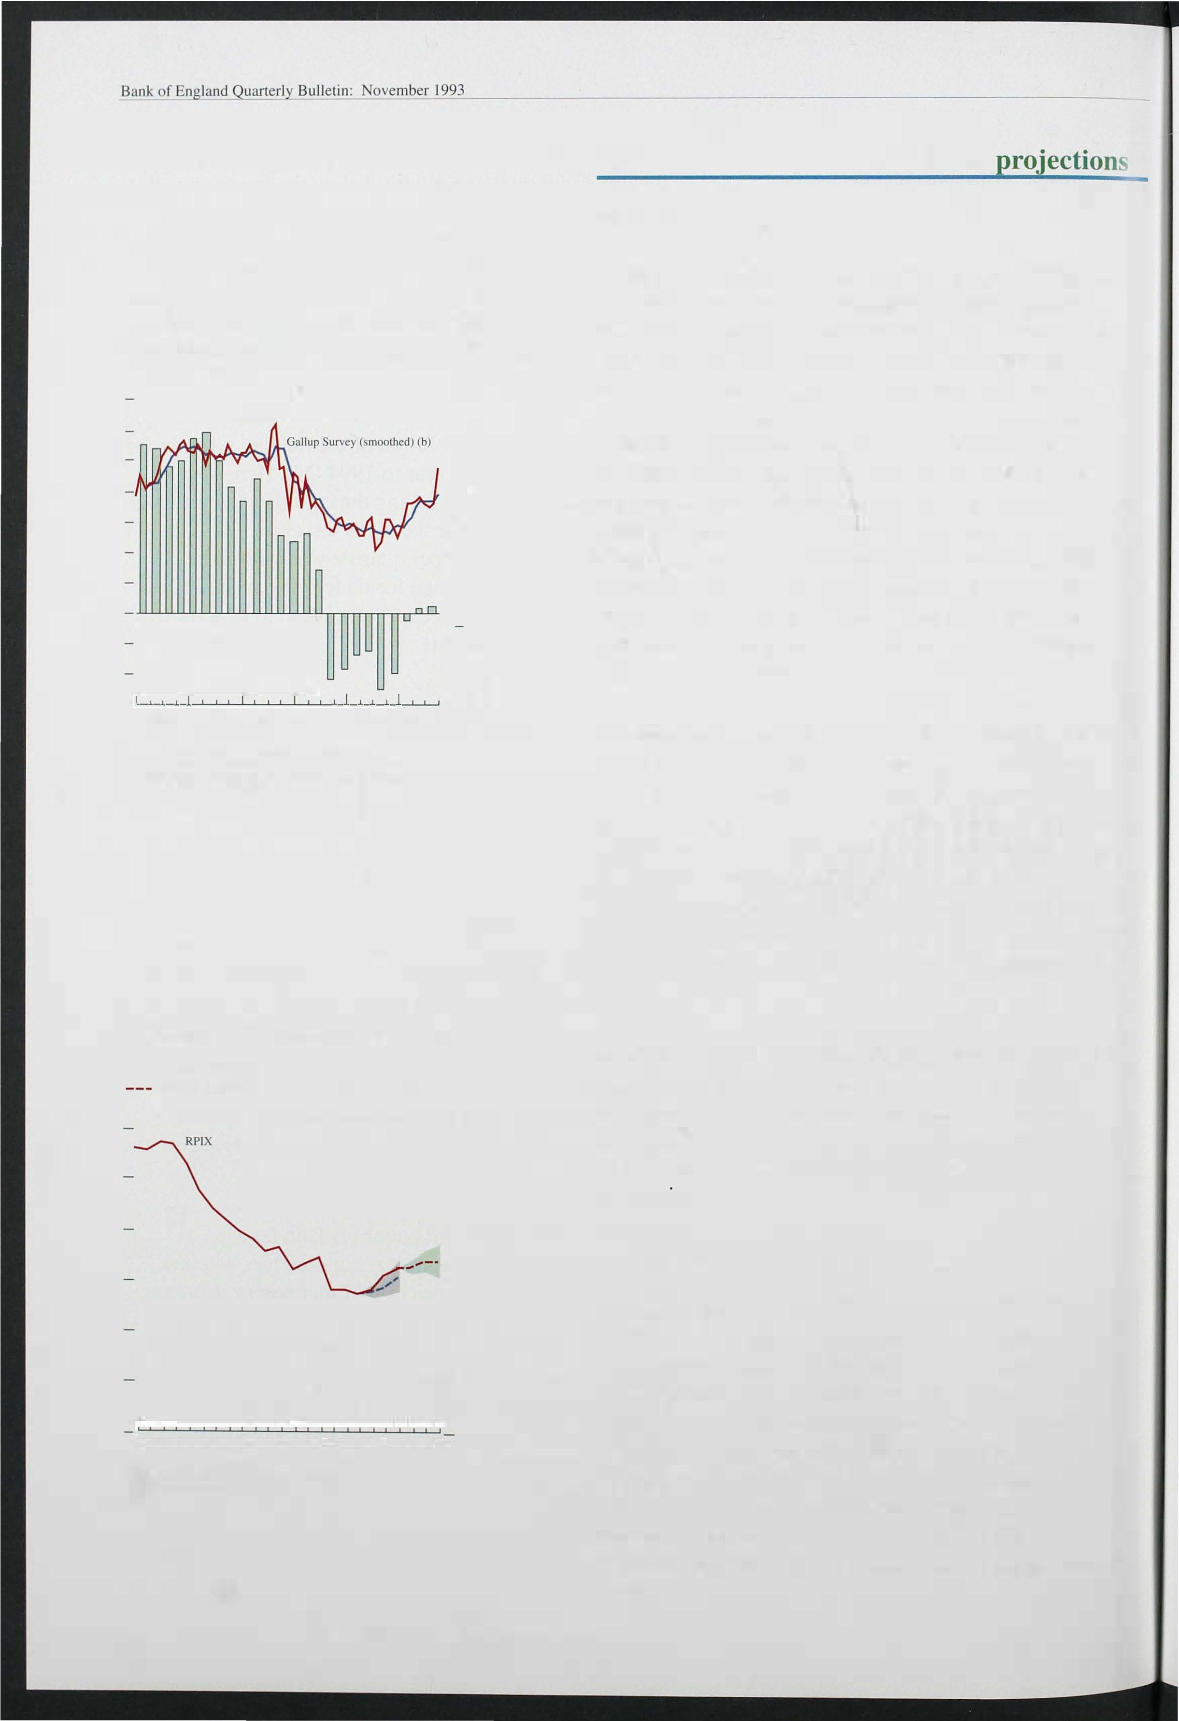

a

- 6

- 5

- 4

- 3

- 2

- I

0

M J S D M J S D

1 992 93

The range is defined the central projection plus or minus the average error on such forecasts in the past.

as

442

inflation-the twelve-month change in the RPI-will

rise rapidly, because cuts in mortgage rates in November and December last year will be dropping out of the companson.

*Longer-term projections*

To conduct monetary policy effectively, it is necessary to form a view about the likely course of inflation over the longer term. Chart 6.8 shows the Bank's projections for

RPIX infl ation to the middle of 1 995, along with the actual figures so far and the projection published in the last *Report.* The projection is based on the assumption of unchanged interest rates, with the exchange rate

holding uncovered interest parity, that is, ensuring nominal rates of return in the United Kingdom and overseas, adjusted for movements in exchange rates, are

equal.

Chart 6.8

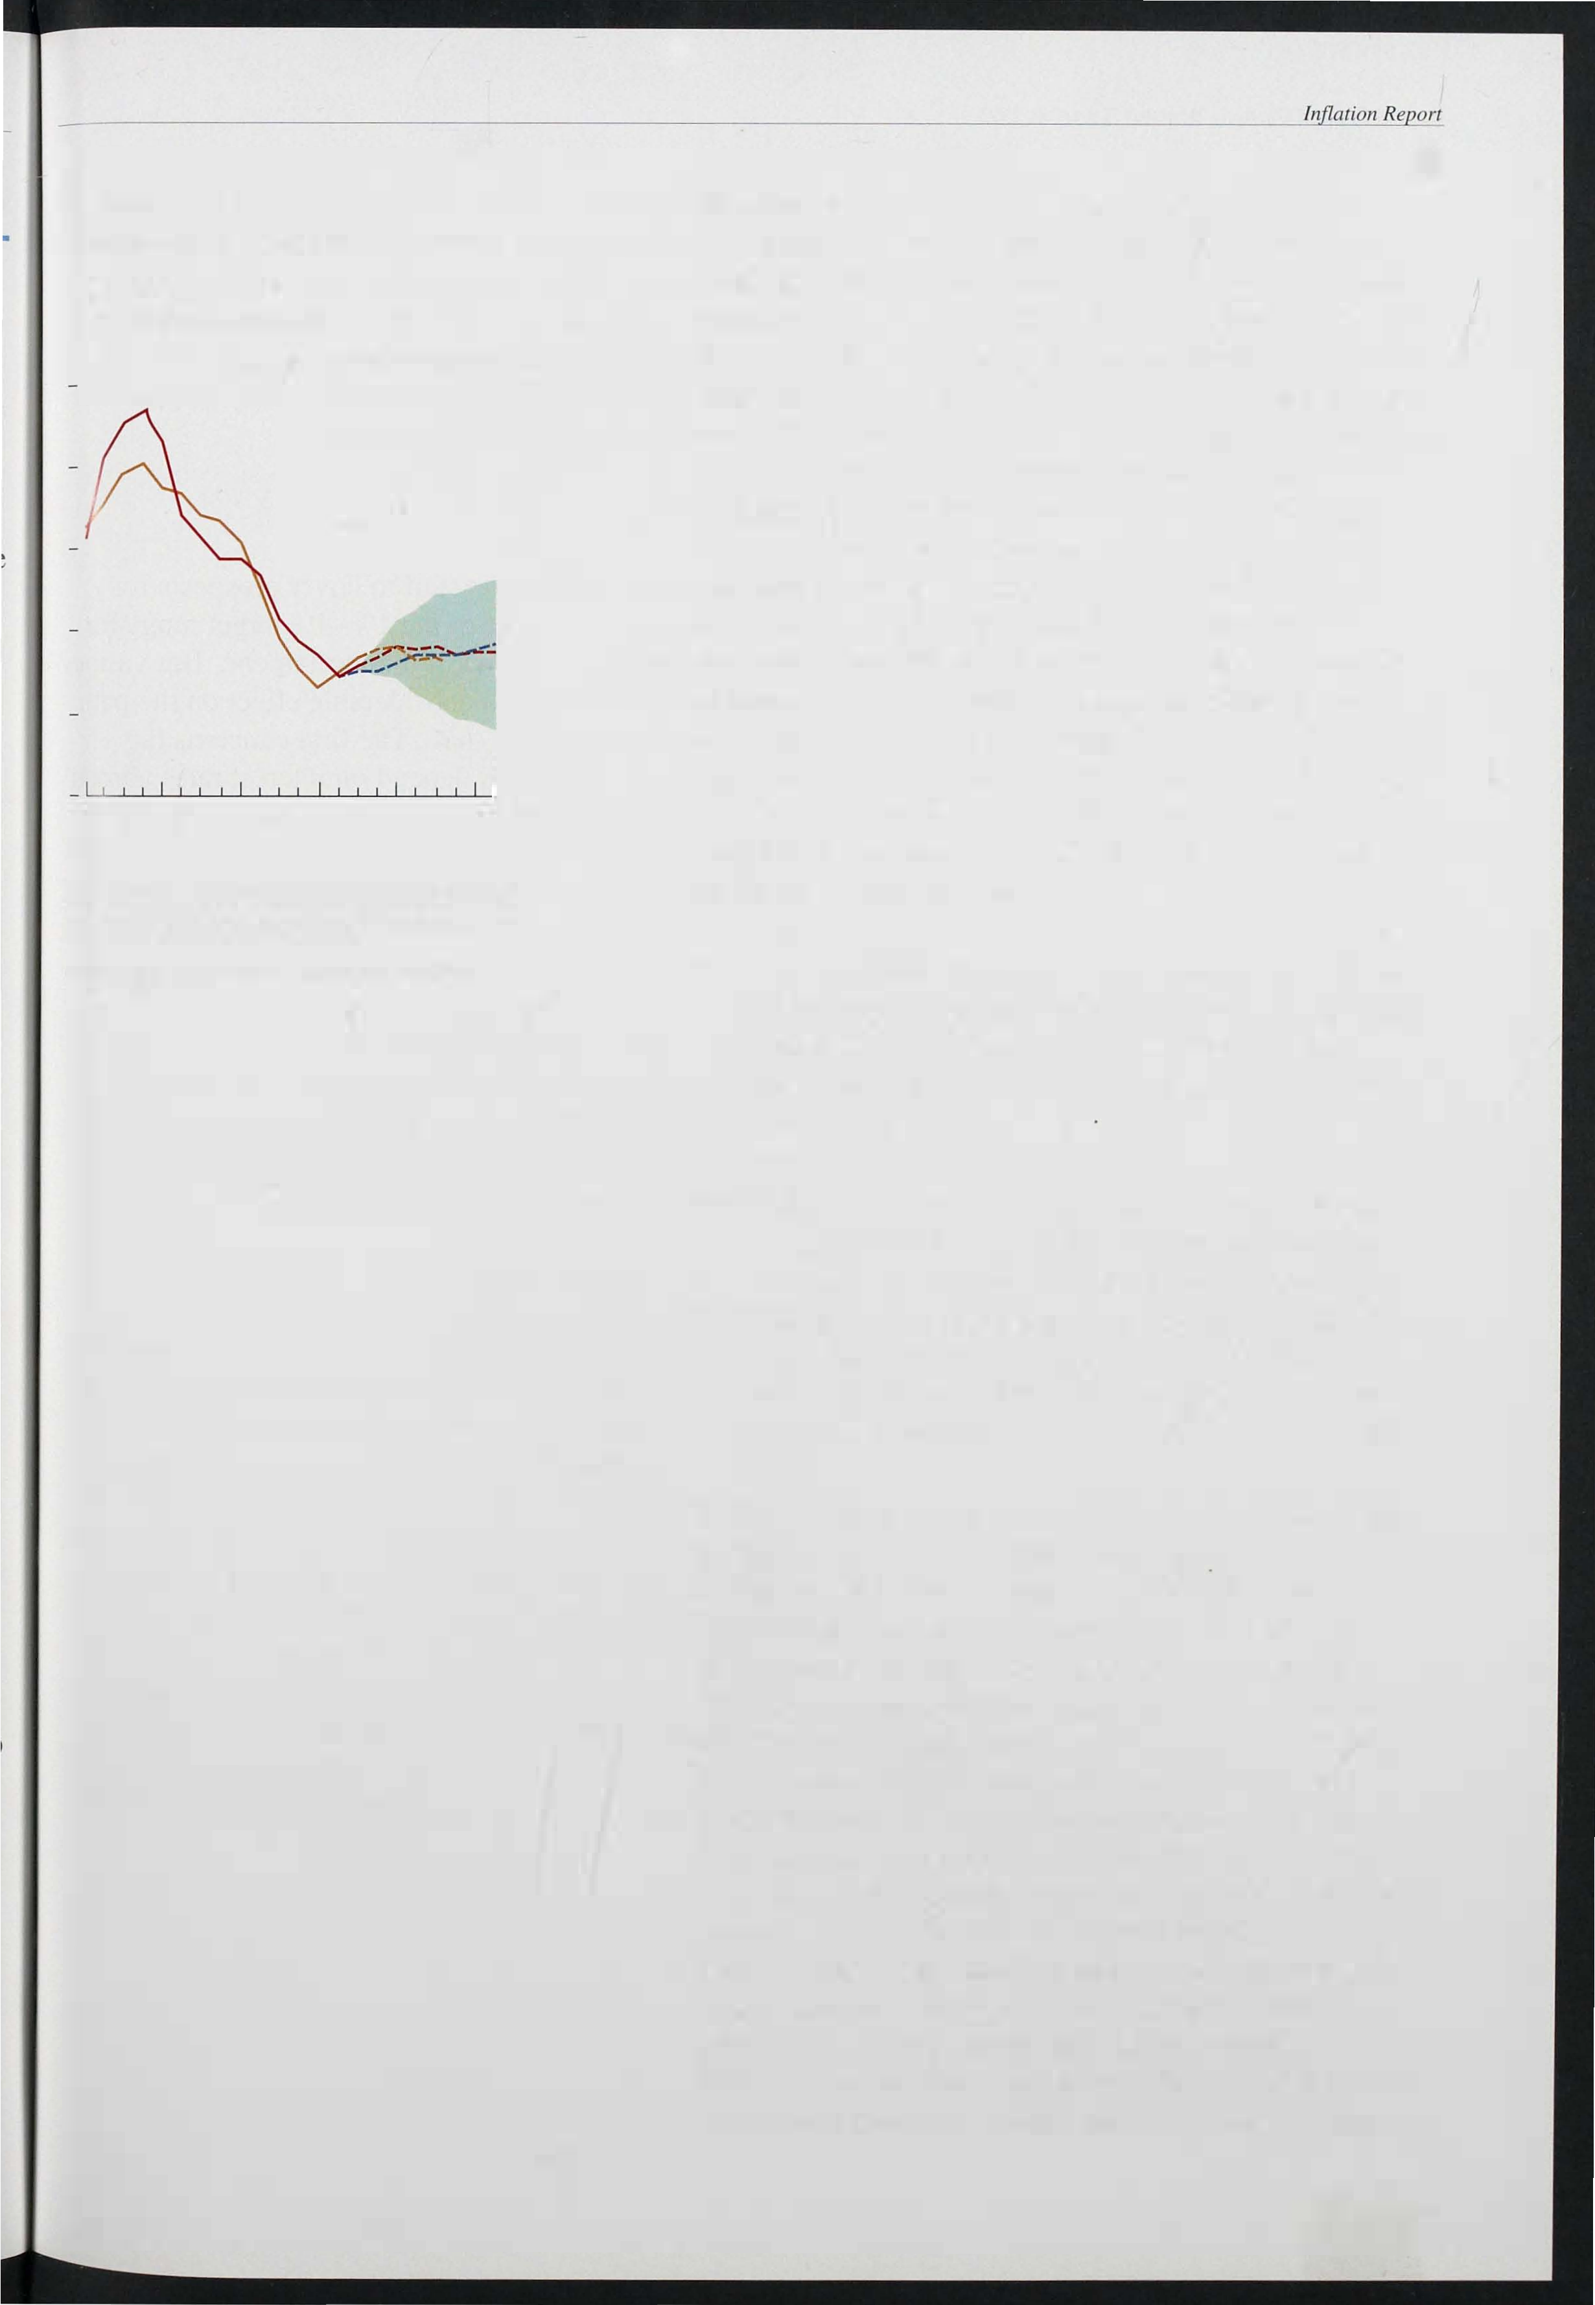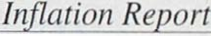

RPIX inflation projections and outturns

� RPIX

* - RPIY (a)
* RPIX (previous Il1flation Report)

Percentage change a year earlier

011

- 1 0

- 8

- 6

- 4

..--.. - 2

1990 91 92 93 94 95

The e is defined as the central projections plus or minus the absolute

pinrotjheecttiholrnd

innalion projections since 1985. The

averaragneg price

error on consumer

is based on broadly unchanged policy, with the exchange r(ne quaner of 1993 set at 81.0 (£ ERI).

(a) RPIX excluding VAT. local authority taxes and excise duties

(Bank

calculations).

The projection for RPIX is little changed from three months ago. The most likely path is for a small rise until the first quarter of next year, peaking at an annual

rate above 3 1/2%. After that RPIX inflation is likely to

fall gradually. Excluding changes in indirect and local authority taxes, it may fall to around 3% by the middle of 1 995 . This reflects the continuing high level of unemployment and the shortfall in output relative to its potential, combined with further falls in inflationary expectations. It is consistent with the current growth rates of the monetary aggregates. The revisions to the Bank forecast have been smaller this time than they were three months ago, because the economic news in the last quarter has been less surprising than the news received in the previous quarter. However, Chart 6.8 shows that RPIX inflation is now expected to be a little higher until the end of 1 994 than was expected in August, and a little lower thereafter. These changes reflect two main factors:

* recent figures for underlying inflation have been a little higher than had been expected in the summer, when it was still uncertain how far price cuts associated with the sales and seasonal foods would be reversed;
* projections for the level of demand in the world economy have been revised downwards repeatedly by most forecasters, including the IMF and OEeD. Subject to the exchange rate assumption, this means that the demand for British exports will be lower towards the end of the forecast horizon, and the output gap higher.

With a floating exchange rate, it is not clear that lower inflation overseas will affect UK inflation at all. If exchange rates were to move to offset inflation differentials between home and overseas, domestic developments alone would determine the domestic inflation rate, and the real exchange rate would not be affected by nominal shocks. In this forecast, however, the exchange rate develops according to uncovered interest parity. The news that real output abroad is lower than had been expected means that real interest rates overseas are likely to be lower than UK real rates, and to remain so for the rest of the forecast period. There has been a deflationary shock in Europe, and the resulting change in the exchange rate only partially offsets the effect of the change in the outlook for overseas inflation. The result is that lower inflation in the rest of the world is expected to lead to smaller price increases for imports

443

from the middle of 1 994, and sterling's real exchange rate is expected to rise a little, given the assumptions of the projection. The feed-through from world to UK inflation is not one for one, but it is l arge enough to generate the slight fall in inflation we see in 1 994 H2 and 1 995 HI, compared with the essentially flat profile presented in the last *Inflation Report.*

*Uncertainties*

Our projections will soon start to cover prospects for achieving the lower half of the 1 %-4% target range for RPIX inflation by the end of the Parliament. But various uncertainties will have a considerable effect on the path of inflation even before that. The first concerns the exchange rate. This will depend on interest rates abroad as well as in the United Kingdom. On the whole, other EC countries have been reluctant to see big depreciations of their currencies since the demise of the narrow band of the exchange rate mechanism, so interest rates are falling only as fast as they are cut in Germany. Overseas interest rates will also be influenced by the level of activity, which has been weaker than most observers expected. If attempts to stimulate recovery lead to bigger than expected cuts in interest rates, this would be likely to push up the sterling exchange rate and reduce inflationary pressures in the short run.

A second source of uncertainty is the behaviour of wage bargainers. If firms and employees believe that inflation will remain low, then any target level of real wages will be associated with lower nominal wages and prices than otherwise, But it is possible that the i ncreases in headline i nflation likely in the next few months may slow down the revision of inflationary expectations. In which case, there is a danger that wage bargainers will settle for excessively high nominal wages, followed by increases in producer prices unwarranted by the stance of monetary policy. It needs to be properly understood that one-off boosts to the level of prices, for i nstance from higher indirect taxes, do not mean any slackening

of anti-inflationary policy, and should not be regarded as

permanent increases in the underlying rate of inflation.

44

# onclusions



Since the August *Report,* most twelve-month measures of i nflation have risen. Headline inflation has gone up from 1.2% to . 1 . 8 % ; RPIX inflation from 2.8% to 3.3%; and inflation measured by an index which excludes both mortgage interest payments and taxes from 2.8% to 3.5%. There were two main reasons behind these rises: in June, retail discounts were unusually large and widespread, and food prices unusually low, whereas between June and September discounts fell and food price inflation rose. It was u nclear in August how far these effects would unwind. The higher price level will lead to a higher twelve-month inflation rate than was expected at the time of the August *Report,* until the effect drops out of the index in the middle of 1 994. But it does not imply a higher rate of increase of prices further into the future.

Given current policies, the B ank's view of the most l ikely outturn is that i nflation-both headline and RPIX

-will rise until the middle of 1 994 and then start to decline again. The new i nformation available since the August *Report* has led to a small upward revision in the twelve-month i nflation rates expected over the next few months, but it has not produced any significant change to the expected rate of inflation two years from now. The central projection remains within the target range for RPIX inflation. But there is a slight possibility that in the first half of next year inflation will briefly rise above the top of the target range. This is partly because of changes in indirect and local authority taxes. Excluding these taxes, inflation is expected to start falling in early 1 994, and could reach a level close to the middle of the target range in 1 995 . Headline inflation will rise particularly sharply as past reductions in mortgage interest payments fall out of the twelve-month comparison, and mortgage i nterest relief is restricted from next April.

Such projections are i nevitably subject to a large margin of error. What matters is the direction in which inflation is headed. There are particular uncertainties associated with a profile of inflation that first rises and then falls, because that may affect longer-term expectations of i nflation. Expectations of inflation can have a significant effect on wage bargaining. If the short-run

445

increase in inflation is simply extrapolated forward and earnings start to rise more rapidly, then more of the growth of nominal demand which is expected over the next year or two will take the form of higher prices rather than higher output and employment. But if the rise in the published i nflation rates is perceived as temporary, then the monetary stance will be consistent with lower inflation and stronger output.



For this optimistic outcome to be achieved, much will depend on sustaining the credibility of anti-inflationary policies. The continuing output gap, moderate growth of nominal demand, and slow growth in broad money and credit, all point to the possibility of bringing inflation down further at the same time as output growth picks up. And evidence from the yield curve suggests that expectations of i nflation in the medium and long term have fallen again over the past quarter, reflecting growing belief in the inflation target. Implicit in that is a market expectation that the Government will steadily reduce the budget deficit. This perception is crucial, because a substantial rise in the ratio of national debt to national income would lead to fears that the burden of debt would one day be monetised.

446